Plasma Fusion Energy Technology

S Lee^{1,2,3}
¹Institute for Plasma Focus Studies
32, Oakpark Drive,
Chadstone VIC3148, Australia
²INTI University College
71800 Nilai, Malaysia
³Nanyang Technological University
National Institute of Education
Singapore 637616
leesing@optusnet.com.au

S H Saw^{1,2}
¹INTI University College
71800 Nilai, Malaysia
²Institute for Plasma Focus Studies
32, Oakpark Drive
Chadstone VIC3148, Australia
saw_sorheoh@intimal.edu.my

Abstract: Progress of modern civilization is completely correlated with consumption of energy. As energy sources deplete world-wide, further technological progress is doubtful unless a new, clean, limitless energy source is developed. The best choice appears to be nuclear fusion energy which powers all the stars and consequently all life in the Universe. Fusion energy has been demonstrated on earth in the hydrogen bomb. Intensive efforts have been made to harness fusion as an energy source. 50 years of Tokamak research has identified a fusion product (density-confinement time-temperature nτT) of 10²² m⁻³-sec-keV as a minimum requirement for breakeven (Q=1 when the output fusion energy equals the input energy); moreover has pushed the fusion product up by 10⁷ times, to the point when breakeven is only a step away. Immense efforts in science and technology have been expended. The next step necessarily involves international collaboration on an unprecedented scale, to solve the greatest technological challenge we have yet faced. This paper gives a glimpse of the scientific basis and technological achievements to get to the Joint European Torus JET, the biggest fusion experiment, which reached Q=0.6 in 2000. The next step is the International Thermonuclear Experimental Reactor, on which work has just started in Cadarache France. ITER aims to reach Q=10 by the mid 2020’s, to demonstrate feasibility of nuclear fusion as an energy source. Beyond that lies DEMO which will deliver power into the grid by 2040. In the meantime there is room for fusion experiments of smaller scales to provide baseline data and even possibly develop into more efficient fusion reactors. These include laser implosion fusion and the plasma focus. In particular, intensive numerical experiments carried out recently have given new understanding to enable the plasma focus to go beyond its observed performance-saturation, by use of high voltage and current-steps.

- IntroductIon

It is certain that the world is heading for an energy shortage sometime by the middle of this century. Even if we assume that the population of the world can be somehow stopped from growing beyond 10 billion, and that eventually every person consumes only a moderate amount of energy set as just 2/3 of the US 1985 per capita rate, there will be an increasing shortage as supply (fossil, hydro fission) dwindles and consumption rises. This scenario is depicted in Figure 1. This is a moderate scenario. More likely the trend of increasing population will continue as will the trend of increasing consumption per head of population. Hence the trend of energy consumption will increase beyond the rate shown in the scenario of Figure 1. Even in this moderate scenario the situation is unsustainable. Economic and geo-political tensions will reach breaking point and world-wide scale catastrophies will occur unless a large scale long-term new energy source is implemented. Solar, wind and other renewables are small scale in this scheme of things, as they are essentially diffuse sources of energy. The only possibility conceivable today is nuclear fusion energy.

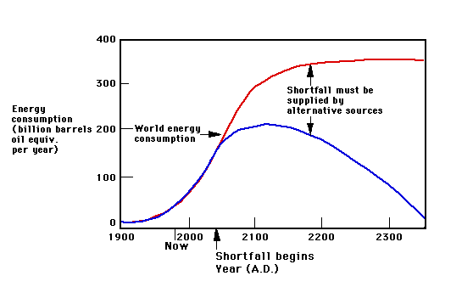
Scenario: World Population stabilizes at 10 billion;
consuming energy at 2/3 US 1985 per capita rate
Fossil, Hydro,
fission
Consumption
Supply
Shortfall
Figure 1. World energy demand outstrips supply even in this conservative scenario.

Nuclear fusion is the process that powers the stars. On earth the release of the power of nuclear fusion has already been demonstrated in the hydrogen bomb. We need now to control this process for peaceful energy generation. The study of plasma physics has led to technological developments which point to the possibility of the use of the fusion process to develop a new, clean and limitless energy source. At the forefront of the efforts to harness this process are Tokamak machines. Technical requirements to harness nuclear fusion include high temperatures, sufficient gas fuel densities and containment times which appear to be attainable in the next generation of Tokamaks. Other programmes to develop nuclear fusion reactors involve inertial methods, including laser implosions and plasma pinch (fast compression) devices such as the plasma focus.

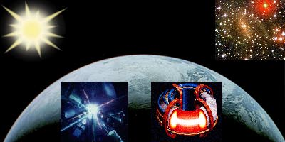
Figure 2. Natural fusion reactors and experimental fusion reactors on earth.
(credits: Figures 1 -11 are taken from some websites in the reference list [1-6])

1.1 Plasma and plasma characteristics

Plasmas form the fourth state of matter, the other three states being solid, liquid and gases. When matter is heated to very high temperatures, some of the atoms in the matter become ionized when electrons are ejected from the atoms. When sufficient ionization is attained, the matter is in an electrically conducting gaseous state which is known as the plasma state. A plasma interacts with electric and magnetic fields. The electrons and ions in a plasma may be controlled by electric and magnetic fields. A plasma has higher energy density (per unit mass) than matter in the other three states. A constituent particle in a gas at room temperature may have several hundredths of eV (electron-volt) of energy whilst a plasma, even a ‘cold’ plasma may have energies of several eV’s (in this context: 1 eV=11,400K). A ‘hot’ plasma may have temperatures exceeding keV’s. More than 99% of matter in the universe, including the stars, exists in the plasma state.

1.2. Applications of plasmas

Plasmas have advantageous properties including high energy densities and ability to be precisely controlled by electric and magnetic fields. These properties lead to many applications [7] including surface processing, cleaning, etching, deposit of advanced materials including diamond-like and harder-than-diamond materials, materials related to nanotechnology, environmental applications such as waste disposal, high-temperature chemistry, MHD converters, thrusters, radiation sources for microelectronics lithography and micromachining, medical applications such as diagnostics, cleaning instrumentation and light sources for spectroscopy. The most important application is nuclear fusion energy.

2. Nuclear Fusion Energy

Plasma nuclear fusion promises a new limitless source of energy [1-6], essential for the continuing progress of human civilization. Mankind now stands at a dividing point in human history; 200 years ago the earth was under-populated (less than 1 billion population consuming little energy per head) with abundant resources of energy; 100 years from now, the earth will be overcrowded (25 billion population with voracious hunger for energy (assuming population doubling time of 45 years or 1.6% per year), with little energy resources left. Rate of growth will slow down amidst intensifying energy-caused conflicts unless a new large-scale source is found.

Plasma nuclear fusion is based on the following most promising nuclear reaction:

₁H² + ₁H³ ₂H⁴ + ₀n¹

The fusing of a deuteron (deuterium nucleus) with a triton (tritium nucleus), see Figure 3, to form a helium nucleus with the liberation of a neutron which carries with it the excess energy of the reaction, this excess energy coming from mass-energy conversion, since the reactons (deuteron nucleus and the tritium nucleus) have more mass than the reaction products (the helium nucleus and the neutron); a clear demonstration of Einstein’s E=mc². In the stars fusion reactions are responsible for the continuing shining of the universe.

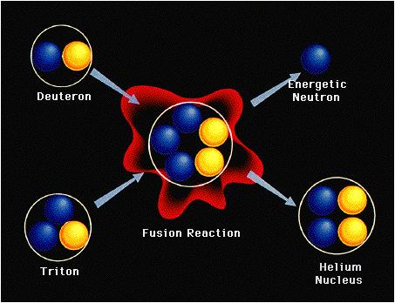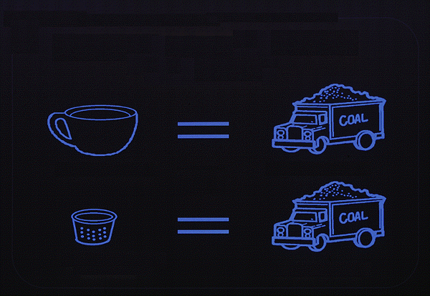
Figure 3. Deuterium-Tritium fusion Figure 4. One thimble of heavy water extracted from 50 cups of water undergoing nuclear fusion produces energy equivalent to a truck of coal.
The plan of fusion scientists is to harness this same power in a controlled fashion in nuclear fusion reactors. The fuel for such reactors is practically limitless. One part in 6000 of sea water is heavy water (D₂O). This heavy water will act as the basic fuel for the nuclear fusion reactors and will last the most voracious usage of mankind for millions of years.

3. Conditions required for nuclear reactors

Thermalised plasmas need to be at a high enough temperature for collisions to be able to overcome the Coulomb repulsive barrier. The ideal ignition temperature for D-T fusion is 4 keV. The other requirements are a high enough density contained for a sufficient period of time. Technological targets are set at: Temperature >10 keV (100 million K) and a density-containment time product nτ>10²¹m⁻³-sec [6]. Attempts to fulfill the nτ criterion appear to have settled down broadly into two approaches:

n=10²⁰ m⁻³, with confinement time τ=10 second (low density, long lived plasmas, contained by magnetic fields) and

n=10³¹ m⁻³, with confinement time τ=10⁻¹⁰ second (super-high density, inertially compressed pulsed plasmas, with confinement time provided by inertia).

The nτ criterion together with the requirement for a high enough ignition temperature give a combined fusion product of: nτT>10²²m⁻³-sec-keV.
On the other hand, both the requirements of high temperature and confinement in stars are provided by gravitational forces.

4. Tokamak

A Tokamak [1-6] may be described as a doughnut shaped plasma vessel in which electric currents are used for heating the plasma and magnetic fields are used to contain the plasma away from the walls. The magnetic fields need special configurations for stability over the period of containment. A schematic is shown in Figure 5 with a cut-away section showing the plasma in the vessel. The transformer core and the field coils to confine the plasma are shown in Figure 6.

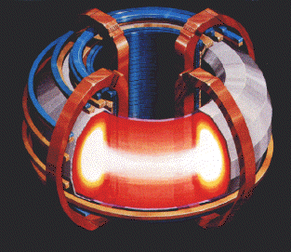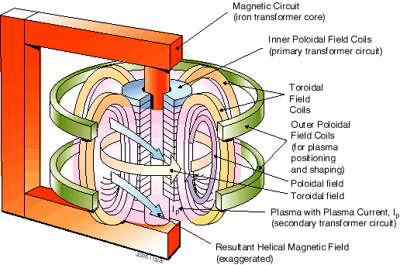
Figure 5. Tokamak vessel Figure 6. Magnetic fields for confining Tokamak Plasmas

The Joint European Torus (JET) sited at Culham, UK, is the world’s largest nuclear fusion research facility [3]. Its structure and a worker inside the toroidal vessel are shown in the Figures 7 & 8.

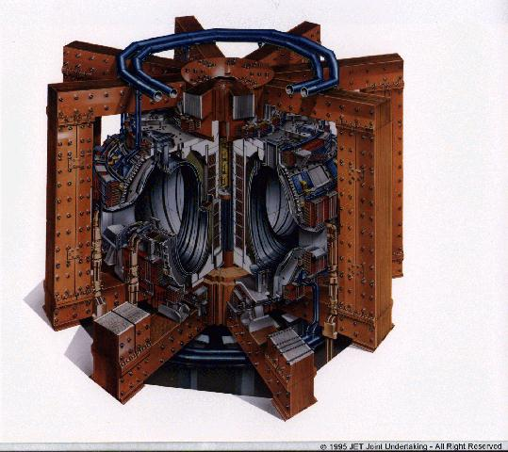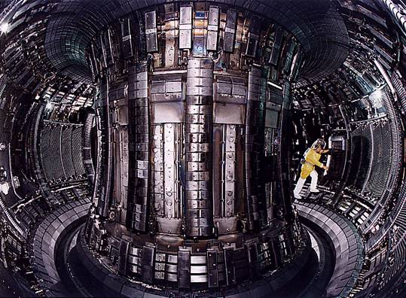
Figure 7. Struture of JET Figure 8. A worker inside the JET chamber

Progress in Tokamak research is depicted in Figure 9, which shows that the fusion product nτT has increased 10 million times in the 51 years of Tokamak research since 1958 [6]. The required fusion temperature of >10 keV has been achieved in several Tokamaks including JET (EU), JT-60 (Japan), TFTR (US) and DIII D (US). Fusion confinement (nτT=10²²m⁻³-sec-keV for Q=1 breakeven; here Q is the ratio of output fusion energy/input energy) is only one step away. Notably JET has already achieved Q=0.6 before year 2000.

Figure 9. Illustrating fusion progress in 51 years. Break-even is only one step away.

Moreover from all the experiments, cutting through all the difficulties in plasma physics and engineering technology, the energy confinement time is known to scale as some functions of plasma current I_{p}, major radius R, minor radius ‘a’ and toroidal magnetic field B. The scaling law may be expressed generally as τ~ I_{p}^{α} R^{β}a^{γ} B^{λ} with the indices all positive. To achieve a sufficiently high nτT the scaling indicates increase in I_{p}, R, a and B.

4.1 International Thermonuclear Experimental Reactor- ITER

In 1985 at the Geneva Superpower Summit, Reagan (USA) and Gorbachev (Soviet Union) agreed on a project [4,6] to develop a new, cleaner, sustainable source of energy-fusion energy. ITER was born. The initial signatories: former Soviet Union, USA, European union (via EURATOM) and Japan were joined by P R China and Republic of Korea in 2003 and India in 2005. The ITER Agreement was signed in November 2006. ITER construction has started in Cadarache, France with first plasma planned for 2018 and D-T experiments for 2022 and beyond.
Figure 10. The structure of ITER (note the man, for scale), and the site at Cadarache in France.
ITER aims to demonstrate that it is possible to produce commercial energy from fusion with a scientific goal of Q> 10; i.e. to deliver 10 times the power it consumes; e.g. using 50 MW of input power to start and sustain the plasma, ITER will produce 500 MW of power from nuclear fusion over the cycle of the experiment.

4.2 Technology of ITER (http://www.iter.org)

4.2.1 The Vacuum Vessel
The Vacuum Vessel is a hermetically-sealed steel container inside the Cryostat that houses the fusion reaction and acts as a first safety containment barrier. In its doughnut-shaped chamber, or torus, the plasma particles spiral around continuously without touching the walls.
The size of the Vacuum Vessel dictates the volume of the fusion plasma; the larger the vessel, the greater the amount of power that can be produced. The vessel will have an internal diameter of 6 metres, measures 19 metres across by 11 metres high, and weigh in excess of 5000 tons.
The Vacuum Vessel will have double steel walls, for Cooling Water to circulate between them. The inner surfaces will be covered with Blanket Modules to provide shielding from high-energy neutrons. Some of these Modules will be used to test materials for Tritium Breeding.
Forty-four ports will provide access to the Vacuum Vessel for Remote Handling operations, Diagnostic systems, Heating, and Vacuum systems.

4.2.2 The Magnets
Ten thousand tons of magnets comprising 18 extremely powerful superconducting Toroidal Field and 6 Poloidal Field coils, a Central Solenoid, and a set of Correction coils that magnetically confine, shape and control the plasma inside the Vacuum Vessel. Additional coils will be needed to mitigate Edge Localized Modes (ELMs), which are highly energetic outbursts near the plasma edge.

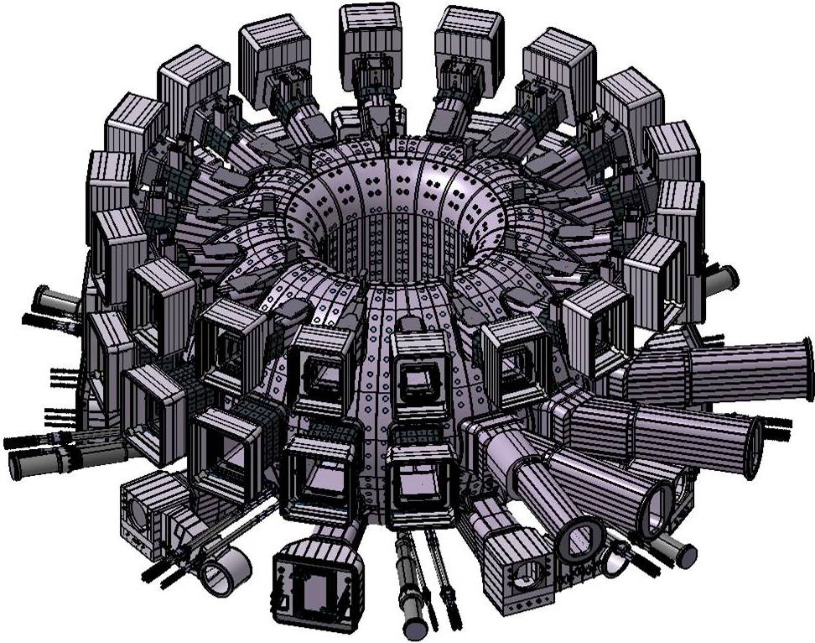
Figure 11. System of Magnetic Fields for controlling and containing the ITER plasma.

4.2.3 The Blanket
The Blanket covers the interior surfaces of the Vacuum Vessel, providing shielding to the Vessel and the superconducting Magnets from the heat and neutron fluxes of the fusion reaction. The neutrons are slowed down in the Blanket where their kinetic energy is transformed into heat energy and collected by the coolants. In a fusion power plant, this energy will be used for electrical power production. The ITER Blanket is one of the most critical and technically challenging components in ITER: together with the Divertor it directly faces the hot plasma.

4.2.4 Tritium breeding modules
At a later stage of the ITER project, test breeding modules will be used to test materials for Tritium Breeding concepts. A future fusion power plant producing large amounts of power will be required to breed all of its own Tritium. ITER will test this essential concept of Tritium self-breeding.

4.2.5 The Divertor
The Divertor is one of the key components of the ITER machine. Situated along the bottom of the Vacuum Vessel (Figure 12), its function is to extract heat and Helium ash -the products of the fusion reaction - and other impurities from the plasma, in effect acting like a giant exhaust pipe. It will comprise two main parts: a supporting structure made primarily from stainless steel and the plasma facing component, weighing about 700 tons. The plasma facing component will be made of Tungsten, a high-refractory material.
4.2.6 Diagnostics

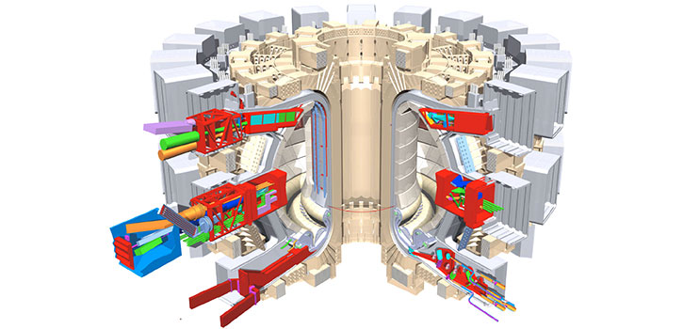
Figure 12. Showing some diagnostic layouts of ITER.

An extensive diagnostic system (50 individual systems) will be installed to provide the measurements necessary to control, evaluate and optimize plasma performance in ITER and to further the understanding of plasma physics. These include measurements of temperature, density, impurity concentration, and particle and energy confinement times.

    - External Heating Systems
The temperatures inside the ITER Tokamak must reach 150 million K - ten times hotter than the Sun’s core- and be sustained in a controlled way in order to extract energy.

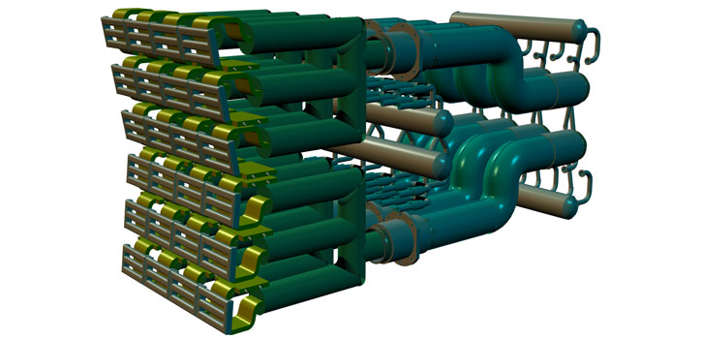
Figure 13. External Heating Systems of ITER.

The ITER Tokamak will rely on three sources of external heating that work in concert to provide the input heating power of 50 MW required to bring the plasma to the necessary temperature. These are neutral beam injection high-frequency electromagnetic waves (Figure 14).
A "burning plasma" will be achieved - one in which the energy of the Helium nuclei from the fusion reaction is enough to maintain the plasma temperature. The external heating is then switched off. A burning plasma in which 50% of the energy needed to drive the fusion reaction is generated internally is an essential step to reaching the goal of fusion power generation.

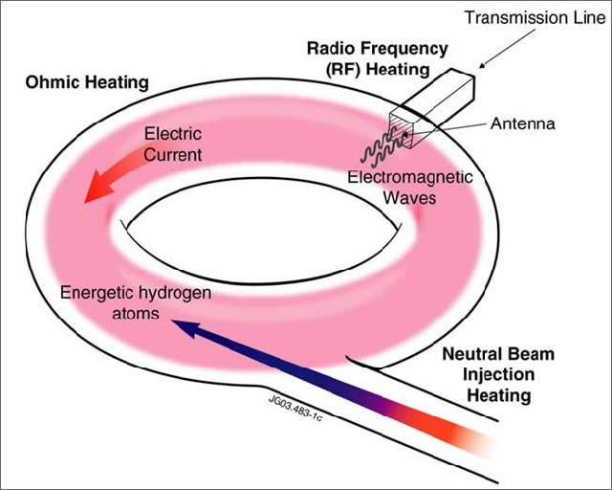
Figure 14. Schematic illustrating a Neutral Beam Injector and two types of high-frequency electromagnetic
waves which will help bring the plasma to temperatures exceeding 150 million K.

  - Beyond ITER

Beyond ITER will be DEMO (early 2030’s). This will be a demonstration fusion power plant which will feed power into electricity grid as early as 2040.
More advanced Tokamak designs include FIRE (Fusion Ignition Research Experiment) a design more compact than JET yet with a design Q=10 [2, 6]. A 1 GW Tokamak ARIES has already been designed.
Some comparative data of plasma cross-sections is in Figure 15, showing the technological advantages of the more advanced yet compact designs. While ITER is being constructed and DEMO is in its conceptual phase, several fusion installations, with different characteristics and objectives, will be operating around the world to conduct complementary research and development in support of ITER.

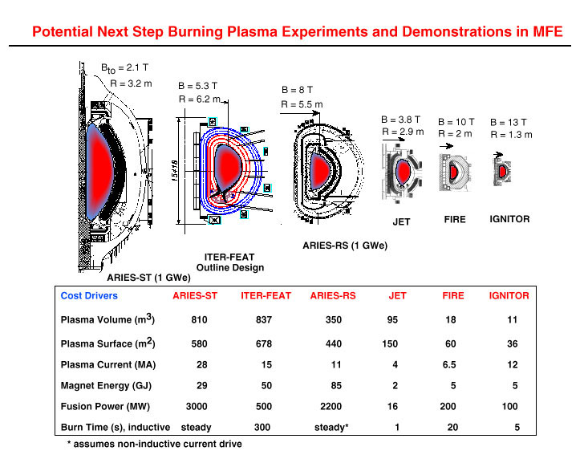
Figure 15. Comparing plasma cross-sections of planned machines with JET.

In Japan, the construction of the International Fusion Materials Irradiation Facility (IFMIF) has started. This installation, part of the "Broader Approach" Agreement, will test and qualify the advanced materials needed for a full-scale fusion plant.
By the last quarter of this century, if ITER and DEMO are successful, our world will enter the Age of Fusion - an age when mankind covers a significant part of its energy needs with an inexhaustible, environmentally benign, and universally available resource.

5. Inertial confinement

The other approach is to use pulsed super high density [8]. The super high density may be achieved by beaming powerful pulsed lasers from all directions onto D-T pellets (typically 0.1 mm radius). The radiation pressure exerted on the surface of the pellet together with the blow-off of hot surface material cause compression of the pellet to super dense conditions which may be 1000 times the density of water. Under these hot and dense conditions, the fuel fusion-ignites. The thermonuclear fusion spreads rapidly through the super-compressed fuel. This is depicted in Figure 16. The whole process takes place in the sub nanosecond range.



Figure 16. Radiation induced super dense implosions leading to fusion burn.

6. Pinches and the plasma focus

There is a view that whereas Tokamaks and laser implosions will likely be the devices to succeed in the efforts to harness nuclear fusion, these are huge programmes which will take extraordinary amounts of combined international resources and cooperation on a scale never before attempted. Ongoing research on other devices such as pinches has shown that these are able to produce nuclear fusion even in devices of much smaller scales [9].
An electrical discharge between two electrodes produces an azimuthal magnetic field which interacts with the column of current, giving rise to a self-compression force which constricts (or pinches) the column. In order to ‘pinch’, or hold together a column of gas at atmospheric density and temperature of 1 million K requires special megaAmpere fast-rise (ns) pulsed-lines. These lines are powered by capacitor banks, and suffer the disadvantage of conversion losses, and high cost of the special technology pulse-shaping line, in addition to the capacitor bank.
A superior method of producing super-dense and super-hot pinch is the plasma focus. This device produces higher densities and temperatures, moreover its method of operation does away with the extra layer of technology required by pulse-shaping line. A simple capacitor discharge is sufficient to power the plasma focus. (Figure 17).

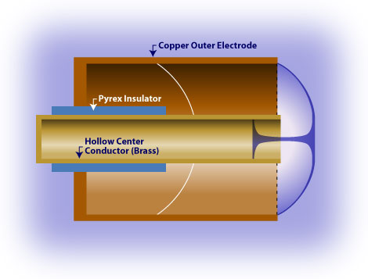
Figure 17. Dense plasma focus device. Image from Glenn Millam. Source: Focus Fusion Society

6.1 Scaling the plasma focus and neutron saturation

The plasma focus has shown great potential for developing into a fusion reactor. It uses a first stage to match the rise-time of a simple capacitor discharge, thus allowing the pinching stage to take place at peak current. Besides powerful bursts of x-rays, ion beams, REB’s and EM radiation, this simple mechanism has increased fusion efficiency so that even a simple table top device is able to demonstrate significant nuclear fusion [9].
The plasma focus offers scalability as it has the same energy density per unit mass across the whole range of very small to very big devices, due to its requirements of the same speed factor (I/a)/p^{0.5} over the whole range of devices. The radiation yield is also predictable [11].
Its multi-radiations enable it to be an excellent source for soft x-ray micro-lithography, micro-machining, materials processing, nanotechnology materials; and for fusion energy[12-17].
Early experiments show that the fusion neutron yield is Y_{n}~E₀², i.e. proportional to the square of input energy [18]; so that break-even could be expected at several tens of MJ. However it was quickly shown that as E₀ approaches just 1 MJ (Figure 18), the expected increase in neutron yield reduces and there appeared to be a tendency for Y_{n} to saturate [19]. The question now being asked: Is there a fundamental reason for neutron saturation [20] or is it just that the large plasma focus devices are not being properly operated?

Figure 18. Illustrating neutron saturation observed in measurements and in numerical experiments. The small black crosses are from numerical experiments. The large coloured crosses are from experiments. The straight line at low energies is Y_{n}~E₀².

6.2. The cause of neutron saturation- and cure?

Extensive numerical experiments were carried out in the last 18 months using the Lee model code [21]; extending from very small plasma focus devices to the largest existing in the world to fix the base and reference lines for these experiments [22-25]; recently extended [26] to 25 MJ devices. The results show that neutron saturation is caused by a ‘motor’ effect. As mentioned earlier, all plasma focus devices are run at the same energy densities which mean the same speeds. These give rise to the same ‘dynamic resistances’ which is of the order of 5 mΩ for every plasma focus, be it a 50 J device or one a million times larger at 50 MJ. Thus, operating the plasma focus at 10-30 kV, will lead to a situation where, as bank capacitance is increased to 1000 uF, the bank surge impedance decreases to 5 mΩ. Further increase in bank energy leads to generator impedance below load impedance; hence current saturation; leading to neutron saturation [27].
The remedy? There is nothing we can do about the dynamic resistance which is needed to provide the drive. What we need is to increase the voltage. For example if we use 300 kV capacitor banks instead of 30 kV, we will move the current saturation asymptotic value to 60MA. Thus plasma focus will have to move into a brave new world of high voltages. Technically there is already a precedence in the German SPEED II [28], a plasma focus designed to operate at 300 kV using Marx, parallel charging, series discharge technique with 6 MA current! MegaAmpere banks with low impedance of the order of 5 mΩ will be more efficient in this situation and may deliver currents up to 100 MA into the plasma focus; at just 2 MJ. Results of numerical experiments (Figure 19) illustrate the diminishing gain of increasingly larger focus devices. Figure 20 shows dramatic improvement when ultra high voltage is used.

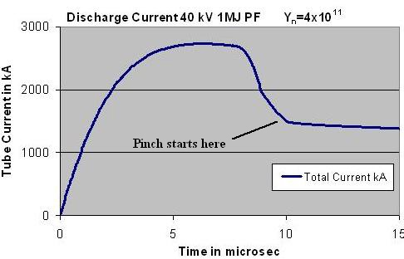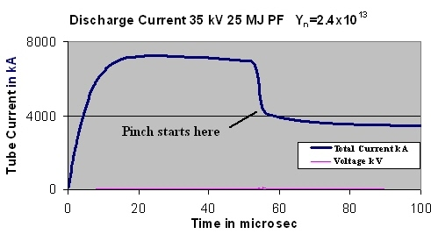
Figure 19. Comparing discharge current amplitudes and neutron yields as bank energy E₀ increases at constant voltage. There is fall away from the ideal scaling law of Y_{n}~E₀² .
[numerical experiments at IPFS & INTI UC May 2009, the 1 MJ PF of Fig 19 agrees with measurements at the ICDMP on PF1000].

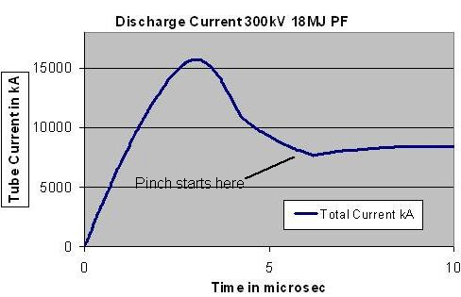
Figure 20. Discharge current reaches much larger values for less E₀ when operated at higher voltage. The neutron yield for this shot is computed as 4x10¹⁴. [numerical experiment at IPFS & UNTI UC, May 2009].

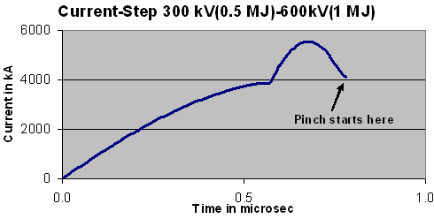
Figure 21. A current step pushes the current value up at the crucial moment when the large pinch ‘dynamic resistance’ tends to drop the current. [numerical experiment at IPFS & INTI UC, July 2009].
Other techniques could be used to increase the current. During the radial phase, in particular, there is a sharp drop in current due to the sharp increase in dynamic resistance. By the time the radial implosion reaches the dense pinch phase the current has dropped by as much as 30-50% for the biggest devices. This drop in current occurs at the time when the current is most crucial, being needed to drive the pinch compression. A current-step would be very usefully applied at this time (see Figure 21). Such current steps have been experimented with in the ‘80s [29, 30]. This technology is feasible. With the combination of low-impedance, high-voltage drivers and current-stepping technology, plasma focus would move into new regimes and once again regain momentum in the quest for fusion energy.

7. Conclusion

Tokamak-based nuclear fusion programmes are moving steadily towards harnessing plasma nuclear energy to provide clean, limitless energy for the continuing progress of civilization. Other smaller scale plasma fusion experiments will also have a role to play in this scientific and technological development, the most challenging and rewarding in the history of Mankind. In particular numerical experiments currently under intensive investigations are pointing the way to plasma focus research to go beyond present neutron saturation regimes; thus to regain momentum for this class of devices in the quest for fusion energy.

8. References

[1] http://fusion.gat.com
[2] http://fire.pppl.gov
[3] http://www.jet.efda.org
[4] http://www.iter.org
[5] http://www.fusion.org.uk
[6] Meade, Dale. “50 Years of Fusion Research”, PPPL Colloquium, April 1, 2009, Princeton, NJ 08543 http://fire.pppl.gov/meade_PPPL_colloq_040109.pdf
[7] Lee, S and Gribkov, Vladimir A. “Cooperation with Small Countries in Plasma Science and Attempts to Apply to Industrial Needs”, ICTP/IAEA Workshop on Plasma Diagnostics and Industrial Applications of Plasmas, October 2000, ICTP Trieste. http://eprints.ictp.it/101/
[8] http://www.hiper-laser.org
[9] S. Lee, T. Y. Tou, S. P. Moo, M. A. Eissa, A. V. Gholap, K. H. Kwek, S. Mulyodrono, A. J. Smith, S. Suryadi, W. Usada, and M. Zakaullah, “A simple facility for the teaching of plasma dynamics and plasma nuclear fusion,” Amer. J. Phys., vol. 56, no. 1, pp. 62–68, Jan. 1988.
[10] S. Lee, in Twelve Years of UNU/ICTP PFF—A Review. Trieste, Italy: Abdus Salam ICTP, 1998, pp. 5–34. IC/ 98/ 231, ICTP Open Access Archive. [Online]. Available: http://eprints.ictp.it/31/
[11] S. Lee and A. Serban, “Dimensions and lifetime of the plasma focus pinch,” IEEE Trans. Plasma Sci., vol. 24, no. 3, pp. 1101–1105, Jun. 1996. http://eprints.ictp.it/42/
[12] M Favre, S Lee, SP Moo, CS Wong X-ray emission in a small plasma focus operating with H2-Ar mixtures. Plasma Sources Science and Technology, 1992.
[13] E P Bogolyubov, V D Bochkov, V A Veretennikov, L T Vekhoreva, V A Gribkov, A V Dubrovskii, Yu P Ivanov, A I Isakov, O N Krokhin, P Lee, S Lee, V Ya Nikulin, A Serban, P V Silin, X Feng and G X Zhang. “A Powerful Soft X-ray Source for X-ray Lithography Based on Plasma Focusing” , Physica Scripta, (1998) 57 488-494.
[14] S. V. Springham, S. Lee, and M. S. Rafique, “Correlated deuteron energy spectra and neutron yield for a 3 kJ plasma focus,” Plasma Phys. Control. Fusion, vol. 42, no. 10, pp. 1023–1032, Oct. 2000.
[15] S V Springham, TL Tan, P Lee, M Zakaullah, S Lee “Spectral study of the electron beam emitted from a 3 kJ plasma focus” PLASMA SOURCES SCIENCE AND TECHNOLOGY, 2005 14, 549-560.
[16] A. Serban and S. Lee, “Experiments on speed-enhanced neutron yield from a small plasma focus,” J. Plasma Phys., vol. 60, 3–15, Aug. 1998.
[17] LY Soh, P Lee, X Shuyan, S Lee, RS Rawat Shadowgraphic studies of DLC film deposition process in dense plasma focus device - IEEE Transactions on Plasma Science, 2004, 32, 448- 455.
[18] Rapp H. “ Measurements referring to plasma focus scaling laws” 1973 Phys Lett A 43A 420-422.
[19] Herold H, Jerzykiewicz A, Sadowski M, Schmidt H (1989) Comparative analysis of large plasma focus experiments performed at IPF, Stuttgart, and IPJ, Swierk. Nucl Fusion 29 1255–1260.
[20] M. Scholz, Report at the ICDMP Meeting, ICDMP, Warsaw, Poland, November 2007.
[21] Lee S Radiative Dense Plasma Focus Computation Package: RADPF
http://www.intimal.edu.my/school/fas/UFLF/
http://www.plasmafocus.net/IPFS/modelpackage/File1RADPF.htm
[22] S. Lee and S. H. Saw, “Neutron scaling laws from numerical experiments,” J. Fusion Energy, vol. 27, no. 4, pp. 292–295, Dec. 2008.
[23] S. Lee and S. H. Saw, “Pinch current limitation effect in plasma focus,”
Appl. Phys. Lett., vol. 92, no. 2, p. 021 503, Jan. 2008.
[24] S. Lee, P. Lee, S. H. Saw, and R. S. Rawat, “Numerical experiments on plasma focus pinch current limitation,” Plasma Phys. Control. Fusion, vol. 50, no. 6, Jun. 2008. 065 012 (8pp).
[25] S. Lee, S. H. Saw, P. C. K. Lee, R. S. Rawat, and H. Schmidt, “Computing plasma focus pinch current from total current measurement,” Appl. Phys.Lett., vol. 92, no. 11, p. 111 501, Mar. 2008.
[26] S. Lee, “Current and neutron scaling for megajoule plasma focus machines,” Plasma Phys. Control. Fusion, vol. 50, no. 10, p. 105 005 (14pp), Oct. 2008.
[27] S Lee “Diagnostics and Insights from Current waveform and Modelling of Plasma Focus” Keynote address presented at the International Workshop on Plasma Diagnostics and Applications, Singapore 2-3 July 2009. http://www.plasmafocus.net/IPFS/Papers/keynoteaddressIWPDA09.doc
[28] G Decker, W Kies, R Nadolny, P Röwekamp, F Schmitz, G Ziethen, K N Koshelev, Yu V Sidelnikov , Observations of soft x‐ray production in the speed 2 plasma focus, 1996 Plasma Sources Sci. Technol. 5 112-118 .
[29] Saw S H 1991 Experimental studies of a current-stepped pinch PhD Thesis Universiti Malaya.
[30] Lee S 1984 ‘A current-stepping technique to enhance pinch compression’ J Phys D: Appl Phys 17 733.

