Scaling the plasma focus for fusion energy considerations

Sor Heoh Saw^{1,3} and Sing Lee^{1,2,3}
(Proceedings: pp 61-70)
¹INTI University College, 71800 Nilai, Malaysia
²NSSE, National Institute of Education, Nanyang Technological University, Singapore 637616
³Institute for Plasma Focus Studies, 32 Oakpark Drive, Chadstone, VIC 3148, Australia

Abstract

Using the Lee model code for dense plasma focus, series of numerical experiments were systematically carried out to determine: the scaling of bank energies with total current and focus pinch current; the scaling of neutron yields with energies and currents; and the possible extension for operation in D-D with extension to D-T. The numerical experiments were carried out over a range of bank energies from 8 kJ extending up to 24 MJ on the PF1000 and a proposed less damped modern bank. It also includes a study on the effects of increasing bank energies by increasing bank charging voltage and capacitance of the bank for a practical optimum plasma focus machine. The results provide convincing data to show that it is possible to scale up the plasma focus machine for D-D neutron yield of 10¹³ per shot and 10¹⁵ neutrons per shot when it is converted to operate in D-T.

Keywords: Dense plasma focus, neutrons source, focus pinch current, fusion energy

1. Introduction
Plasma focus machines can consistently produce considerable amounts of neutrons. The scalability of the device to fusion reactor conditions remains an area of research[1]. Even a simple machine such as the UNU ICTP PFF 3 kJ machine consistently produces 10⁸ neutrons when operated in deuterium [2]. A big machine such as the PF1000 typically produces 10¹¹ neutrons per shot[3]. Gribkov et al [4] had pointed out that Y_{n} =10¹³ in Deuterium is a desired landmark to achieve in a plasma focus device; from the point of view of possible exploitation as a powerful source of fusion neutrons for testing of prospective materials for the first wall components and construction elements in magnetic confinement fusion and, especially, in inertial confinement fusion reactors. Converting such a plasma focus yield to operation in D-T, with Y_{n} =10¹⁵ could produce, during a one-year run, an overall fluence of the order of 0.1–1.0 dpa for such testing purposes, at a very low cost relative to other methods currently being considered. We now examine the requirements to reach this landmark.
This paper presents the results from series of numerical experiments systematically carry out using the Lee model code [5] to investigate the scalability of the plasma focus to achieve Y_{n} =10¹³ D-D yield . Preceding to it is to determine the scaling laws between bank energies and peak total current and peak pinch current; and between Y_{n} and peak total current and peak pinch current[6-9].

2.The Lee model code

2.1. Description of the model
The Lee model code couples the electrical circuit with plasma focus dynamics, thermodynamics and radiation, enabling realistic simulation of all gross focus properties. The basic model, described in 1984 [10] was successfully used to assist several projects [11]-[13]. Radiation-coupled dynamics was included in the five-phase code leading to numerical experiments on radiation cooling [14]. The vital role of a finite small disturbance speed discussed by Potter in a Z-pinch situation [15] was incorporated together with real gas thermodynamics and radiation-yield terms. Before this ‘communication delay effect’ was incorporated, the model consistently over-estimated the radial speeds. This is serious from the point of view of neutron yields. A factor of 2 in shock speeds gives a factor of 4 in temperatures leading to a difference in fusion cross-sections of ~1000 at the range of temperatures we are dealing with. This version of the code assisted other research projects [16]-[18], [19]-[21] and was web-published in 2000[22] and 2005[23]. Plasma self-absorption was included in 2007[21] improving SXR yield simulation. The code has been used extensively in several machines including UNU/ICTP PFF [2], [11],[16],[17],[19],[20], [24],[25], NX2[18], [21], [26], NX1[26], [27] and adapted for the Filippov-type plasma focus DENA [28]. A recent development is the inclusion of the neutron yield, Y_{n}, using a beam–target mechanism [3],[6]-[8],[29], incorporated in recent versions [5] of the code (versions later than RADPFV5.13), resulting in realistic Y_{n} scaling with I_{pinch}[7], [8]. The versatility and utility of the model is demonstrated in its clear distinction of I_{pinch} from I_{peak} [30] and the recent uncovering of a plasma focus pinch current limitation effect [6],[29]. The description, theory, code and a broad range of results of this ‘Universal Plasma Focus Laboratory Facility’ are available for download from [5].

2.2 A brief description of the code
The five phases are summarised as follows:
- Axial phase: Described by a snowplow model with an equation of motion coupled to a circuit equation. The equation of motion incorporates the axial phase model parameters: mass and current factors f_{m} and f_{c} respectively. The mass swept-up factor f_{m} accounts for not only the porosity of the current sheet but also for the inclination of the moving current sheet- shock front structure and all other unspecified effects which have effects equivalent to increasing or reducing the amount of mass in the moving structure, during the axial phase. The current factor, f_{c} , accounts for the fraction of current effectively flowing in the moving structure (due to all effects such as current shedding at or near the back-wall and current sheet inclination). This defines the fraction of current effectively driving the structure, during the axial phase.

- Radial inward shock phase: Described by four coupled equations using an elongating slug model. The first equation computes the radial inward shock speed from the driving magnetic pressure. The second equation computes the axial elongation speed of the column. The third equation computes the speed of the current sheath, also called the magnetic piston, allowing the current sheath to separate from the shock front by applying an adiabatic approximation. The fourth is the circuit equation. Thermodynamic effects due to ionization and excitation are incorporated into these equations, these effects being important for gases other than hydrogen and deuterium. Temperature and number densities are computed during this phase. A communication delay between shock front and current sheath due to the finite small disturbance speed is crucially implemented in this phase. The model parameters, radial phase mass swept-up and current factors, f_{mr} and f_{cr} , are incorporated in all three radial phases. The mass swept-up factor f_{mr} accounts for all mechanisms which have effects equivalent to increasing or reducing the amount of mass in the moving slug, during the radial phase. The current factor, f_{cr} , accounts for the fraction of current effectively flowing in the moving piston forming the back of the slug (due to all effects ). This defines the fraction of current effectively driving the radial slug.

- Radial reflected shock (RS) phase: When the shock front hits the axis, because the focus plasma is collisional, a reflected shock develops which moves radially outwards, whilst the radial current-sheath piston continues to move inwards. Four coupled equations are also used to describe this phase, these being for the reflected shock moving radially outwards, the piston moving radially inwards, the elongation of the annular column and the circuit. The same model parameters, f_{mr} and f_{cr} , are used as in the previous radial phase. The plasma temperature behind the RS undergoes a jump by a factor approximately two.

- Slow compression (quiescent) or pinch phase: When the out-going RS hits the in-coming piston the compression enters a radiative phase in which for gases such as neon, radiation emission may actually enhance the compression where we have included energy loss/gain terms from Joule heating and radiation losses into the piston equation of motion. Three coupled equations describe this phase; these being the piston radial motion equation, the pinch column elongation equation and the circuit equation, incorporating the same model parameters as in the previous two phases. Thermodynamic effects are incorporated into this phase. The duration of this slow compression phase is set as the time of transit of small disturbances across the pinched plasma column. The computation of this phase is terminated at the end of this duration.

- Expanded column phase: To simulate the current trace beyond this point, we allow the column to suddenly attain the radius of the anode and use the expanded column inductance for further integration. In this final phase the snowplow model is used, and two coupled equations are used; similar to the axial phase aforementioned. This phase is not considered important as it occurs after the focus pinch.

2.3. Computation of Neutron yield
The neutron yield is computed using a phenomenological beam-target neutron generating mechanism described recently by Gribkov et al [3] and adapted to yield the following equation. A beam of fast deuteron ions is produced by diode action in a thin layer close to the anode, with plasma disruptions generating the necessary high voltages. The beam interacts with the hot dense plasma of the focus pinch column to produce the fusion neutrons. The beam-target yield is derived [6] as:

Y_{b-t}= C_{n} n_{i}I_{pinch}²z_{p}²(ln(b/r_{p}))σ /U^{0.5} (1)

where  n_{i} is the ion density, b is the cathode radius, r_{p} is the radius of the plasma pinch with length z_{p}, σ the cross-section of the D-D fusion reaction, n- branch[31] and U, the beam energy. C_{n} is treated as a calibration constant combining various constants in the derivation process.
The D-D cross-section is sensitive to the beam energy in the range 15-150 kV; so it is necessary to use the appropriate range of beam energy to compute σ. The code computes induced voltages (due to current motion inductive effects) V_{max} of the order of only 15-50 kV. However it is known, from experiments that the ion energy responsible for the beam-target neutrons is in the range 50-150 keV [3], and for smaller lower-voltage machines the relevant energy could be lower at 30-60keV[1]. Thus in line with experimental observations the D-D cross section σ is reasonably obtained by using U= 3V_{max}. This fit was tested by using U equal to various multiples of V_{max}. A reasonably good fit of the computed neutron yields to the measured published neutron yields at energy levels from sub-kJ to near MJ was obtained when the multiple of 3 was used; with poor agreement for most of the data points when for example a multiple of 1 or 2 or 4 or 5 was used. The model uses a value of C_{n} =2.7x10⁷ obtained by calibrating the yield [5], [6] at an experimental point of 0.5 MA.

The thermonuclear component is also computed in every case and it is found that this component is negligible when compared with the beam-target component.

3. Procedures for Numerical Experimetns
The Lee model code is configured to work as any plasma focus by inputting the bank parameters, L₀, C₀ and stray circuit resistance r₀; the tube parameters b, a and z₀ and operational parameters V₀ and P₀ and the fill gas. The standard practice is to fit the computed total current waveform to an experimentally measured total current waveform [5]-[8], [23], [24], [29], [30] using four model parameters representing the mass swept-up factor f_{m}, the plasma current factor f_{c} for the axial phase and factors f_{mr} and f_{cr} for the radial phases.
From experience it is known that the current trace of the focus is one of the best indicators of gross performance. The axial and radial phase dynamics and the crucial energy transfer into the focus pinch are among the important information that is quickly apparent from the current trace.

The exact time profile of the total current trace is governed by the bank parameters, by the focus tube geometry and the operational parameters. It also depends on the fraction of mass swept-up and the fraction of sheath current and the variation of these fractions through the axial and radial phases. These parameters determine the axial and radial dynamics, specifically the axial and radial speeds which in turn affect the profile and magnitudes of the discharge current. The detailed profile of the discharge current during the pinch phase also reflects the Joule heating and radiative yields. At the end of the pinch phase the total current profile also reflects the sudden transition of the current flow from a constricted pinch to a large column flow. Thus the discharge current powers all dynamic, electrodynamic, thermodynamic and radiation processes in the various phases of the plasma focus. Conversely all the dynamic, electrodynamic, thermodynamic and radiation processes in the various phases of the plasma focus affect the discharge current. It is then no exaggeration to say that the discharge current waveform contains information on all the dynamic, electrodynamic, thermodynamic and radiation processes that occurs in the various phases of the plasma focus. This explains the importance attached to matching the computed current trace to the measured current trace in the procedure adopted by the Lee model code.
For this series of experiments we configure the Lee model code using a published current trace measured from the PF1000 with C₀ = 1332 μF, operated at 27 kV, 3.5 torr deuterium, with cathode/anode radii b = 16 cm, a = 11.55 cm and anode length z₀ = 60 cm[3]. In the numerical experiments we fitted external (or static) inductance L₀= 33.5 nH and stray resistance r₀ = 6.1 mΩ (damping factor RESF= stray resistance/(L₀/C₀)^{0.5}=1.22). The fitted model parameters are: f_{m} = 0.13, f_{c} = 0.7, f_{mr} = 0.35 and f_{cr}=0.65. Figure 1 shows the computed current trace [5], [6], [29] agrees very well with the measured trace through all the phases, axial and radial, right down to the bottom of the current dip indicating the end of the pinch phase. This agreement confirms the model parameters for the PF1000. Once the model parameters have been fitted to a machine for a given gas, these model parameters may be used with some degree of confidence when operating parameters such as the voltage are varied [5]. With no measured current waveform available for the higher megajoule numerical experiments, it is reasonable to keep the model parameters that we have got from the PF1000 fitting.

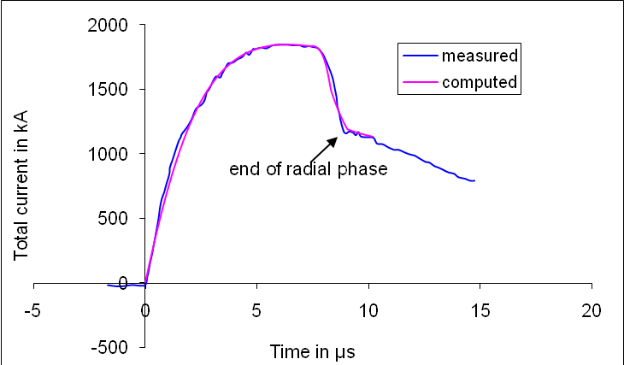

Figure 1. Current fitting computed current to measured current traces to obtain fitted parameters f_{m} = 0.13,
f_{c} = 0.7,f_{mr} = 0.35 and f_{cr}=0.65.

3.1. Determining the scaling laws for neutrons from numerical experiments over a range of energies from 8.5 kJ to 24.5 MJ
Using the model parameters determined in the above for PF1000, we run the first series of numerical experiments on PF1000 at V₀ = 35kV, P₀ =10 Torr, L₀=33.5nH, RESF=1.22 and the c=b/a=1.39 for varying bank energies from 8.5 kJ to 24.5 MJ. This series of numerical experiments is operated at optimum pressure of 10 torr deuterium, and the ratio b/c retained at 1.39.
The numerical experiments were carried out for C₀ ranging from 14 µF to 39960 µF corresponding to energies from 8.5 kJ to 24.5 MJ. For each C₀, we parametrically varied z₀ and then 'a' to find the optimum combination of z₀ and 'a' for each given C₀ corresponding to an end axial speed of about 10 cm/µs. The optimum combinations for each C₀ and with the peak total current, peak pinch current and neutron yield computed for the range of bank energies from 8.5 kJ to 24.5 MJ are tabulated in Table 1.

Table 1. Numerical experiments to find the scaling of I_{peak}, I_{pinch} and Y_{n} with C₀
E₀ | C₀ | a | z₀ | I_{peak} | I_{pinch} | Y_{n}
kJ | uF | Cm | Cm | kA | kA | 10¹⁰
24476 | 39960 | 23.55 | 500.0 | 5678 | 2368 | 1320
18765 | 30636 | 22.80 | 400.0 | 5479 | 2267 | 1094
14685 | 23976 | 21.90 | 350.0 | 5268 | 2165 | 906
11422 | 18648 | 21.00 | 300.0 | 5046 | 2062 | 737
6527 | 10656 | 18.73 | 220.0 | 4506 | 1827 | 438
4895 | 7992 | 17.66 | 160.0 | 4229 | 1721 | 329
4079 | 6660 | 16.88 | 140.0 | 4043 | 1650 | 273
3263 | 5328 | 15.90 | 120.0 | 3812 | 1563 | 215
2448 | 3996 | 14.53 | 86.6 | 3510 | 1461 | 159
1632 | 2664 | 12.69 | 65.0 | 3101 | 1316 | 102
816 | 1332 | 9.95 | 45.0 | 2458 | 1086 | 45.4
748 | 1221 | 9.62 | 42.0 | 2383 | 1059 | 40.9
680 | 1110 | 9.18 | 38.0 | 2295 | 1032 | 36.3
612 | 999 | 8.82 | 36.0 | 2208 | 1000 | 31.8
544 | 888 | 8.47 | 35.0 | 2116 | 965 | 27.3
476 | 777 | 8.05 | 33.0 | 2012 | 926 | 22.9
408 | 666 | 7.60 | 31.0 | 1898 | 882 | 18.6
340 | 555 | 7.04 | 28.0 | 1766 | 833 | 14.5
272 | 444 | 6.38 | 24.0 | 1613 | 778 | 10.8
204 | 333 | 5.59 | 20.0 | 1425 | 706 | 7.1
136 | 222 | 4.74 | 17.0 | 1205 | 613 | 3.8
68 | 111 | 3.47 | 12.0 | 888 | 476 | 1.21
34 | 56 | 2.48 | 8.0 | 644 | 363 | 0.346
17 | 28 | 1.72 | 5.0 | 457 | 272 | 0.085
8.5 | 14 | 1.28 | 4.0 | 335 | 202 | 0.017

The results show no saturation of the peak total current and peak pinch current as the energies of the bank is increased except for a lesser degree of corresponding increased in the currents.
Figure 2 shows the computed I_{peak} as a function of C₀, from the numerical experiments which show no saturation; although there is a scaling shift from I_{peak}~ E₀^{0.47} to I_{peak}~E₀^{0.22} which is seen when plotted on log-log scale (see Figure 3).

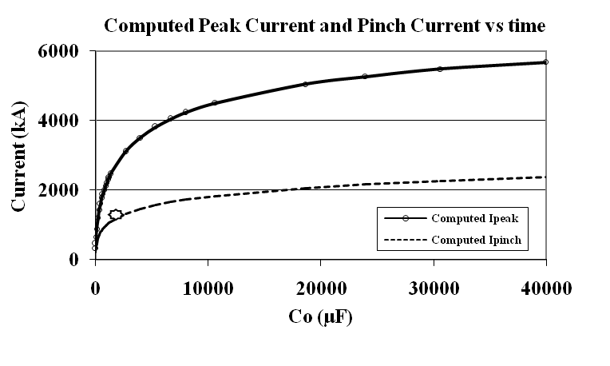
Figure 2. I_{peak} (top trace) computed from numerical experiments as a function of C₀. Also shown is the I_{pinch} curve (lower trace). The single point at the 2 MA level is an experimental PF1000 point.
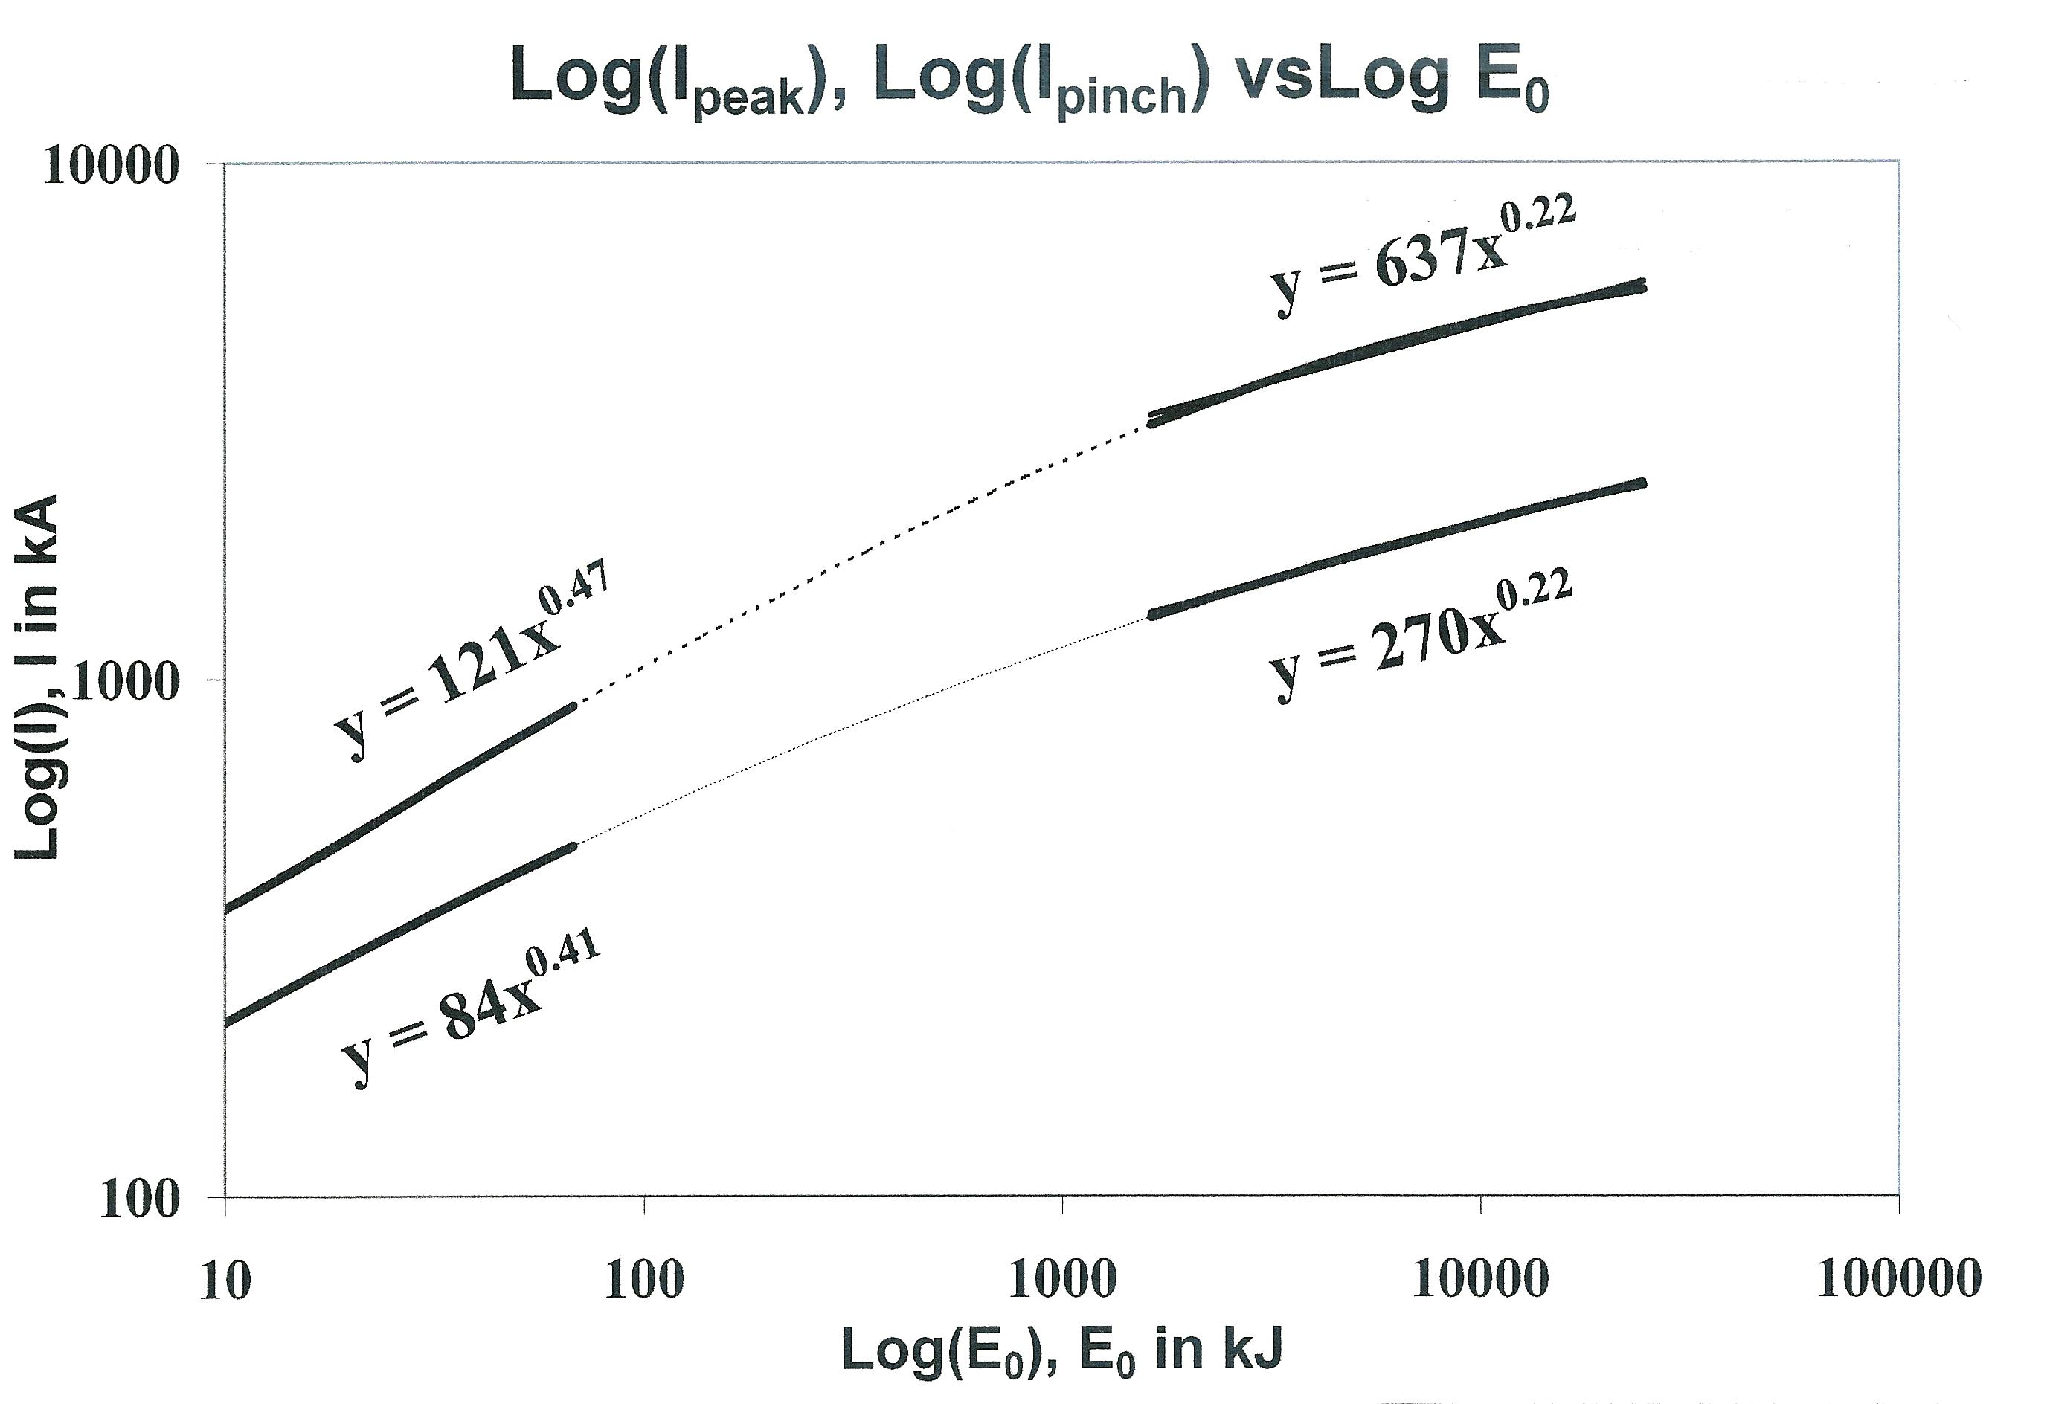
Figure 3. Log I_{peak} (top curve) and Log I_{pinch} vs Log E₀, showing no saturation for E₀ up to 24.5 MJ

Similarly, the I_{pinch} scaling with E₀ slows down from I_{pinch}~E₀^{0.41} to I_{pinch}~E₀^{0.22} (see Figure 3), but again no saturation. We would like to emphasize that the findings in earlier papers [6], [7], [29], [30] concluded that it is the I_{pinch} scaling, rather than I_{peak} which directly affects the neutron yield scaling.
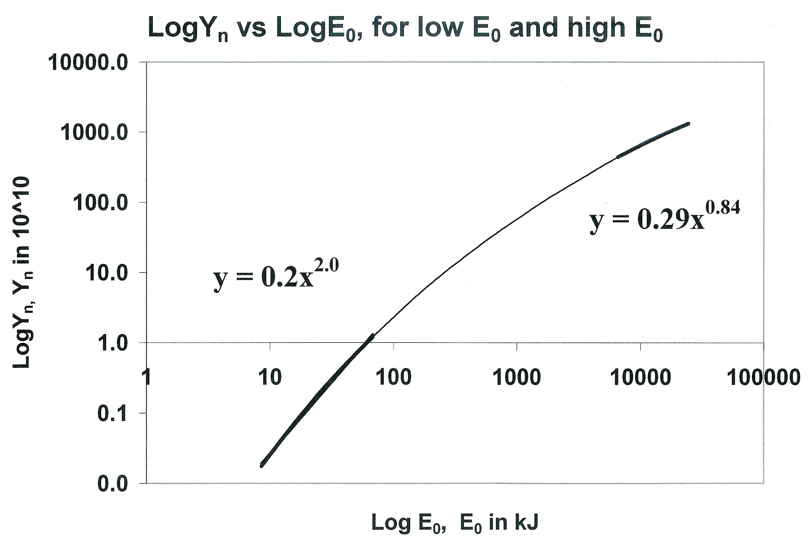
Figure 4. Y_{n} plotted as a function of E₀ in log-log scale, showing no saturation of neutron yield up to 24.5 MJ,
the highest energy investigated.
For this series of experiments we find that the Y_{n} scaling decreases from Y_{n}~E₀^{2.0} at tens of kJ to Y_{n}~E₀^{0.84} at the highest energies (up to 24.5MJ). This is shown in Figure 4.

Because of the way Y_{n} versus E₀ scaling slows down at the megajoule level and the corresponding way I_{peak} and I_{pinch} scaling with E₀ also slow down, the scaling of Y_{n} with I_{peak} and I_{pinch} over the whole range of energies investigated up to 24.5 MJ (Figure 5) are as follows:

Y_{n}=3.2x10¹¹I_{pinch}^{4.5}; Y_{n}=1.8x10¹⁰I_{peak}^{3.8} where I_{pinch} (0.2 to 2.4) and I_{peak} (0.3 to 5.7) are in MA.

Figure 5. Log(Y_{n}) scaling with Log(I_{peak}) and Log(I_{pinch}), for the range of energies investigated, up to 24.5 MJ

In the above series of numerical experiments we have shown that as the bank energies of the plasma focus increases from 10kJ to 25MJ:

I_{peak}~ E₀^{x} where x=0.47 at tens of kJ and x=0.22 at the highest energies (up to 24.5MJ)
I_{pinch}~ E₀^{x} where x=0.41 at tens of kJ and x=0.22 at the highest energies (up to 24.5MJ)
Y_{n}~E₀^{x} , where x=2.0 at tens of kJ and x=0.84 at the highest energies (up to 24.5MJ)

Y_{n} does not saturate with increasing E₀ at the megajoule level and the resultant scaling laws for Y_{n} in relation to the total peak current, I_{peak} and the total pinch current I_{pinch} are:

Y_{n}=3.2x10¹¹I_{pinch}^{4.5} where I_{pinch} (0.2 to 2.4) in MA; and
Y_{n}=1.8x10¹⁰I_{peak}^{3.8} where I_{peak} (0.3 to 5.7) in MA

This first series of numerical experiments show that it is possible to scale up the plasma focus machine to fusion reactor conditions to yield 10¹³ D-D neutrons at 2.5 MeV. This is achieved at bank energy E₀=18.7 MJ with I_{peak}= 5.5 MA and I_{pinch}=2.3 MA, corresponding to the focus anode length z₀=4 m and anode radius a=22.8 cm and cathode radius b=31.7 cm.

  - Investigating the effect of RESF on Y_{n} yield.
The PF1000 has an unusually high damping factor represented by RESF=1.22. As it is practically possible for a modern capacitor bank system to be very much less damped with RESF=0.12, we proceed to run the second series of numerical experiments with RESF changed to 0.12. Again for each C₀, we parametrically varied z₀ and then 'a' to find the optimum combination of z₀ and 'a' for each given C₀ corresponding to an end axial speed of about 10 cm/µs. The optimum combinations for each C₀ and with the peak total current, peak pinch current and neutron yield computed for the range of bank energies from 68kJ to 24.5 MJ are tabulated in Table 2. Figure 6 shows the summary of the results.

Table 2 Numerical experiments with less resistive bank of RESF=0.12
E₀ | C₀ | a | z₀ | I_{peak} | I_{pinch} | Y_{n}
kJ | uF | cm | cm | kA | kA | 10¹⁰
24476 | 39960 | 28.25 | 450.0 | 6774 | 2720 | 2255
18765 | 30636 | 27.44 | 430.0 | 6612 | 2622 | 1968
14685 | 23976 | 27.01 | 350.0 | 6488 | 2541 | 1711
11421 | 18646 | 26.34 | 300.0 | 6327 | 2449 | 1460
8159 | 13320 | 25.26 | 260.0 | 6077 | 2314 | 1157
6527 | 10656 | 24.62 | 210.0 | 5909 | 2236 | 974
4895 | 7992 | 23.61 | 160.0 | 5663 | 2130 | 777
4079 | 6660 | 22.83 | 140.0 | 5487 | 2060 | 668
3263 | 5328 | 21.72 | 110.0 | 5252 | 1976 | 558
2448 | 3996 | 20.36 | 93.0 | 4948 | 1866 | 437
1632 | 2664 | 18.40 | 75.0 | 4512 | 1711 | 303
816 | 1332 | 14.74 | 47.0 | 3726 | 1466 | 154
748 | 1221 | 14.26 | 44.0 | 3623 | 1436 | 140
680 | 1110 | 13.90 | 43.0 | 3528 | 1402 | 127
612 | 999 | 13.46 | 41.0 | 3419 | 1366 | 113
476 | 777 | 12.42 | 37.0 | 3161 | 1280 | 85.72
340 | 555 | 10.61 | 28.0 | 2763 | 1175 | 58.43
204 | 333 | 8.81 | 22.0 | 2312 | 1025 | 32.30
136 | 222 | 7.33 | 17.0 | 1954 | 913 | 19.46
68 | 111 | 5.45 | 12.0 | 1472 | 735 | 7.64

.
Figure 6. Log-log plots of Y_{n} (lower trace), I_{pinch} (middle trace) and I_{peak} (top trace) versus E₀
for a high performance bank up to 25 MJ; computed from numerical experiments

These results show that using a less resistive modern bank, RESF=0.12 reduces the E₀ required to reach Y_{n}=10¹³ in Deuterium to some 8MJ with corresponding I_{peak}=6 MA, I_{pinch}= 2.3 MA, the focus length z₀=2.6 m, anode radius a=25.3 cm and cathode radius b=35.2 cm as compared to19 MJ with corresponding I_{peak}= 5.5 MA, I_{pinch}=2.3 MA, the focus length z₀=4 m, anode radius a=22.8 cm and cathode radius b=31.7 cm for the earlier heavily damped bank with RESF=1.22.

3.3. Investigating the effect on Y_{n} as operating voltage is increased from 35 kV to 90 kV, at C₀ = 777 µF
We run a third series of numerical experiments for a practical optimum configuration [8] with c=b/a=1.39, L₀=36 nH, P₀=10 Torr and C₀=777 uF, and vary V₀ from 35 kV to 90 kV. The results are summarized in Table 3 and plotted in Figure 7 in log-log scale.

Table 3. Numerical experiments on effect of increasing V0, at fixed C0 of 777 µF
V₀ | E₀ | B | a | z₀ | I_{peak} | I_{pinch} | Y_{n}
kV | kJ | cm | cm | cm | kA | kA | 10¹⁰
90 | 3147 | 39.92 | 27.65 | 25 | 7580 | 2483 | 1228
70 | 1904 | 31.14 | 22.40 | 30 | 5955 | 2091 | 631
50 | 971 | 23.44 | 16.86 | 35 | 4365 | 1652 | 246
35 | 476 | 16.69 | 12.01 | 37 | 3074 | 1286 | 88

Figure 7 shows that Y_{n}~V₀^{2.8} over the range of voltages examined from 35-90kV. Looking at this scaling, it may at first sight be tempting to think in terms of increasing the voltage further. However it is then necessary to look more closely at that prospect.

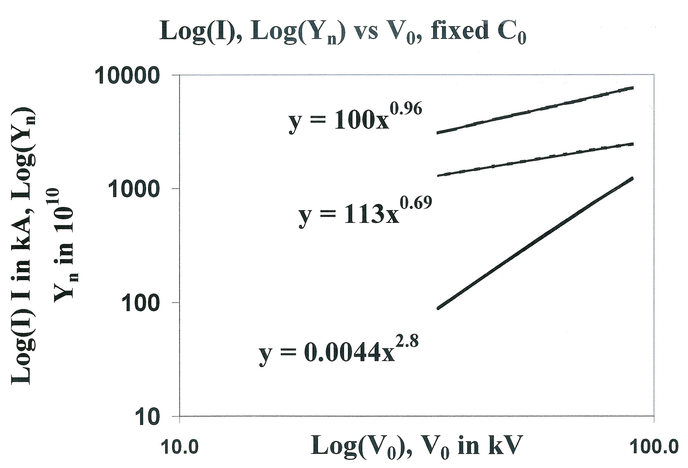

Figure 7. Scaling of currents and Y_{n} as functions of operating voltage V₀.
Top curve:Log(I_{peak}), middle curve: Log(I_{pinch}) and bottom curve: Log(Y_{n}).

An examination of the computed results shows that the computed effective beam energy [6], [7], [29] for 90kV is already at the 330 keV level. Looking at data for the D-D cross-section [31] as a function of beam energy, it is seen that above 300 keV, the rise in D-D fusion cross-section is very slow. Hence we wish to highlight that there is little advantage operating above 90kV. In fact the situation is actually disadvantageous to increase operating voltage if one considers changing to D-T operation. The D-T fusion cross-section [31] has already peaked at 120 keV; and operating at 90 kV with the beam energy at 330 keV, the beam energy is already too high; the D-T cross-section having dropped by a factor around 3.6 from its peak. It seems then that from this point of view there is no advantage to operate a plasma focus at higher than 90 kV. For conversion to D-T operation it would probably be better to operate at a lower voltage. It would then be necessary to increase C₀ until 10¹⁵ D-T neutrons is reached.

3.4. Investigating operation at 90 kV, varying E₀ by varying C₀; at 10 Torr, L₀=36 nH, and b/a=1.39; RESF=0.12
We consider the effect of operating at 90kV. We run the fourth series of numerical experiments at 90 kV with increasing E₀ (by increasing C₀) to obtain the energy required to reach Y_{n}=10¹³ D-D neutrons per shot. At each C₀, z₀ is varied whilst adjusting ‘a’ for an end axial speed of 10 cm/us. The optimum z₀ is thus found for each C₀ . Results are shown in Figure 8. Again at this higher voltage, no saturation is found for I_{peak}, I_{pinch} or Y_{n}. At 90 kV the results show that the E₀ required for Y_{n}=10¹³ D-D fusion neutrons per shot is reduced further to 3MJ, with C₀= 777 µF as shown in the following Figure 8. The values of I_{peak} and I_{pinch} are respectively 7.6 and 2.5 MA. Furthermore at 90 kV with the highest value of C₀ investigated as 39960 µF, the storage energy is 162 MJ. At that storage energy, optimized Y_{n} is 4.5x10¹⁴ D-D neutrons/shot with I_{peak}=17.3 MA and I_{pinch}=5.7 MA.

Figure 8. Numerical experiments at 90 kV, varying C₀, to obtain scaling of I_{peak}, I_{pinch} and Y_{n} with E_{0.} Log(Y_{n}):
steepest curve; Log(I_{peak}): dotted curve; Log(I_{pinch}): other curve. Y_{n} in units of 10¹⁰ D-D neutrons/shot; I_{peak} and I_{pinch} in kA.

4. Conclusions
This paper finds that it is possible to scale up the focus to fusion conditions. In the first series of numerical experiments we have shown that as the bank energies of the plasma focus increases from 10kJ to 25MJ:

I_{peak}~ E₀^{x} where x=4.7 at tens of kJ and x=0.22 at the highest energies (up to 25MJ)
I_{pinch}~ E₀^{x} where x=4.1 at tens of kJ and x=0.22 at the highest energies (up to 25MJ)
Y_{n}~E₀^{x} , where x=2.0 at tens of kJ and x=0.84 at the highest energies (up to 25MJ)

Y_{n} does not saturate with increasing E₀ at the megajoule level and the resultant scaling laws for Y_{n} in relation to the total peak current, I_{peak} and the total pinch current I_{pinch} are:

Y_{n}=3.2x10¹¹I_{pinch}^{4.5} where I_{pinch} (0.2 to 2.4) in MA; and
Y_{n}=1.8x10¹⁰I_{peak}^{3.8} where I_{peak} (0.3 to 5.7) in MA

To scale up from a PF1000-like capacitor bank requires close to 19 MJ to reach a target D-D neutron yield of 10¹³ per shot. The energy requirement can be reduced to 8 MJ using a modern capacitor bank with typical lower damping operating at typical voltage of 35 KV. By increasing the operational voltage to 90kV, the energy requirement is further reduced to 3 MJ. Because of the high effective beam energy already at 90 kV, there is little advantage to operate at voltages above 90 kV for D-D neutron yield; from this point of view.

References
- M G Haines in Laser and Plasma Technology, edited by S Lee, B C Tan, C S Wong, A C Chew (World Scientific, Singapore, 1985), pp 560-585.
- S Lee, “Twelve Years of UNU/ICTP PFF—A Review,” IC/ 98/ 231 Abdus Salam ICTP, Miramare, Trieste; 1998, pp.5-34. ICTP Open Access Archive http://eprints.ictp.it/31/.
- V A Gribkov, A Banaszak, B Bienkowska, A V Dubrovsky, I Ivanova-Stanik, L Jakubowski, L Karpinski, R A Miklaszewski, M Paduch, M J Sadowski, M Scholz, A Szydlowski and K Tomaszewski, “Plasma dynamics in the PF-1000 device under full-scale energy storage: II. Fast electron and ion characteristics versus neutron emission parameters and gun optimization perspectives,” J. Phys. D: Appl. Phys. 40, 2007, pp. 3592-3607.
- Gribkov V A et al, “Plasma dynamics in PF-1000 device under full-scale energy storage: I. Pinch dynamics, shock wave diffraction, and inertial electrode,” J Phys. D: Appl. Phys. 40, 2007, pp 1977-1989.
- Lee S Radiative Dense Plasma Focus Computation Package: RADPF http://www.intimal.edu.my/school/fas/UFLF/File1RADPF.htm http://www.plasmafocus.net/IPFS/modelpackage/File1RADPF.htm
- S Lee and S H Saw, “Pinch current limitation effect in plasma focus,” Appl. Phys. Lett. 92, 2008, 021503.
- S Lee and S H Saw, “Neutron scaling laws from numerical experiments,” J Fusion Energy 27, 2008, pp. 292-295.
- S Lee, “Current and neutron scaling for megajoule plasma focus machine,” Plasma Phys. Control. Fusion 50, 2008, 105005, (14pp).
- S Lee, S H Saw, L Soto, SV Springham, S P Moo, “Numerical experiments on plasma focus neutron yield versus pressure compared with laboratory experiments,” Plasma Physics and Controlled Fusion 51,2009,075006 (11p).
- S Lee, “Plasma focus model yielding trajectory and structure” in Radiations in Plasmas, ed B McNamara (Singapore: World Scientific Publishing Co, ISBN 9971-966-37-9) vol. II, 1984, pp. 978–987
- S Lee S et al, “A simple facility for the teaching of plasma dynamics and plasma nuclear fusion,” Am. J. Phys. 56, 1988, pp. 62-68.
- T Y Tou, S Lee and K H Kwek, “Non perturbing plasma focus measurements in the run-down phase,” IEEE Trans. Plasma Sci. 17, 1989, pp. 311-315.
- S Lee, “A sequential plasma focus,” IEEE Trans. Plasma Sci., vol. 19, no. 12, 1991, pp. 912-919.
- Jalil bin Ali, “Development and Studies of a small Plasma Focus,” PhD thesis, Universiti Teknologi Malaysia, Malaysia, 1990.
- D E Potter, “The formation of high-density z-pinches,”Nucl. Fusion, vol 18 pp813-823, 1978.
- S Lee and A Serban A, “Dimensions and lifetime of the plasma focus pinch,” IEEE Trans. Plasma Sci., vol. 24, no.3, 1996, pp. 1101-1105.
- Liu Mahe, “Soft X-rays from compact plasma focus,” PhD thesis, NIE, Nanyang Technological University, Singapore, 2006. ICTP Open Access Archive: http://eprints.ictp.it/327/.
- S Bing, “Plasma dynamics and x-ray emission of the plasma focus,” PhD Thesis, NIE, Nanyang Technological University, Singapore, 2000. ICTP Open Access Archive: http://eprints.ictp.it/99/.
- A Serban and S Lee, “Experiments on speed-enhanced neutron yield from a small plasma focus,” J Plasma Physics, vol. 60 part 1, 1998, pp. 3-15.
- M H Liu, X P Feng, S V Springham and S Lee, “Soft x-ray measurement in a small plasma focus operated in neon,” IEEE Trans. Plasma Sci. 26, 1998, pp. 135-140.
- D Wong, P Lee, T Zhang, A Patran, T L Tan, R S Rawat and S Lee, “An improved radiative plasma focus model calibrated for neon-filled NX2 using a tapered anode,” Plasma Sources Sci. Technol. 16, 2007, pp. 116-123.
- S Lee. (2000–2007). http://ckplee.myplace.nie.edu.sg/plasmaphysics/.
- S Lee. (2005). ICTP Open Access Archive: http://eprints.ictp.it/85/.
- S V Springham, S Lee and M S Rafique, “Correlated deuteron energy spectra and neutron yield for a 3 kJ plasma focus,” Plasma Phys. Control. Fusion, vol 24, 2000 pp 1023-1032
- M A Mohammadi, S Sobhanian, C S Wong, S Lee, P Lee and R S Rawat , “The effect of anode shape on neon soft x-ray emissions and current sheath configuration in plasma focus device,” J. Phys. D: Appl.Phys. 42, 2009, 045203 (10pp).
- Lee S, Lee P, Zhang G, Feng X, Gribkov V A, Mahe L, Serban A, and Wong T K S 1998 IEEE Trans. Plasma Sci. 26 1119
- E P Bogolyubov, V D Bochkov, V A Veretennikov, L T Vekhoreva, V A Gribkov, A V Dubrovskii, Yu P Ivanov, A I Isakov, O N Krokhin, P Lee, S Lee, V Ya Nikulin, A Serban, P V Silin, X Feng and G X Zhang, “A powerful soft x-ray source for x-ray lithography based on plasma focusing” 1998 Phys. Scripta., vol. 57, 1998, pp. 488-494.
- V Siahpoush, M A Tafreshi, S Sobhanian and S Khorram, “Adaptation of Sing Lee’s model to the Filippov type plasma focus geometry,” Plasma Phys. Control. Fusion 47, 2005, pp. 1065-1072.
- S Lee, P Lee, S H Saw and R S Rawat, “Numerical experiments on plasma focus pinch current limitation,” Plasma Phys. Control. Fusion 50, 2008, 065012 (8pp).
- S Lee, S H Saw, P C K Lee, R S Rawat and H Schmidt, “Computing plasma focus pinch current from total current measurement,” Appl. Phys. Lett. 92 , 2008, 111501
- Huba J D 2006 Plasma Formulary pg44
- Sadowski M J and Scholz M 2002 Nukloenika 47 31-7
- Gribkov V A 2003 Private Communication

