From Electric Birth through Micro-nova to Streaming Demise of the Plasma Focus-
Knowledge and Applications*

S Lee^{1,2,3} and S H Saw^{1,2}

¹ NTI International University, 71800 Nilai, Malaysia
²Institute for Plasma Focus Studies, 32 Oakpark Drive, Chadstone, 3148 Australia
³ Physics Department, University of Malaya, Malaysia*
Corresponding author. E-mail: leesing@optusnet.com.au
Abstract
The plasma focus is a copious source of multiple radiation and highly energetic particles: hard and soft x-rays, electromagnetic radiation, fusion neutrons, relativistic electron beams, fast ion beams and highly energetic plasma streams with shock fronts exceeding Mach 1000. All these complex interactive radiation and particle streams are generated from a device which typically could be table-top located. It is a triumph of modern science and technology that we can now present a complete picture of the plasma focus in the lifetime of its dynamic evolution. That lifetime typically occupies all of 10 microseconds; from the time a spark starts the electric current which rises to 100 kA within a microsecond, driving a shock wave to Mach 100 straight down the coaxial tube; to the radial compression phase when increasing electromagnetic forces doubles the speed of the hot plasma shock waves; before the final focusing action; squeezing the plasma into a superheated highly dense ‘pinch’ with temperatures exceeding that of the centre of the sun. From this minute cauldron of hot dense matter comes forth the rich explosion of multiple radiation and energetic particles and beams. In a typical device this “micro-nova” lasts less than 0.1 microsecond. This paper uses sequences of detailed nanosecond-exposure pictures to show the evolution of the plasma pinch, conveying the idea of the very high speeds and hence high temperatures involved. Although detailed knowledge of many specific areas within the lifetime of the plasma focus is still lacking so that the microscopic view in many areas need to be filled in; yet there is a satisfactory picture of the whole processes linking the plasma focus as it evolves from stage to stage. Particularly exciting are the many applications that have been demonstrated using the multiple radiation and energetic particles for micro-lithography, micro-machining, advanced materials manipulation and fabrication down to nano-levels. Work is on-going for materials interrogation and identification with security implications; and generation of complex radiation and particle pulses of relevance to nuclear fusion reactors. Numerical experiments gain valuable insights that guide future developments and applications, suggesting new devices for compression and yield enhancements. An integrated hardware and numerical experiment package can also be profitably developed to train manpower and generate applications for the dawning of the Fusion Age.

Keywords: Plasma focus, List the keywords covered in your paper. These keywords will be used by the publisher to produce a keyword index. 3-5 words (Times New Roman, 11pt)

Introduction
The Plasma Focus is a compact powerful pulsed source of multi-radiation [1]. Even a small table-top sized 3 kJ plasma focus produces an intense burst of radiation with extremely high. powers. For example when operated in neon, the x-ray emission power peaks at 10⁹ W over a period of nanoseconds. Powerful ion beams are emitted typically carrying 10¹⁵ 100 keV ions per kJ of discharged energy. When operated in deuterium the neutron burst produces rates of neutron typically 10¹⁵ neutrons per second over burst durations of tens of nanosecond. The emission comes from a point source making these devices among the most powerful laboratory pulsed radiation sources in the world. These sources are plasma-based.
When matter is heated to a high enough temperature, it ionizes and becomes plasma. It emits electromagnetic radiation. The spectrum depends on the temperature and the material. The higher the temperature and the denser the matter, the more intense is the radiation. Beams of electrons and ions may also be emitted. If the material is deuterium, nuclear fusion may take place if the density and temperature are high enough. In that case neutrons are also emitted. Typically the temperatures are above several million K and compressed densities above atmospheric density starting with a gas a hundredth of an atmospheric density.
One way of achieving such highly heated material is by means of an electrical discharge through gases. As the gas is heated, it expands, lowering the density and making it difficult to heat further. Thus it is necessary to compress the gas whilst heating it, in order to achieve sufficiently intense conditions. An electrical discharge between two electrodes produces a constricting magnetic field which pinches the column. In order to ‘pinch’, or hold together, a column of gas at about atmospheric density at a temperature of 1 million K, a rather large pressure has to be exerted by the pinching magnetic field. Thus an electric current of at least hundreds of kA are required even for a column of small radius of say 1 mm. Moreover the dynamic process requires that the current rises very rapidly, typically in under 0.1 μs in order to have a sufficiently hot and dense pinch. Such a pinch is known as a super-fast super-dense pinch; and requires special MA fast-rise (ns) pulsed-lines. These lines may be powered by capacitor banks, and suffer the disadvantage of conversion losses and high cost due to the high technology pulse-shaping line, in addition to the capacitor banks.
A superior method of producing the super-dense and super-hot pinch is to use the plasma focus. Not only does this device produce superior densities and temperatures, moreover its method of operation does away with the extra layer of technology required by the expensive and inefficient pulse-shaping line. A simple capacitor discharge is sufficient to power the plasma focus.
The Plasma Focus
The plasma focus is divided into two sections. The first is a pre-pinch (axial) section. The function of this section is primarily to delay the pinch until the capacitor discharge (rising in a damped sinusoidal fashion) approaches its maximum current. This is done by driving a current sheet down an axial (acceleration) section until the capacitor current approaches its peak. Then the current sheet is allowed to undergo transition into a radial compression phase. Thus the pinch starts and occurs at the top of the current pulse. This is equivalent to driving the pinch with a super-fast rising current; without necessitating the fast line technology. Moreover the intensity which is achieved is superior to the line driven pinch.
The two-phase mechanism of the plasma focus [2] is depicted in Figure 1. The inner electrode (anode) is separated from the outer concentric cathode by an insulating backwall (see Figure 2). The electrodes are enclosed in a chamber, evacuated and typically filled with gas at about 1/100 of atmospheric pressure. When the capacitor voltage is switched onto the tube, breakdown occurs axisymmetrically between the anode and cathode across the backwall. The ‘sheet’ of current lifts off the backwall as the current rises to a sufficient value.
.

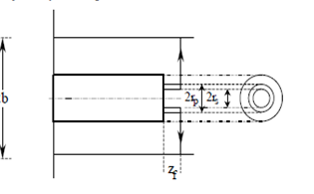

Figure 1. Schematic of the axial and radial phases. The top figure depicts the axial phase, the right section the radial phase. In the left section, z is the effective position of the current sheath-shock front structure. In the bottom figure, r_{s} is the position of the inward moving shock front driven by the piston at position r_{p}. Between r_{s} and r_{p} is the radially imploding slug, elongating with a length z_{f}. The capacitor, static inductance and switch powering the plasma focus is shown for the axial phase schematic only.

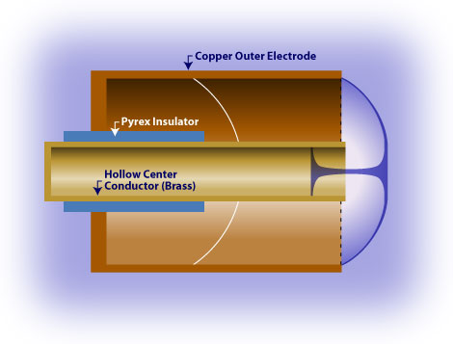
Figure 2. Dense plasma focus device. Image from Glenn Millam. Source: Focus Fusion Society [3]
Axial phase: The self-magnetic force of the current then pushes the current sheet, accelerating it supersonically down the tube. This is very similar to the mechanism of a linear motor. The speed of the current sheet, the length of the tube and the rise time of the capacitor discharge are matched so that the current sheet reaches the end of the axial section just as the discharge reaches its peak value. This phase typically lasts 1-3 μs for a plasma focus of several kJ.

Radial Phase: The part of the current sheet in sliding contact with the anode then ‘slips’ off the end ‘face’ of the anode forming a cylinder of current, which is then pinched inwards. Imploding inwards at higher and higher speeds, the shock front coalesces on-axis and a super-dense, super-hot plasma column is pinched onto the axis (see Figure 2). This column stays super-hot and super-dense for typically ten ns for a small focus. The column then breaks up and explodes. For a small plasma focus of several kJ, the most intense emission phase lasts for the order of several ns. The radiation source is spot-like (1mm diameter) when viewed end-on.

The Pinch Phase of the plasma focus
A filtered photo of the million K pinch
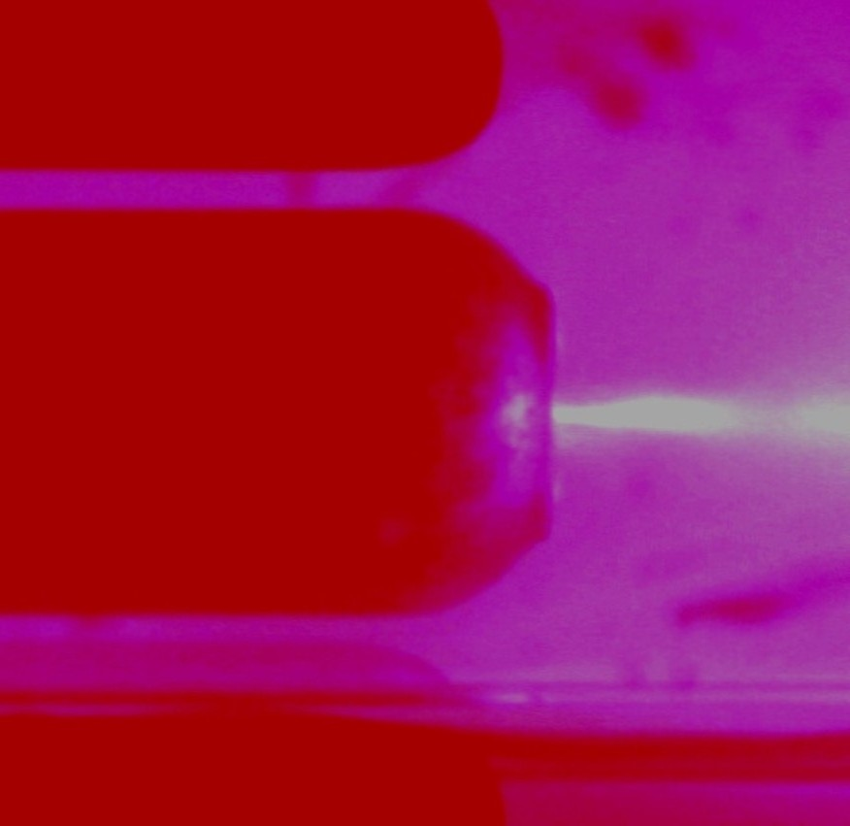
Figure 3. A still photo of the million C plasma pinch produced in the INTI PF (taken by Paul Lee) Using suitably chosen filters, the most intense optical radiation is shown, which turns out to be the pinch; all other phases of dynamics, being less optically intense, are filtered away.
Figure 3 shows a photograph of the INTI PF [4,5] pinch taken with an ordinary digital camera. The long-exposure allows light from all the phases of the PF device to be incident on the recording CCD. But the combination of filters allows only the brightest part of the discharge dynamics to be shown; hence the pinch (the brightest part of the column) is recorded. The more diffuse part of the column at the right edge of the photo is the post-pinch plasma stream.
Nanosecond shadowgraphs of the plasma focus pinch and post-pinch
To capture time-resolved images of the focus pinch an exposure time of 1 ns is necessary to freeze the motion to less than 0.3 mm (since the highest speed of the current sheet is expected to be around 30 cm/µs (or 0.3 mm/ns). A collimated laser beam with an exposure time of 1 ns is shone through the plasma focus (side-on) and the shadow of the moving plasma is cast onto a recording CCD. The plasma self light is filtered away. The time of the laser pulse is adjustable. A composite sequence of shots is obtained [6] as shown in Figure 4. The time of the image is recorded on top of the image with t=0 being the time when the plasma focus pinch is judged to be at its most compressed state.
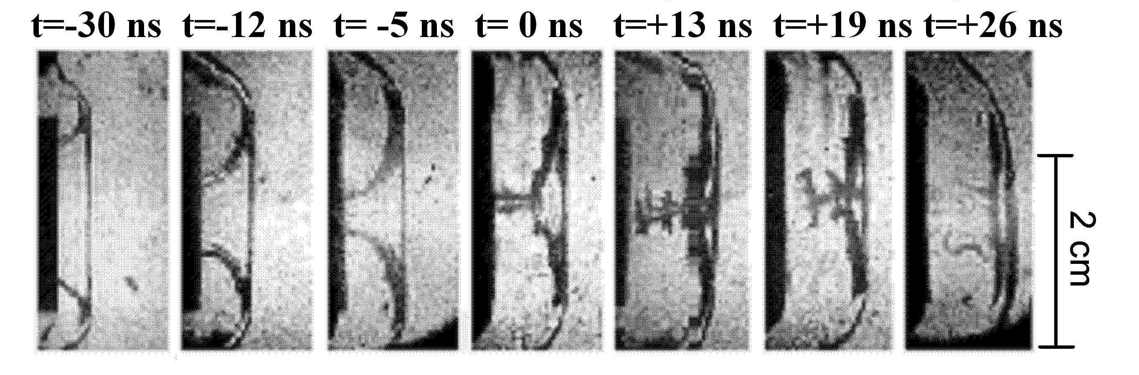
Figure 4. A composite sequence [6] of the radial implosion dynamics of the plasma focus (anode shown pointing sideways- left to right)
From this sequence the average speed of implosion from a=8mm (t=-30 ns) to a~0.5 mm (t=0) is found to be 0.25 mm/ns or 25 cm//µs. The peak speed is more as the current sheet is accelerating as it speeds inwards. Taking the speed of 25 cm/µs, due to the equipartition of energy in a shock the on-axis temperature is immediately found to be 1.5x10⁶K; and on shock reflection, all the kinetic energy is stagnated causing the column to reach a temperature of 3x10⁶K. The instability break-up of the column is seen in the last 3 frames.
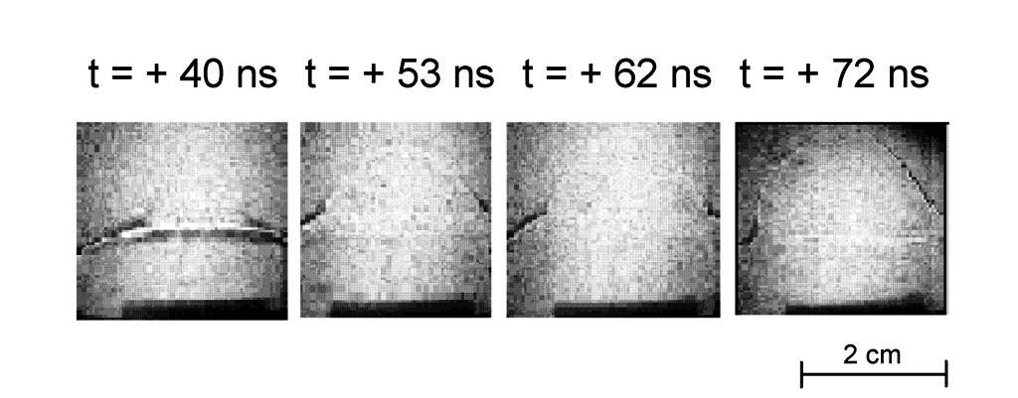
Figure 5. A sequence showing post focus axial shock waves blown out from the pinch [6] (anode shown pointing up)
In Figure 5 the anode is shown pointing upwards (whereas in Figure 4 the anode is pointing left to right). The sequence [6] follows that of the inward implosion and instability break-up of the pinch. This post-focus sequence shows that 14 ns after the break-up (shown in the sequence of Fig 4) a fast shock wave is shot out from the focus region traversing 9 mm in 22 ns or 40 cm/µs.
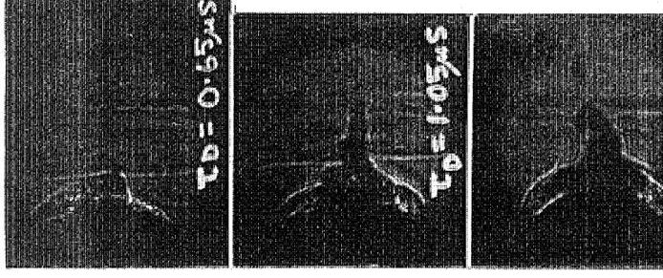
Figure 6. Composite sequence [7] showing anode-sputtered copper plasma jet occurring at a later time (anode shown pointing up)
Figure 6 shows a sequence of shadowgraphs taken at a much later time from 0.65 µs (t=+650 ns) to 1.75 µs. Measurements [7] show that this copper jet comes from material sputtered from the anode by the electron beam. This copper jet travels much more slowly at 2 cm/µs containing ¼ mg of copper carrying 50 J of kinetic energy
The radiations from the plasma focus are produced for the 3 kJ PF from -5ns to +26 ns (Figure 4). First the soft x-rays which is characteristic of the gas (particularly in gases from nitrogen upwards in atomic number) start to be emitted just before t=0; the ion beams emitted in a downstream direction and the electron beam in the opposite direction towards the anode; and the neutrons (from deuterium pinches) are emitted just after t=0; as are the hard x-rays. The high speed axial shock waves (Figure 5) carrying considerable energy and the associated post-pinch plasma streaming and then the slower jet from anode sputtered materials (see Figure 6) constitute the final products of the plasma focus phenomenon. The use and control of these ‘streaming death’ products are proving of importance for plasma focus materials modification, fabrication and deposition as thin films.
From electrical birth through micro-nova to streaming demise of the Plasma Focus
The above images reveal detailed dynamics of the radial phases of the 3 kJ plasma focus, from the compression to the pinch and instability break-up to the subsequent fast plasma streaming, these processes taking just over 100 ns extending another microsecond or so to the anode-sputtered copper jet. Many other diagnostics are used to find more information for all the phases of the plasma focus. At the same time a comprehensive and complete numerical experiment code is available to be configured to run as any plasma focus in the world. This code [8] needs only one measurement from the selected plasma focus namely the current waveform. With this current waveform fitted to the computed waveform the code outputs all the dynamics from axial to radial phase and pinch phase giving speeds, times and dimensions of the pinch, condition of the plasma, radiation and neutron yields, and the numbers and energetics of the ion beam, electron beams, post-pinch fast plasma stream and the anode-sputtered copper jet. An example is shown in Fig 7 of the simplest measurement requiring only a current coil. All the information of that plasma focus shot – from electrical birth (start of axial phase) through the pinch (end of radial phase) to the streaming death- is contained in the current waveform and to some extent in the voltage waveform, also shown in Fig 7.
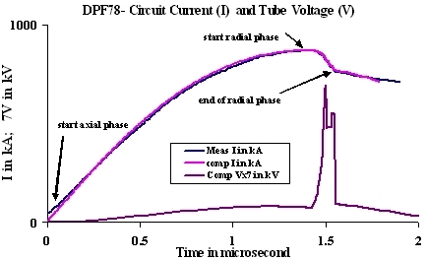
Figure 7. Computed current waveform fitted to the measured current waveform. Indicated on the current trace are the start and end of axial phase, start and end of radial phase. This fitting of the computed current calibrates the code configured as the DPF78 for this figure. The code then outputs realistic dynamics, lifetime and dimensions of the pinch and yields and energetics for this shot.
Research Towards Applications
The small group of plasma focus experts gathered here today to review the research conducted in our institutions have researched on the following applications to various levels of success. The list is not exhaustive but is a useful guide. More details will be added as our conference proceeds.
- Microelectronics lithography towards nano-scale using focus SXR, EUV and electrons
- Micro-machining
- Surface modification and alloying, deposition of advanced materials: superconducting films, fullerenes, DLC films, TiN, ZrAlON, nanostructured magnetic CoPt thin films
- Surface damage for materials testing in high-radiation and energy flux environment
- Diagnostic systems of commercial/industrial value: CCD-based imaging, multi-frame ns laser shadowgraphy, pin-hole and aperture coded imaging systems, neutron detectors, diamond and diode x-ray spectrometer, vacuum uv spectrometer, ccd-based electron energy analyser, Faraday cups, mega-amp current measurement, pulsed magnetic field measurement, templated SXR spectrometry, water-window radiation for biological applications; neutron activation and gamma ray spectroscopy
6. Pulsed power technology; capacitor discharge, Pulsed power for plasma, optical and lighting systems, triggering technology, repetitive systems, circuit manipulation technology such as current-steps for enhancing performance and compressions; powerful multi-radiation sources with applications in materials and medical applications
- Plasma focus design; complete package integrating hardware, diagnostics and software.
- Fusion technology and fusion education, related to plasma focus training courses
Conclusion: Presenting some products
Micro-lithography and micro-machining towards nano-scale
Figure 8 shows the NX2 (2 kJ, 400 kA, 16 shots per second, 300 W neon SXR per shot, 10 minute burst duration) in its original set-up for micro-lithography. Figure 8(a) is a schematic of the 1-tonne (1.4 m high) structure with the focus chamber surrounded by the capacitor bank and raised above the ground on pillars made up of ALE chargers, gas distributors and trigger sub- systems.The lithography assembly is suspended below (behind) the focus electrodes platform see also Figure 8(d) which shows clearly the extraction of the neon SXR though the rear of the anode.
Figure 8(b) shows some details of the water-cooled anode and cathode structures. Figure 8(c) shows the m-high beamline for monitoring the SXR mounted above the plasma focus chamber. Figure 8(d) shows the details of the lithography beamline 1=hollow anode; 2= cathode; 3=focus pinch; 4= SXR beam extracted with a diverging angle; 5= magnets for deflecting electron beam; 6= holder with 3 in-line apertures extracting the SXR beam but reducing the shock/blast waves from the discharge; 7= berylium window; 8= SXR mask with pattern to be lithographed; 9= SXR resist on which lithograph pattern is formed; 10= substrate holding the SXR resist. Figure 8(e) shows 6 small squares in two rows. The top row are test structures replicated in resist of PMMA495. The left square of the second row is the SXR lithography test mask consisting of 200 nm gold features placed on a supporting100 nm membrane of Si3N4. The other two squares are test structures replicated in ERP40 positive resist. Figure 8(f) shows details of two sub-micron replicated lithographed structures.

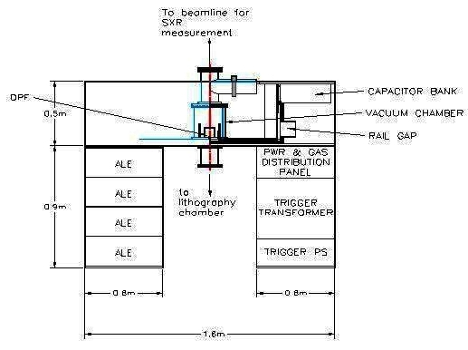
(c)
(b)
(f)
(a)

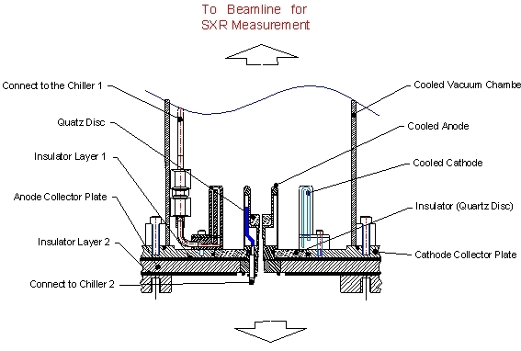
(b)

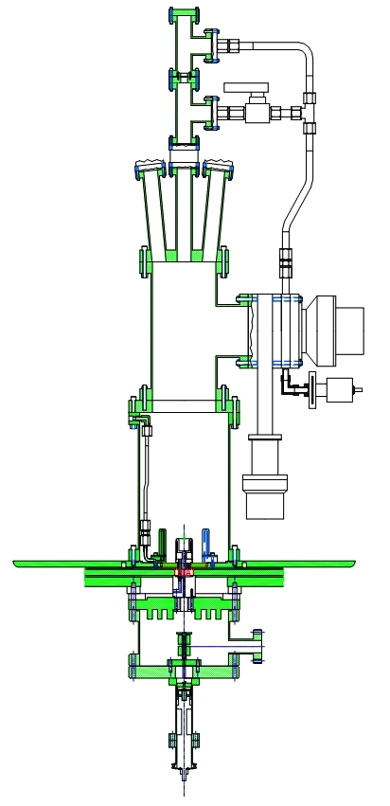
(c)

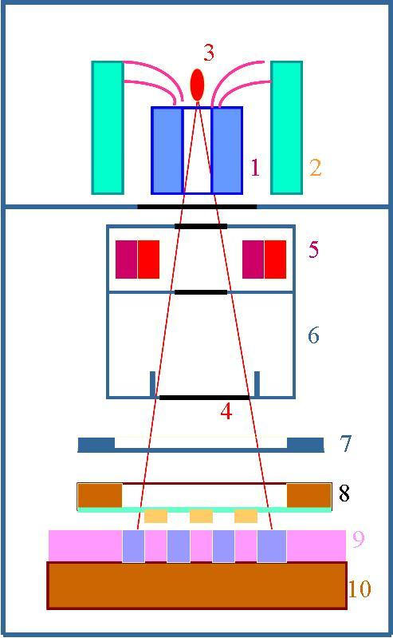
(d)

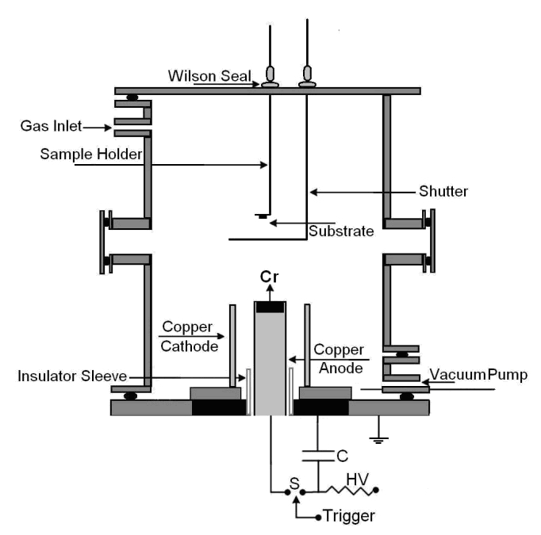
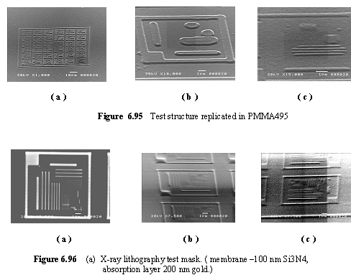
(e)

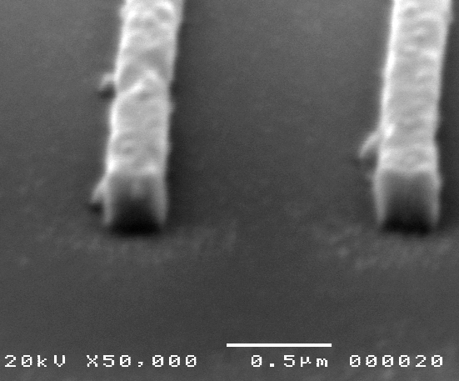
(f)

Figure 8 NX2 (Singapore) Lithographic machine, duplicated test structures and sub-micron lines [9]

The NX2 is also used in repetitive mode for the related application of micro-machining, producing sub-micron high aspect ratio trenches; very well defined and with a much greater depth than the width. Figure 9 is a SEM image of a 100 nm trench micro-machined with neon SXR.

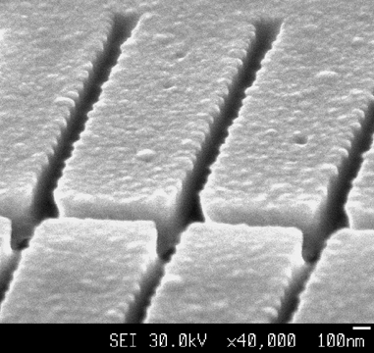

Figure 9. The NX2 producing micro-machined samples [9]

Materials deposition and advanced materials fabrication
A simple set-up for depositing thin films is shown in Figure 10. The centre of the anode is inserted with a cylinder of chromium and argon may be used as the operating gas.
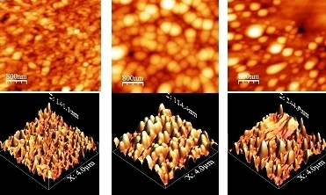


Figure 10. 2 kJ plasma focus for thin film deposition [10]; and samples of deposited chromium (Right side, top 2 rows) & TiN films (right side, bottom image)

The electron beam from the pinch impacts on the chromium producing a post pinch chromium jet which moves to the sample, coating it within 20-30 shots. The shutter is opened for the process to begin only when the device is focussing strongly. For coating a sample surface with TiN the chromium is replaced with titanium, and nitrogen is used as the operating gas. After the pinch the fast nitrogen plasma stream impacts the sample followed microseconds later by the anode-sputtered titanium plasma.

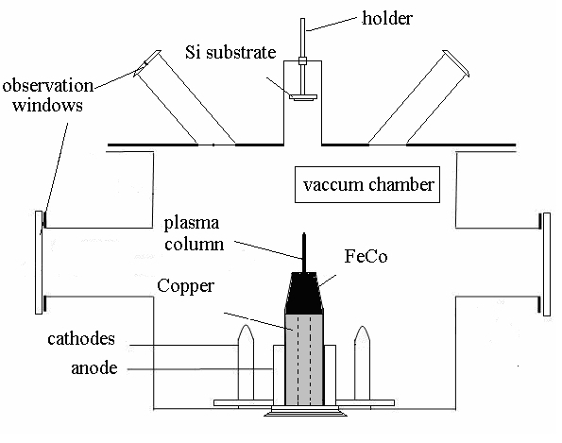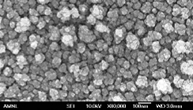
Figure 11 NX2 set-up for depositing thin films; deposited thin films with 100nm FeCo agglomerates [11]

Figure 11 shows the NX2 set-up for fabricating advanced nano-materials. In this set-up 100 nm agglomerates of FeCo are deposited consisting of grains typically 20 nm across. This material has potential for the next generation of ultra-high density of magnetic data storage. Other possible candidates are nano-structured materials like CoPt and FePt which are are also deposited.

A world-class product: Integrating a proven hardware package with a proven numerical experiments package: Developing the most powerful training and research system for the dawning of the Fusion Age

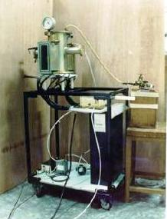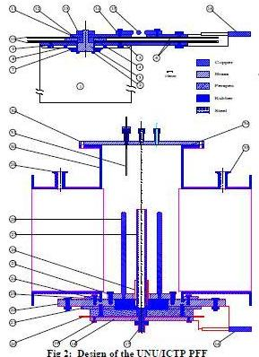
Figure 12. The trolley based UNU/ICTP PFF 3 kJ plasma focus training and research system [12]

Figure 12 shows the UNU/ICTP PFF 3 kJ system, already acknowledged as a very successful training and research package. It is ready to be updated technologically and then integrated to the Lee Model code with emphasis on dynamics, radiation and materials applications.
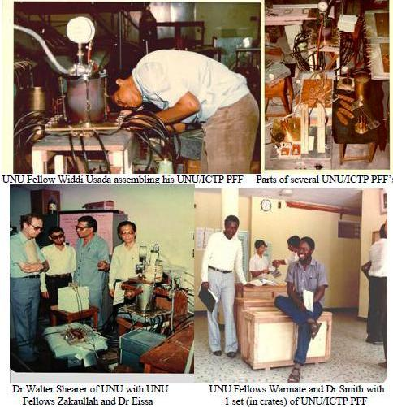
Figure 13 Building on a tradition (shown in this pictoral record) [12-14] the small plasma focus is ready to be developed into the world’s most effective training and research package when integrated with the Lee model code [2.8] with emphasis on dynamics, radiation and materials applications.

It will draw on the spirit and tradition of the UNU/ICTP PFF (shown in the pictorial record of Figure 13) and the Lee model code. It will be the world’s most effective training and research package developed to help meet the needs of scientific and engineering manpower for the inevitable dawning of the Fusion Energy Age [15].
Acknowledgments
In acknowledgement you may thank all the people/organizations who provided their assistance to you in forms of advice, suggestions, and any others.
References
- A Bernard, H Bruzzone, P Choi, H Chuaqui, V Gribkov, J Herrera, K Hirano, A Krejci, S Lee, C Luo, F Mezzetti, M Sadowski, H Schmidt, K Ware, C S Wong, V Zoita Scientific Status of Plasma focus Research. J Moscow Physical Society, 8, 93-170 (1998) .
- S Lee Plasma focus model yielding trajectory and structure. In Radiations in Plasmas, McNamara, B., Ed.; World Scientific, Singapore: Volume II, pp. 978–987 (1984)
- Glenn Millam Focus Fusion Society
- S H Saw, S Lee, F Roy, PL Chong, V Vengadeswaran, ASM Sidik, YW Leong & A Singh-In-situ determination of the static inductance and resistance of a plasma focus capacitor bank – Rev Sci Instruments 81, 053505 (2010)
- S Lee, S H Saw, R S Rawat, P Lee, R Verma, A.Talebitaher, S M Hassan, A E Abdou, Mohamed Ismail, Amgad Mohamed, H Torreblanca, Sh Al Hawat, M Akel, P L Chong, F Roy, A Singh, D Wong, K Devi. Measurement and Processing of Fast Pulsed Discharge Current in Plasma Focus Machines- J Fusion Energy DOI: 10.1007/s10894-011-9456-6 Online First™ 28 July 2011
- Muhammad Shahid Rafique. Compression Dynamics and Radiation Emission from a Deuterium Plasma Focus PhD thesis Nanyang Technological University, Singapore (2000).
- S. Lee, Harith Ahmad, T.Y. Tou, K.H. Kwek and C.S. Wong. Dynamics of REB-sputtered copper plasma jets. J. Fiz. Mal., Malaysia 6: 23-28 (1985)
- S Lee Radiative Dense Plasma Focus Computation Package: RADPF http://www.plasmafocus.net/IPFS/modelpackage/File1RADPF.htm (2012)
http://www.intimal.edu.my/school/fas/UFLF/File1RADPF.htm (2019)
- G.X.Zhang. Plasma Soft x-ray source for Microelectronics lithography. PhD thesis, Nanyang Technological University, Singapore (1999).
- M. Ghoranneviss*, S. Javadi, M. Habibi, Z. Abdolahi, S. Lee, S.H. Saw Investigation of Structural Properties of Chromium Thin Films Prepared by Plasma Focus Device (submitted for publication)
- R S Rawat, Z Ahang, J J Lin, Z Y Pan and P Lee Application of Plasma Focus Device for Deposition of Nanostructured Magnetic Thin Films and Ion-irradiation Induced Nanostructuring of PLAD Grown Magnetic Thin Films Proceedings of International Workshop On Plasma Computations & Applications, Editors S H Saw et al 23-32 (2008)
- S.Lee, S.P.Moo, C.S.Wong, A.C.Chew. Twelve Years of UNU/ICTP PFF- A Review. IC/98/231, ICTP Preprint, International Centre for Theoretical Physics, Trieste, Italy (1998), 101 pages.
- S.Lee, T.Y.Tou, S.P.Moo, M.A.Eissa, A.V.Gholap, K.H.Kwek, S.Mulyodrono, A.J. Smith, Suryadi, W.Usala, M. Zakaullah. A simple facility for the teaching of plasma dynamics and plasma nuclear fusion. Amer J. Phys., USA, 1988, 56: 62-68.
- S Lee and S H Saw. J Fusion energy 30, 398-403 (2011)
- Sing Lee & Chiow San Wong Initiating and Strengthening Plasma Research in Developing Countries Physics Today pg 31-36 May 2006

