**From Beam-target to Thermonuclear Fusion in the Dense Plasma Focus Pinch**

**Sing LEE**

*Institute for Plasma Focus Studies, 32 Oakpark Drive, Chadstone VIC3148, Australia*

*Physics Department, University of Malaya, 50603 Kuala Lumpur, Malaysia*

*INTI International University, 71800 Nilai, Malaysia*

*Nilai University, 71800 Nilai, Malaysia*

**(*Corresponding author’s e-mail: leesing@optusnet.com.au)**

*Received: xxx, Revised: xxx, Accepted: xxx*

**Running title: From Beam-target to Thermonuclear Fusion in the Dense Plasma Focus Pinch**

**Abstract**

1: Background concepts:

Electromagnetic drive, MRN and typical speeds, Speed factor S

Mach >> 1 driven plasmas, temperature vs speed

Cross-sections for nuclear fusion, D-T: beam-target and thermonuclear

2: DPF Fusion: Beam-target predominance: Throughput scaling

Inductive voltages generate tens to hundreds of keV

Shock speed generates around 0.5 keV

Optimum pinch conditions for neutron yield in beam-target mode

Throughput (Output/Input) Scaling to break-even Q =1

Breakeven point found through numerical experiments

Role of high pressure ion energy moderation from too high MeV through optimum 100 keV

3: Transitioning to thermonuclear mode

How?

Optimum conditions for neutron yield in thermonuclear mode

Throughput (Output/Input) Scaling to break-even Q =1

Breakeven point found through numerical experiments

4: Beam-target (DPFQ1) breakeven point compared to thermonuclear breakeven point

Comparison of DPFQ1 and thermonuclear break-even points

Proposing a feasible test point DPF0.01

Conclusions

**Keywords:** denseplasma focus, beam-target fusion, break-even DPF, beam-target DPF, thermonuclear DPF

**Introduction**

In the early days of dense plasma focus DPF research, the observation [1,2] that fusion neutron yield Yn ~ E02, (E0 = the capacitor storage energy) gave rise to the hope that energy break-even could occur at E0 of just hundreds of MJ, simply by increasing the capacity, hence stored energy of the DPF. However it was shown that dominance of dynamic resistance of current sheet motion on circuit behavior as capacity increases leads to vanishingly small bank impedances resulting in scaling deterioration of discharge current, and a corresponding yield scaling deterioration to Yn ~ E00.8 [3]. This suggests no break-even unless capacitor voltages are greatly increased, aided by increase in operational pressure [4].

1. **Some background concepts for DPF:**

**Electromagnetic drive:**

Interaction of electric current and magnetic field (JXB) produces high plasma speeds and temperature. Electromagnetic drive is efficient when the magnetic Reynolds number MRN is high. For electromagnetic drive to be efficient, the condition is that MRN >>1. For high Mach shock waves we have shown [5] MRN ~ v4; where v is shock speed ; with transition point to MRN >> 1 at v around 5 cm/s for D-D plasma ; with lower speeds required for gases of higher atomic numbers. In the DPF this condition MRN >>1 is typically fulfilled because plasma speeds are highly supersonic and exceed 5 cm/s.

For electromagnetic drive, the speed is governed by a fundamental factor S= (I/a) / 0.5

Over range of existing DPF’s (sub kJ - MJ) in deuterium S ~ 70 – 200, practically constant [6].

Value of S: typically 100 (kA/cm) per Torr0.5

Value of (I/a) : Typically 200 kA/cm

Value of operational pressure: Typically 4 Torr (~ 0.01 atm)

**High Mach (Mach >> 1) shock waves:**

A convenient unit of speed for electromagnetically driven systems is cm/s. (1 cm/s = 104 m/s ~ Mach 10 in D-T). In DPF’s, speeds are typically 10 cm/s and higher. Thus DPF plasma drives are characterized by Mach > 100 supersonic shock waves. Shock wave systems are equi-partitioned with approximately equal amounts of energy in the thermal modes and the kinetic components. The shock conservation equations enable the plasma temperature T to be computed [7] from the shock speed q.

For a 50%-50% D-T shock system:

T = 2.8x10-5q2 (1)

**Cross-sections for D-T nuclear fusion :**

The fusion cross-section applicable to D-T Beam - target is shown in Fig. 1.

We note that the cross-section  at 10 keV deuteron energy is 1013 higher than that at 1 keV ; and that from 10 keV to peak value of  at ~ 100 keV, there is another increase of 103 in the cross-section. Peak value of  occurs at ~100 keV. At higher beam energy,  drops. At beam ion energy of 1 MeV,  has dropped almost 100 times in value.



Fig 1. D-T fusion cross-section vs deuteron energy [8,9]

**Cross-sections for nuclear fusion: Thermonuclear:**

Relevant cross-section is the <v> ie product of cross-section and particle speed v averaged over Maxwellian distribution at temperature



Fig 2.Value of <v> based on Maxwellian distribution for D-T reaction [8,9]

Note that increase of temperature from 0.1 to 1 keV increases the value of <v> increases by 109 times. Further increase of temperature from 1 to 10 keV, <v> increases a further 104 times. There is then a small increase of less than 10 times in <v> to its peak value at T= 70 keV. From <v> point of view, good operational point is around 70 keV

**2: Present-generation DPF (sub kJ to MJ) operate predominantly in beam-target mode: why?**

All present DPF’s (sub kJ to MJ) operate with same speed: axial around 10 cm/s and radial around 20 cm/s [6,7]. This gives a temperature in D-T of ~ 0.3 x 106 K for the axial phase plasma and ~ 1.2 x 106 for the radial phase on axis shock; to about 2.4 million K in the stagnated plasma column on shock reflection on-axis. The gross pinch temperature is typically < 0.5 keV (1 keV = 1.14 x 107 K) – very low temperature from fusion point of view.

On the other hand, resulting from highly supersonic piston action, inductive voltages (back EMF motor effect, if we like) typically 20 – 40 kV are generated, producing 60 – 120 keV ions. These energies are near optimum from fusion point of view.

The two effects combined to ensure low thermonuclear component compared to the Beam – plasma target component of the fusion yield. This situation has the advantage of low investment in plasma energy vs optimum beam energy

**Beam-target fusion scaling: output fusion energy to input energy.**

We first ask the question: How many D-T neutrons (from beam-plasma target) do we get per unit pinch energy. Modelling by the Lee code provides the number of beam-target neutrons [10-12] as follows:

*Yb-t*= *Cn ni Ipinch*2*zp*2(ln(*b*/*rp*))σ/*U*1/2  (2)

where *Ipinch*is the current flowing through the pinch at start of the slow compression phase; *rp*and *zp* are the pinch dimensions at end of that phase. Here *Cn*is a constant which in practice we will calibrate with an experimental point. Here all quantities are in SI units with U = 3Vmax (Vmax is maximum induced tube voltage) in keV and the constant Cn = 1.4 x 107 (a calibrated value)

The pinch energy [13] at temperature T is

*Epinch*= [*kT*/ (-1)] *ni*(1+*Zeff*) *rp*2*zp*,  (3)

where k = Boltzmann constant,  = specific heat ratio = 5/3 ; Zeff = 1 (for fully ionized D-T plasma).

Assume an equilibrium pinch, equate the confining magnetic pressure to the hydrostatic plasma pressure. Thus:

Ipinch2 = 2x107 nikT (1+Zeff)rp2 (4)

Divide Yb-t by Epinch, replacing Ipinch2 in Yb-t by the RHS of Eq (4) we get the required number of beam-target neutrons per unit pinch energy. Note: ((ln(b/rp)) ~ 2 and zp ~ 1.4 a ([6,7] for fully ionized hollow anode DPF)

General scaling for number of D-T DPF beam-target neutrons

Yb-t / Epinch = 5 x 1014 ni a [σ/U1/2] (5)

This general scaling stipulates that the number of beam-target neutrons depends on the pinch ion density, the anode radius ‘a’; and the energy of the D-T beam ions through the fraction [σ/U1/2].

This beam – target scaling is optimised by choosing optimum factor [σ/U1/2], using Fig 3.



Fig 3. Value of [σ/U1/2] versus U

Note : At optimum deuteron beam energy of 100 keV, the scaling for Yb-t / Epinch is optimized:

(Yb-t / Epinch)100keV = 2.5 x 10-14 ni a (6)

A D-T neutron has energy of 14.1 MeV ie 2.26 x 10 -12 J. Estimating that Epinch ~10% of the stored energy E0, then we have the ratio

Q100keV = (Eb-t / E0)100keV = 6 x 10-27 ni a (7)

For Q > 1 ( ie better than break-even)

6 x 10-27 ni a > 1 (8)

Example: ‘a’= 1 m then for Q>1

ni > 1.7 x 1026 m-3 (optimum 100 keV)

(ie 6 atm of fill pressure is sufficient for break-even).

Numerical experiments disagree. In fact thousands of runs have been made using the Lee code [10-12] in DPF’s of meter-size anode radius at beam-target conditions (following present generation DPF’s with axial speed around 10 cm/s) – over years! Nothing approaching anywhere near break-even has been observed in these numerical experiments at such DPF sizes and densities; and even bigger sizes and greater densities!

Discrepancy- is due to condition of 100 keV beam ion energy, which is not met in the code results.

We analyse the induced tube voltages [10,12].

 (9)

V = V1 + V2

V = V1 + V21 V22 (10)

We compute the various components and the induced tube voltage in Table 1.

Table 1. Computed components of induced tube voltages

|  |  |  |  |  |  |  |  |
| --- | --- | --- | --- | --- | --- | --- | --- |
|  | Tube | dI/dt*position | speed*I | dz/dt | drp/dt | Beam ion | |
|  | Voltage kV | term kV | term kV | term kV | term kV | | Energy keV |
|  | V | V1 | V2 | V21 | V22 |  | |
| NX2 15kV | 25.1 | -10.6 | 35.7 | 17.1 | 18.6 | 75 | |
| PF1000 27kV | 25.7 | -29.8 | 55.5 | 29.1 | 26.4 | 77 | |
| PF1000 27kV RESF=0.1 | 57.0 | -65.6 | 122.6 | 62.9 | 59.7 | 171 | |
| 25MJ 35kV | 61.7 | -285.2 | 347.0 | 185.2 | 161.8 | 185 | |
| 162MJ 90kV | 106 | -484 | 590 | 308 | 282 | 317 | |
| 16200MJ 900kV | 1459 | -6121 | 7581 | 3970 | 3610 | 4380 | |

For DPF’s operating in the beam-target mode, the values of speeds are kept at low levels of 10 cm/s for axial and 20 cm/s for the radial phases. This ensures plasma temperatures that are low for fusion, at the same time ensures high ion beam speeds.

The speed factor S = (I/a)/ 01/2 needs to be kept at around 100. Thus as ‘a’ increases, I increases proportionally; so with (I/a) = 200 kA per cm anode radius, we need 20 MA for 1 m anode radius. The increase in operational pressure to 6 atm will require a further increase of current to around 500 MA. A large DPF (with smallest possible radius ratio c) has a dynamic resistance (ie resistance due to motion) of 2 m. Thus to get a current of 500 MA requires a capacitor voltage of at least 1 MV. From the last example of Table 1, which is just under 1 MV, the beam ion energy is about 5 MeV.

Thus the scaled-up m-sized DPF operated at atmospheric pressure will have beam ion energies of multiple MV; way past optimum [σ/U1/2]. Indeed at 10 MeV this cross-section parameter has dropped by 1000 times from optimum value. These estimates provide a guide for numerical experiments for a scaled-up DPF, to obtain an operational point for a B-T device; although we know the beam ions will be far too energetic.

**Beam-target numerical experiment (1.2 MV, 5 atm) generating Q = 0.002**

Table 2. Parameters of a 1.2 MV, 5 atm a = 1m D-T DPF

|  |  |  |  |  |  |
| --- | --- | --- | --- | --- | --- |
| **Lo** | **Co** | **b** | **a** | **zo** | **ro m** |
| **20** | **10000** | **120** | **100** | **60** | **0.15** |
| **massf** | **currf** | **massfr** | **currfr** | **Model Parameters** | |
| **0.08** | **0.7** | **0.2** | **0.7** |  |  |
| **Vo** | **Po** | **MW** | **A** | **At-1 mol-2** | **Operational** |
| **1200** | **4000** | **5** | **1** | **2** | **Parameters** |

Table 3a: Computed plasma parameters for 1.2 MV, 5 atm D-T DPF

|  |  |  |  |  |  |  |  |  |  |  |  |  |
| --- | --- | --- | --- | --- | --- | --- | --- | --- | --- | --- | --- | --- |
| E0 | RESF | c=b/a | Ipeak | Tp | va | vs | vp | rmin | zmax |   | Vmax | ni |
| kJ |  |  | kA | 106 K | cm/s | cm/s | cm/s | cm | cm | ns | kV | 1023/m3 |
| 7.2E+06 | 0.11 | 1.20 | 3.5E+05 | 0.11 | 8.3 | 8.5 | 6.8 | 30.0 | 162 | 6527 | 1,337 | 1051 |

Table 3b: Computed neutron yield parameters for 1.2 MV, 5 atm D-T DPF

|  |  |  |  |  |  |  |  |  |
| --- | --- | --- | --- | --- | --- | --- | --- | --- |
| Yn | EINP | SF | ID | EN | EN/E0 |  |  |  |
| 1010 | % |  | kA/cm | kJ |  | Yth | Yb-t | Yn |
| 6.1E+08 | 43.4 | 55 | 3476 | 1.4E+04 | 0.002 | 5.0E-12 | 6.1E+18 | **6.1E+18** |

Beam ion energy 5 MeV; number of ions in beam = 1.3 x 1022 [14,15]; number fusion reacted is 6.1x1018; with remnant practically 1.2 x 1022 ions available for fusion reaction in exiting the pinch.

[/U0.5] is down from optimum value by almost 1000 times (see Fig 3).

Using a SIRIM code, estimates by M Akel [16] indicate that a 1 m path in 5 atm D-T is sufficient to slow D-T beam ions to 100 keV. In schematic shown below the ion beam will be moderated to 100 keV in its path (> 1m) before leaving the chamber. In thus slowing down the 5 MeV D-T beam so that the beam energy goes down towards its optimum fusion value and finally below that value, the beam-target yield will achieve its optimum value of almost 1000 times higher than that computed by the Lee code which applies at the exit of the focus pinch.Such a schematic is shown in Fig 4. With the high pressure path enhancement, the example that is discussed reaches a Q~1.

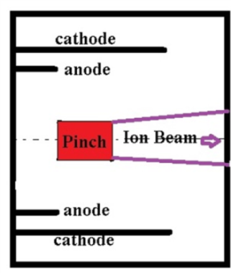

Fig. 4 Schematic showing ion beam with fusion enhancement

**Discharge current waveform and radial trajectories of 1.2 MV, 5 atm, a = 1m; D-T DPF**

The discharge current and radial trajectories are shown in Figs 5 and 6.

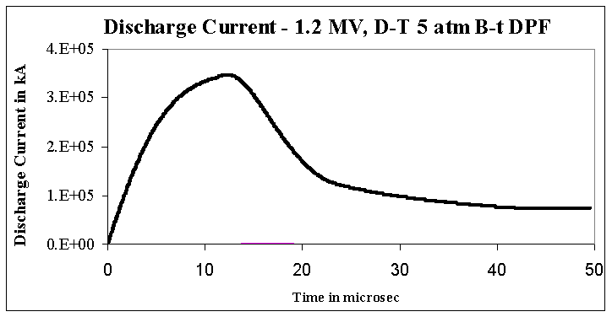

Fig 5. Discharge current of the DPF- 1.2 MV, 5 atm D-T

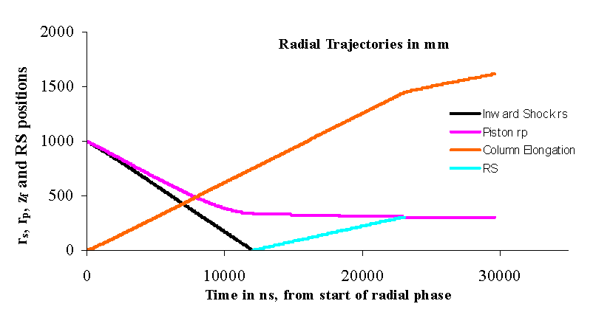

Fig 6. Pinch trajectories during radial phase for DPF- 1.2 MV, 5 atm D-T

.

**3: Transitioning to thermonuclear mode**

To operate the DPF pinch at thermonuclear conditions for D-T, the pinch temperature needs to be increased from the sub-keV of present-day DPF’s to near 70 keV. Analysis (below) shows an optimum temperature of 20 keV (see Fig 7 below). This requires about 7 times faster plasma speeds than presently used. This first estimate (oversimplified) requires the axial speed to be increased to 70 cm/s and radial speed to be increased to 150 cm/s. Speed factor S needs to increase to 1000 (from present day 100).

Moreover, density is ~1000x higher. (as will be seen in next section).

Hence current per unit anode radius increases to 60 MA/cm (from present-day 200 kA/cm ).

**Thermonuclear scaling: derive the ratio: Yth / Epinch at thermonuclear pinch conditions.**

*Yth*= 0.5*ni*2*rp*2*zf*<σv>   where <σv> is the thermalised fusion cross section-velocity product corresponding to the plasma temperature T [8,9], for the lifetime of the pinch .

Dividing this number by Epinch: we obtain the number of D-T neutrons per J of pinch energy.

*Yth / Epinch = 0.17 <σv> /(kT)] ni*           

where <σv> is the thermalised fusion cross section-velocity product corresponding to the plasma temperature, for the lifetime of the pinch .

General scaling of Q as function of ni at pinch temperature T

Eth/E0 = 240[<v>/kT] ni          

where kT is in keV. Here estimate Epinch = 0.1 E0 and energy of 1 D-T neutron as 14.1 x 103 keV. Note the Q value is a function of (ni   and the fusion x-section parameter [<v>/kT].

It is useful to plot the value of [<v>/kT].as a function of T in order to optimize the yield shown in Eq (12)

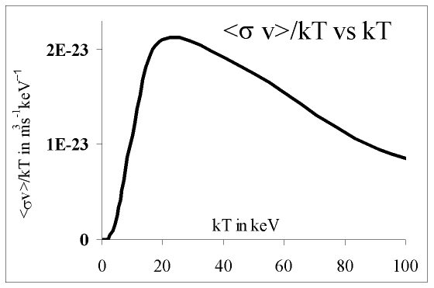

Fig 7. Optimising the temperature at which [<v>/kT] is highest

**Selecting optimum operational temperature**

From [<v>/kT] curve, optimum occurs around T = 20 keV; highest value = 2.1 x 10-23 m3s-1(keV)-1. Such a concept was expressed in seminal form by Lawson [17,18] who selected 25 keV, pioneering the concept of Lawson criterion.

**Scaling of Q as function of ni  at optimum temperature of 20 keV**

Eth/E0 = 5x 10-21 ni  (13)

Fixing operation at this optimum temperature, the requirement for better than break-even ie Eth/E0 >1 is

ni  > 2 x 1020 m-3s 20 keV (14)

This criterion applied specifically to the DPF is comparable to the well-known Lawson’s ni  criterion (ni  > 1.5 x 1020).

**Example**

For present-day DPF operating at T ~ 0.5 keV pinch duration is ~10-20 ns per cm ‘a’, governed by transit time of small disturbance speed across the pinch diameter.

At 20 keV the lifetime is around 2 ns per cm ‘a’. For a = 1 m the lifetime   is 200 ns.

For Q > 1, the requirement is ni  > 1027; close to 50 atm

These estimates provide guidance for numerical experiments to find an operational point for Q>1.

Numerical experiments found an operational thermonuclear point for Q>1 as follows, with bank, tube abd operational parameters in Table 4; and computed plasma, pinch and energy parameters in Tables 5a and b.

Table 4: Parameters of a thermonuclear DPF at Q >1.

|  |  |  |  |  |  |
| --- | --- | --- | --- | --- | --- |
| **L0** | **C0** | **b** | **a** | **z0** | **r0 m** |
| **18** | **7,000** | **160** | **155** | **13,500** | **0.1** |
| **massf** | **currf** | **massfr** | **currfr** | **Model Parameters** | |
| **0.1** | **0.7** | **0.4** | **0.8** |  |  |
| **V0** | **P0** | **MW** | **A** | **At-1 mol-2** | **Operational** |
| **800,000** | **55,000** | **5** | **1** | **2** | **Parameters** |

Table 5a: Computed plasma parameters for thermonuclear DPF

|  |  |  |  |  |  |  |  |  |  |  |  |  |
| --- | --- | --- | --- | --- | --- | --- | --- | --- | --- | --- | --- | --- |
| E0 | RESF | c=b/a | Ipeak | Tp | va | vs | vp | rmin | zmax | ⧫ | Vmax | ni |
| kJ |  |  | kA | 106 K | cm/s | cm/s | cm/s | cm | cm | ns | kV | 1023/m3 |
| 2.2E+12 | 0.062 | 1.03 | 6.2E+07 | 267 | 242 | 257 | 205 | 30.2 | 258 | 250 | 1.2E+07 | 7E+04 |

Table 5b: Computed neutron yield parameters for thermonuclear DPF

|  |  |  |  |  |  |  |  |  |
| --- | --- | --- | --- | --- | --- | --- | --- | --- |
| Yn | EINP | SF | ID | EN | EN/E0 | Yth | Yb-t | Yn |
|  | % |  | kA/cm | kJ |  |  |  |  |
| 1.1E+27 | 45.7 | 1,719 | 4.0E+05 | 2.4E+12 | 1.09 | 1.1E+27 | 2.9E+22 | 1.1E+27 |

The numerical experiments also produce the current waveform, dynamics and temperature for this thermonuclear DPF shown in Figures 8 and 9a and b.

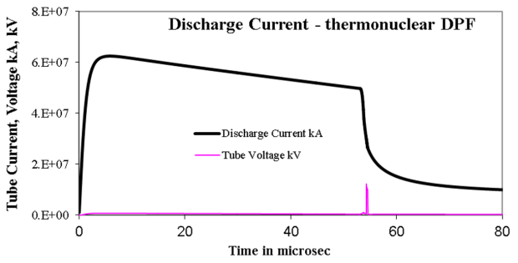

Fig 8. Discharge current of the thermonuclear DPF

**Thermonuclear DPF - Radial Dynamics and Temperature**

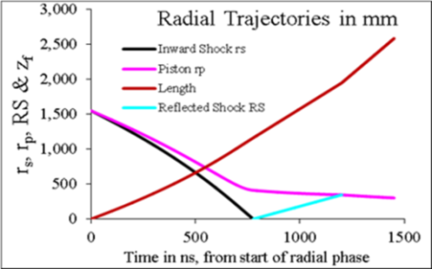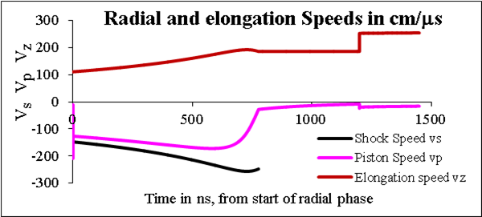

Fig 9a Pinch trajectories and speeds during radial phase for thermonuclear DPF- at Q>1

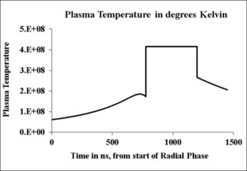

Fig 9b Plasma Temperatures during radial phase for thermonuclear DPF- at Q>1.

**4: Comparison: Beam-Target vs Thermonuclear**

In Table 6 we compare the two break-even points we have found for the beam-target and the thermonuclear DPF’s.

Table 6: Comparison of beam – target versus thermonuclear break-even points

|  |  |  |  |  |  |  |  |  |  |
| --- | --- | --- | --- | --- | --- | --- | --- | --- | --- |
| D-T | E0 | V0 | P0 | a | T | U | Yn | Q | Effective Q |
|  | GJ | MV | Atm | m | keV | keV | At pinch |  | Path beyond pinch |
| B-T (DPFQ1) | 7.2 | 1.2 | 5.3 | 1 | 0.1 | 4.0E+03 | 6.0E+18 | 0.002 | ~1 |
| Thermonuclear | 2.E+06 | 800 | 72.3 | 1.6 | 23 | 1.2E+07 | 1.1E+27 | 1.1 |  |

The B-T point (DPFQ1) requires much less extreme conditions; though still far away from what is technically proven. For example, the highest pressures that DPF’s have been operated at is not much more than 50 Torr, less than 0.1 atm [19,20].

A technically feasible device is therefore proposed – DPF0.01- to reach Q~0.01.

The bank and tube parameters are given in Table 7.

Table 7: Bank and tube parameters for DPF0.01

|  |  |  |  |  |  |
| --- | --- | --- | --- | --- | --- |
| L0 nH | C0 F | b cm | a cm | z0 cm | R0 m |
| 30 | 20 | 18 | 15 | 3 | 3 |
| massf | currf | massfr | currfr |  | |
| 0.08 | 0.7 | 0.2 | 0.7 |  |  |
| Vo kV | Po Torr | MW | A | At-1 mol-2 |  |
| 900 | 100 | 5 | 1 | 2 |  |

Using these bank and tube parameters, numerical experiments produce the current waveform shown in Fig 10 and plasma and energy parameters compiled in Tables 8a and 8b.

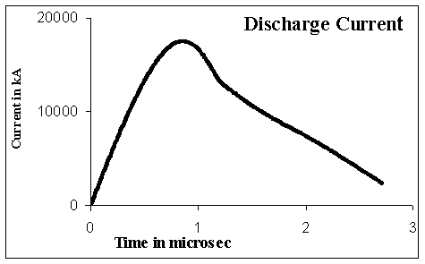

Fig 10. Discharge current of DPF0.01

Table 8a Computed plasma parameters DPF0.01

|  |  |  |  |  |  |  |  |  |  |  |  |  |
| --- | --- | --- | --- | --- | --- | --- | --- | --- | --- | --- | --- | --- |
| E0 | RESF | c=b/a | Ipeak | Tp | va | vs | vp | rmin | zmax |             | Vmax | ni |
| kJ |  |  | kA | 106 | cm/s | cm/s | cm/s | cm | cm | ns | kV | 1023/m3 |
| 8100 | 0.08 | 1.2 | 18000 | 2.3 | 11.9 | 27.3 | 18.1 | 4.1 | 23.9 | 282 | 746 | 31.5 |

Table 8b: Computed neutron yield parameters for DPF0.01

|  |  |  |  |  |  |  |  |  |  |
| --- | --- | --- | --- | --- | --- | --- | --- | --- | --- |
| Yn | EINP | SF | ID | EN | EN/E0 | Yth | Yb-t | Yn | Nion in beam |
|  | % |  | kA/cm | kJ |  |  |  |  |  |
| 6.6E+13 | 36.1 | 0.5 | 117 | 0.15 | **2E-05** | 4.5E+06 | 6.6E+13 | **6.6E+13** | 8.4E+18 |

The code computes a Q of 2 x10-5; with a beam ion energy > 2 MeV. This excessively high ion energy has dropped the fusion cross-section parameter [/U0.5] by almost 1000 times. The operational pressure is only 100 Torr, so a suitable fusion enhancing drift tube of length 1 m containing 10 atm D-T gas is needed, see Fig 11. Such a schematic for the DPF has been suggested by Hossein Sadeghi et al [21]. This high pressure section may for example be separated from the DPF chamber by a molybdenum foil of several microns thickness through which the D-T beam passes with little attenuation. The D-T ions exit the pinch in a beam with divergence around 10-20 degrees. A beam-shaper BS, uses magnetic field to reduce this divergence so that most of the remnant ions travels down the high pressure tube. The fusion yield is enhanced as the energy of the ions attenuates downwards going through the optimum fusion value of 100 keV. The result is a Q of 0.01.

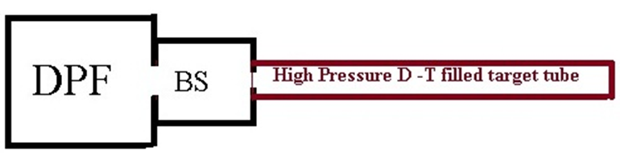

**Molybdenum foil partition**

Fig 11. Schematic of the fusion enhancing reaction tube containing 10 atm D-T gas.

**Conclusions**

Beam-target scaling at optimum beam ion energy of 100 keV suggests 1.2 MV 5 atm D-T DPF would suffice for breakeven at stored capacitor energy of 7 GJ in a device designated as DPFQ1. It is noted that such a device generates D-T beams with ion energies far above the optimum 100 keV, however the high pressure operation ensures energy moderation to through optimum within the DPF chamber thus enhancing the fusion yield to the optimum value. For comparison scaling of thermonuclear DPF is obtained, guiding numerical experiments to an operational point of 800 MV 70 atm, 23 keV [achieving Q = 1.2 at stored energy of 2 million GJ]. Comparison of the two possible operational points shows that the beam-target Q~1 point is 700 times lower in operational voltage, 300,000 times lower in capacitor energy, 14 times lower in operational pressure than the thermonuclear Q ~ 1 operational point. The beam-target operational point (DPFQ1) is much closer to present-day DPF in every operational parameter than the thermonuclear breakeven point. However the capacitor bank requirements and operational pressure of DPFQ1 are still considerably above what has been proven for DPF’s. Therefore, a present-day technologically feasible point: DPF0.01: 900 kV (8 MJ) 100 Torr with Q ~ 0.01 is proposed for initial test. This DPF necessitates a fusion booster 10 atm D-T target tube. Finally we note that this presentation deals with gross DPF pinch (scalable); and have not discussed structures within the pinch (such as hot spots) which could modify the gross scaling.

**References**

[1] H. Rapp, Phys. Lett. A 43A, 420–422 (1973)

[2]. A. Bernard, H. Bruzzone, P. Choi, H. Chuaqui, V. Gribkov, J. Herrera, K. Hirano, A. Krejei, S. Lee, C. Luo, F. Mezzetti, M. Sadowski, H. Schmidt, K. Ware, C. S. Wong, and V. Zoita, “Scientific status of plasma focus research,” J. Moscow Phys. Soc., vol. 8, no. 2, pp. 93–170, 1998

[3]. S. Lee, "Neutron yield saturation in plasma focus: A fundamental cause," Applied Physics Letters, vol. 95, no. 151503, 2009.

[4]. S. Lee, "Current and neutron scaling for megajoule plasma focus machines," Plasma Physics and Controlled Fusion, vol. 50, no. 10, p. 105005, 2008

[5]. S. Lee, S.H. Saw, Abdelmagid A. Elfetouri, A.M. Shengher, E.O. Shummaki and N.A. Hassan. Magnetic Reynolds Number and Current Sheath Structure. J. Fiz. Mal, Malaysia (1991), 12: 25-29.

[6]. S.Lee & A.Serban. Dimensions & Lifetime of Plasma Focus Pinch. IEEE Trans Plasma Science. USA (1996) 24, 1101-1105.

[7]. S Lee and S H Saw. Course on Plasma Focus Numerical Experiments Manual 200 pages . Joint ICTP-IAEA Workshop on Dense Magnetized Plasmas and Plasma Diagnostics, 15-26 November 2010, Trieste, Italy- Course on Plasma Focus Numerical Experiments Manual 200 pages <http://indico.ictp.it/event/a09172/session/46/contribution/28/material/1/0.pdf>

[8].  S Glasstone and R H Lovberg, Controlled Thermonuclear Reactions. D Van Nostrand Company, New Jersey (1960)

[9]. J.D.Huba. 2006 Plasma Formulary pg44 <Http://wwwppd.nrl.navy.mil/nrlformulary/NRL_FORMULARY_07.pdf>]

[10]. Lee S. Radiative Dense Plasma Focus Computation Package: RADPF. <http://www.plasmafocus.net/IPFS/modelpackage/File1RADPF.htm>

[11]. S. Lee and S. H. Saw, "Pinch current limitation effect in plasma focus," Applied Physics Letters, vol. 92, no. 2, p. 021503, 2008

[12]. S. Lee, "Plasma Focus Radiative Model: Review of the Lee Model Code," Journal of Fusion Energy, vol. 33, no. 4, pp. 319-335, 2014

[13]. S Lee, S H Saw, M Akel, H-J Kunze, P Kubes, and M Paduch. Conditions for Radiative Cooling and Collapse in Plasma Focus illustrated with Numerical Experiments on the PF1000. IEEE Trans Plasma Sci. Volume: 44 (2) , 165 – 173 (2016) DOI: 10.1109/TPS.2015.2497269

[14]. S. Lee, S. H. Saw, "Plasma Focus Ion Beam Fluence and Flux –Scaling with Stored Energy," PHYSICS OF PLASMAS, vol. 19, no. 112703, 2012.

[15]. S. Lee, S. H. Saw, "Plasma Focus Ion Beam Fluence and Flux –for various gases," PHYSICS OF PLASMAS, vol. 20, no. 062702, 2013.

[16]. M Akel, private correspondence, October 2017

[17]. https://en.wikipedia.org/wiki/Lawson_criterion

[18]. Lawson, J. D. (December 1955).  [Some Criteria for a Power producing thermonuclear reactor](http://www.efda.org/wpcms/wp-content/uploads/2012/10/dec05-aere-gpr1807.pdf) (PDF) (Technical report). Atomic Energy Research Establishment, Harwell, Berkshire, U. K.]

[19] J M Koh, R S Rawat, A Patran, T Zhang, D Wong, S V Springham, T L Tan, S Lee, P Lee, “Optimization of the high pressure operation regime for enhanced neutron yield in a plasma focus device” Plasma Sources Sci. Technol. 14 (2005) 12– 18.

[20] E.J. Lerner, K Murali and A Haboub, “Theory and Experimental Program for p-11B Fusion with the Dense Plasma Focus” J Fusion Energy (2011) 30:367–376

[21] Hossein Sadeghi, Reza Amrollahi et al , “High Efficiency Focus Neutron Generator” Plasma Phys Contr Fusion online 12 September 2017 • © 2017 IOP Publishing Ltd

**Names of 5-9 referees**

1. Assoc Prof. Paul Lee, NTU/NIE, Singapore **paul.lee@nie.edu.sg**

2. Prof Mohammad Akel, Syrian Atomic Energy Commission, Syria, **makel@aec.org.sy**

3. Dr Tania Davari, Teheran University, Iran. **tadavari@gmail.com**

4 Prof Mohamed Abdul Halim, Benha University, Egypt **mohamed.abdalhalim@fsc.bu.edu.eg**

5. Prof Ali Abdou, Penn State University, USA. **aea48@psu.edu**