**MODEL PARAMETERS VERSUS GAS PRESSURE IN NX-3 PLASMA FOCUS DEVICE OPERATED IN NEON, HYDROGEN AND DEUTERIUM USING THREE DIFFERENT ELECTRODES**

Muhammad Rasyid1, S. Lee2,3, R. S. Rawat1, T. L. Tan1, L. Ngoei1, P. Lee1

[Natural Sciences and Science Education](http://www.nie.edu.sg/natural-sciences-and-science-education), *Nanyang Technological University*

*National Institute of Education*

1 Nanyang Walk, Singapore 637616

1[Natural Sciences and Science Education](http://www.nie.edu.sg/natural-sciences-and-science-education), *Nanyang Technological University, National Institute of Education*

*2*Institute for Plasma Focus Studies, Melbourne, Australia ([www.plasmafocus.net](http://www.plasmafocus.net))

3INTI International University, Nilai, Malaysia

**ABSTRACT**

**Plasma focus device NX-3 operated with various filling gases (Ne, H2 and D2) was used and model parameters of mass and current in the axial and radial phase of plasma focus were found by matching the measured and calculated current waveform over a range of filling gas pressures. The current waveform is one of the best indicators of the performance of a plasma focus device and the results obtained in this study will be useful in studying other plasma parameters. Three anodes designs were used and in the first design A20Z126, we found that Neon gas has a value of *fm* = 0.042 ± 0.0085, Hydrogen gas has an *fm* = 0.120 ± 0.012, and Deuterium has a *fm* = 0.150 ± 0.040. For anode design A26Z126, we found Neon gas has a value of *fm* = 0.126 ± 0.020, and Hydrogen gas has *fm* = 0.330 ± 0.073. For the final anode design A40Z70, Neon gas has a value of *fm* = 0.087 ± 0.015, and Hydrogen gas has an *fm* = 0.335 ± 0.050. The *fmr* was generally constant within each anode, filling gas and operational voltage, and the values for *fc* and *fcr* were kept constant at 0.7.**

1. **INTRODUCTION**

The plasma focus radiative model – Lee’s model [1] has evolved to its present 6 phase form [2] and used by researchers to simulate the electrical and radiation emission profile of a conventional Mather-type plasma focus devices such as the NX-3 [3]. However, in principle, there are no limits to the electrode configurations, machine parameters, and operating parameters for the Lee’s model – so it could be used for any plasma focus devices [4].

The Lee Model has also been used in various applications, e.g.in design optimization of plasma focus devices [5], estimating soft X-ray yield to develop a SXR source for microelectronic lithography [6-8], as a neutron source [9] and in studying various plasma focus phenomena [10].

In this work, we carried out measurements of current waveforms against pressure for these filling gases to find the axial and radial phase model parameters *fm*, *fmr*, *fc* and *fcr* versus the filling gas [11, 12].These model parameters describe the effective mass swept axially down the tube and radially into the radial slug. The aim is to fit the computed current waveform to the measured current waveform. Once matched, the fitted model parameters assure that the computation proceeds with all physical mechanism accounted for – especially the gross energy and mass balance.

We studied three different electrodes: A20Z126, A26Z126 and A40Z70, with three different filling gases: Ne, H2 and D2.

A similar study was conducted in 2012 with two different plasma focus devices and found the *fm* of Argon in AECS PF-2 was 0.05 ± 0.01 over 0.2 – 1.2 Torr; and *fm* of Neon in INTI PF was 0.04 ± 0.01 over 0.7 – 4.1 Torr. The value of *fc*= 0.7 was fitted for all cases [13].

1. **MATERIALS AND METHODS**

*Lee Model Code: RADPFV5.15*

The radiative dense plasma focus computation package RADPFV5.15 – Lee Model has been an important tool as it (1) allows for simulation to design optimal plasma focus devices, (2) to estimate the soft x-ray production and neutron yield and (3) to find the focus pinch current waveform from a measured discharge current waveform. The current waveform is the best indicator of performance of plasma focus devices [3, 7-9, 13-14]. The axial and radial phase dynamics and the important energy transfer into the focus pinch are amongst the most significant information that is readily apparent from these current trace.

The exact time profile of the total current waveform is governed by the bank parameters (*Lo*, *Co* and *ro*), the focus tube geometry (*a*, *b* and *zo*) and the operational parameters (*Vo* and *po*). The current trace is also dependent on the fraction of mass swept up and the fraction of sheath current and the variance of these fractions through the axial and radial phases. These parameters govern the axial and radial dynamics (*fm*, *fmr*, *fc* and *fcr*), specifically the axial and radial speeds which in turn affect the profile and size of the discharge current. A table of these parameters is listed below (See Table 1).

|  |  |  |  |
| --- | --- | --- | --- |
| *Lo:* | external or static inductance | *a:* | anode inner radius |
| *Co:* | capacitance | *b:* | electrode outer radius |
| *ro:* | circuit resistance | *zo:* | anode length |
| *Vo:* | charging voltage | *po:* | fill pressure |
| *fm:* | fraction of mass swept down the tube in the axial direction of the current sheath | *fmr:* | fraction of mass swept into the radial slug |
| *fc:* | fraction of current flowing in the magnetic piston | *fcr:* | fraction of current flowing into the radial slug |

**Table 1**: Parameters for Lee Model

The discharge current waveform contains information on all the thermodynamic, electrodynamics, dynamic and radiation processes that happen in the different phases of the plasma focus. Thus, this explains the importance attached to matching the computed total current trace to the measured total current trace in the Lee Model Code.

*Experimental Set Up – NX-3*

The NX-3 plasma focus device is powered by a 100μF, 20kJ capacitor bank. It consists of eight low-inductance capacitors (#SM203YW012H produced by Aerovox Corp., USA) connected in parallel. The experimental set up is shown in Figure 1 below. The NX-3 is fired at two operational voltages, 10kV and 14kV for this study and it was found that the total impedance of the system is 63nH. The DPF chamber is vacuum pumped down to less than 10-3 mbar using a turbo molecular pump before filling with the working gas. We fill the chamber with the filling gas by slowly opening a needle valve, setting the desired gas pressure as measured by a vacuum capacitance diaphragm gauge. Before and after a shot was fired, the pressure was recorded to ensure correct pressure measurements and that there was no appreciable leakage

**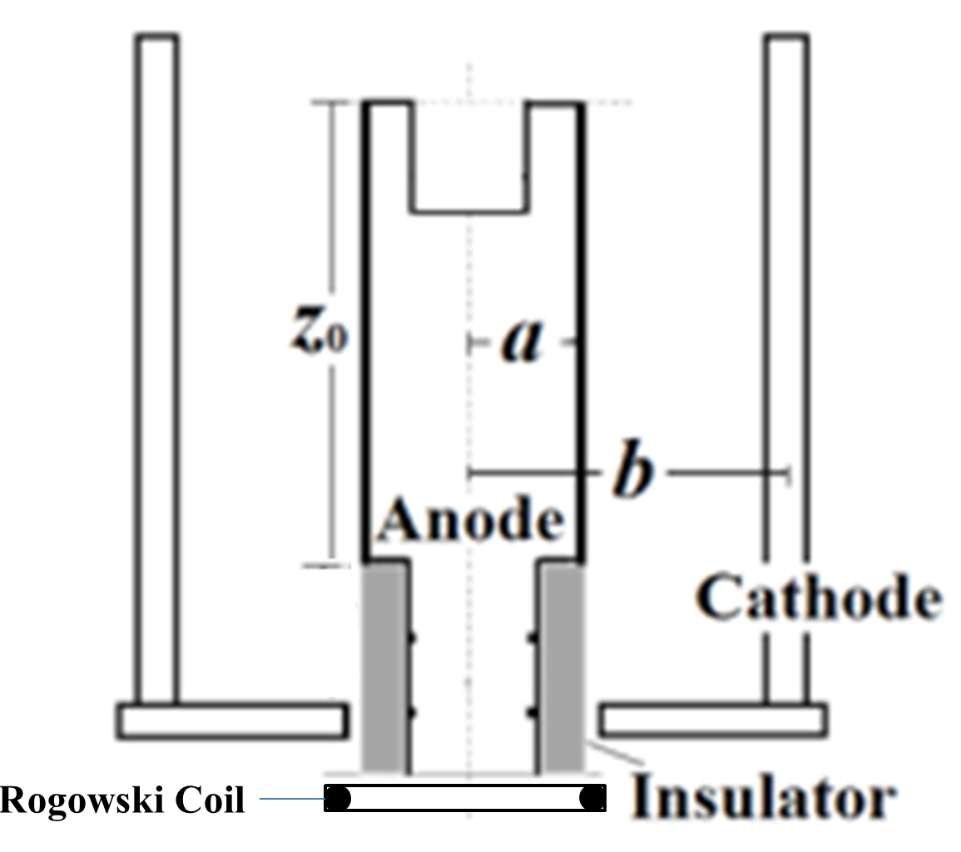  
Figure 1** The simplified electrode assembly configuration

The simplified electrode assembly configuration with the high bandwidth Rogowski Coil is shown in Figure 1. Three different electrodes were used, they are:

1. A20Z126: *a* = 20mm, *b* = 56 mm, *zo* = 126 mm
2. A26Z126: *a* = 26mm, *b* = 56mm, *zo* = 126mm
3. A40Z70: *a* = 40mm, *b* = 56mm, *zo* = 70mm

The diagnostic set up includes a Rogowski Coil, which was used to measure the electric discharge current that drives the physical processes in the NX-3 plasma focus device. These physical processes will then affect the current waveform produced – which is the most important indicator of the performance of a plasma focus device.

A mixed signal oscilloscope (Yokogawa DLM20054 2.5GS/s 500MHz) was used to capture the current trace from the plasma focus device. The data was then analyzed to fit the Lee Model.

*Fitting Procedures*

In this study, we fitted the computed current to the measured current by varying the pressure to find the optimal model parameters against pressure for the three anodes and filling gases (Ne, H2 and D2). However, note that Deuterium gas was only used for anode A20Z126 at 10kV due to experimental constraints.

The Lee Model Code RADPFV5.15 used was written in Visual basic using Microsoft Excel. The data points from the experiments carried out on NX-3 were used, and the parameters for the three anodes and filling gases can be found in Table 2 below.

|  |  |  |  |
| --- | --- | --- | --- |
| **Bank parameters** | *Lo* = 47 nH, *Co* = 100μF, *ro* = 3 mΩ | | |
| **Tube parameters** | **A20Z126**  *a* = 20mm,  *b* = 56 mm,  *zo* = 140 mm | **A26Z126**  *a* = 26mm,  *b* = 56mm,  *zo* = 140mm | **A40Z70**  *a* = 40mm,  *b* = 56mm,  *zo* = 84mm |
| **Operation parameters**: | **Neon**MW = 20, A = 10, At-Mol = 1 | | |
| *Vo* = 10kV,  *po* = 0.38 – 7.60 Torr  *Vo* = 14kV,  *po* = 0.38 – 19.00 Torr | *Vo* = 10kV,  *po* = 0.38 – 2.28 Torr  *Vo* = 14kV,  *po* = 1.52 – 3.80 Torr | *Vo* = 10kV,  *po* = 0.38 – 6.08 Torr  *Vo* = 14kV,  *po* = 0.38 – 7.60 Torr |
| **Hydrogen**MW = 2, A = 1, At-Mol = 1 | | |
| *Vo* = 10kV,  *po* = 0.38 – 7.60 Torr  *Vo* = 14kV,  *po* = 0.38 – 15.20 Torr | *Vo* = 10kV,  *po* = 2.28 – 5.32 Torr  *Vo* = 14kV,  *po* = 3.04 – 6.08 Torr | *Vo* = 10kV,  *po* = 0.38 – 7.60 Torr  *Vo* = 14kV,  *po* = 0.38 – 7.60 Torr |
| **Deuterium**MW = 4, A = 1, At-Mol = 1 | | |
| *Vo* = 10kV,  *po* = 0.76 – 4.56 Torr | **Not Experimented** | **Not Experimented** |

**Table 2** Summary of parameters used in the Lee Model Code for the study of massf and massfr with 3 anodes and 3 filling gases

We initially configured the *Lo* and *ro* as 63nH and 8.9mΩ, but it was adjusted down to 47nH and 3.0mΩ to better fit the computed current waveform to the measured current waveform. It was also found in another study that the value *Lo* measured using the ‘short-circuit’ test is an over-estimate [14]. We also adjusted the *zo* to 140mm for A20Z126 and A26Z126, and 84mm for A40Z70 as we included the length from the tip of the anode to the base of the NX-3 chamber. We also included two amendments a time shift and calibration adjusters (multiplier) to align the measured current waveform to the computed waveform more accurately.

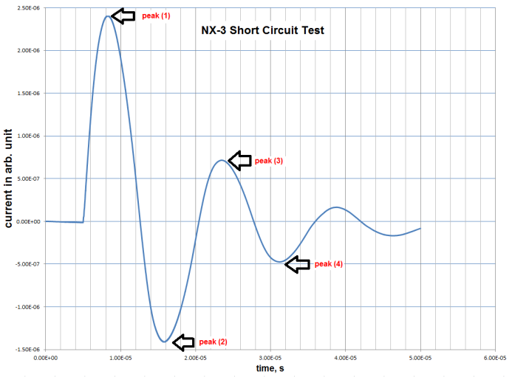

**Figure 2** Current trace for NX-3 short circuit test. This experiment was done with Neon gas at 25 mbar.

The Rogowski coil needs to be calibrated for this experiment and we did a short-circuit test to find the calibration factor. The calibration factor, *K1* can be found using the formula: ${ K}_{1}=Ȋ/V_{1}$. The actual peak current can be calculated using:

$$ȊȊ= \frac{πC_{o}V_{o}}{T}\left(1+f\right)$$

where ${ C}_{o}$ and $V_{o}$ are known capacitance and voltage,*T* is the periodic time and $f$ is the reversal ratio between voltage peaks of successive cycles in the recorded current trace. The successive cycle current trace can be found in Figure 2 above. The value of *K1* = 1.34 x 108kA/Vs was used.

$$f= \frac{1}{n-1}(\frac{V_{2}}{V_{1}} + \frac{V_{3}}{V_{2}}+…+ \frac{V_{n}}{V_{n-1}})$$

where n is the number of cycles in the signal and *V1* to *Vn* are absolute values of the decreasing amplitude of the consecutive half cycles of the Rogowski coil signal (See Figure 4).

The Rogowski coil measures the *dI/dt* of the plasma in arbitrary units, which needs to be converted to current in kA. To do this, we integrate the *dI/dt* with respect to time to obtain the *Iarb* in arbitrary units. This is then multiplied by the calibration factor, *K1* to obtain the actual current in kA. A sample of *dI/dt (arb. units)* against *t (s)* and *I (kA)* against *t(s)* graphs for Neon gas at 14kV in anode A20Z126 at 4.56 Torr are shown in Figure 3 below.

|  |  |
| --- | --- |
|  |  |
|  | |

**Figure 3** The graph on top shows the dI/dt measured using the Rogowski Coil and the right shows the I in kA after integration and multiplying by the calibration factor, K1.

With the measured current waveform obtained, we used the Lee Model Code to fit the computed current waveform to the measured current waveform. Figure 4shows the sample fitting of the current waveform.

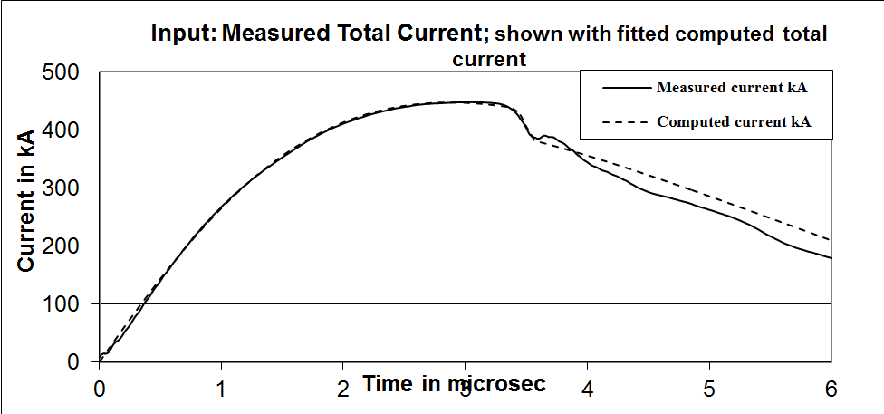

**Figure 4** Fitting of computed current to the measured current.

1. **RESULTS AND DISCUSSION**

Results are divided into three parts to correspond to the three different anodes. Results for anode A20Z126 can be found in Table 3 and Figure 5; results for anode A26Z126 can be found in Table 4 and Figure 6; results for anode A40Z70 can be found in Table 5 and Figure 7. It was found that the variation of *fm* and *fmr* was small enough (±25%) for all gases in all 3 anodes within the optimized pressure regions.

|  |  |  |  |
| --- | --- | --- | --- |
| **Filling Gas** | **Operational Voltage** | **Massf, *fm*** | **Massfr, *fmr*** |
| Neon | 10 kV | 0.044 ± 0.008 | 0.24 – 0.25 |
| 14 kV | 0.040 ± 0.009 | 0.23 – 0.25 |
| Hydrogen | 10 kV | 0.120 ± 0.015 | 0.25 – 0.35 |
| 14 kV | 0.120 ± 0.008 | 0.10 – 0.20 |
| Deuterium | 10 kV | 0.150 ± 0.040 | 0.20 – 0.25 |

**Table 3**Summary of results obtained from RADPFV5.15 of Lee Model for NX-3 for anode **A20Z126** for the optimized pressure regions.

|  |  |  |  |
| --- | --- | --- | --- |
| **Filling Gas** | **Operational Voltage** | **Massf, *fm*** | **Massfr, *fmr*** |
| Neon | 10 kV | 0.134 ± 0.027 | 0.11 |
| 14 kV | 0.117 ± 0.008 | 0.11 |
| Hydrogen | 10 kV | 0.360 ± 0.050 | 0.20 – 0.30 |
| 14 kV | 0.300 ± 0.090 | 0.300 |

**Table 4**Summary of results obtained from RADPFV5.15 of Lee Model for NX-3 for anode **A26Z126** for the optimized pressure regions.

|  |  |  |  |
| --- | --- | --- | --- |
| **Filling Gas** | **Operational Voltage** | **Massf, *fm*** | **Massfr, *fmr*** |
| Neon | 10 kV | 0.095 ± 0.015 | 0.23 |
| 14 kV | 0.078 ± 0.014 | 0.11 |
| Hydrogen | 10 kV | 0.300 ± 0.050 | 0.80 |
| 14 kV | 0.370 ± 0.050 | 0.20 – 0.30 |

**Table 5**Summary of results obtained from RADPFV5.15 of Lee Model for NX-3 for anode **A40Z70** for the optimized pressure regions.

**Figure 5** Comparison of mass factor, *fm* values obtained from calculated and measured current waveforms using Lee Model Code on NX-3 for Anode **A20Z126**.

**Figure 6** Comparison of mass factor, *fm* values obtained from calculated and measured current waveforms using Lee Model Code on NX-3 for Anode **A26Z126**.

**Figure 7** Comparison of mass factor, *fm* values obtained from calculated and measured current waveforms using Lee Model Code on NX-3 for Anode **A40Z70**.

For anode A20Z126 – from the fitting results for the 3 filling gases, we can conclude that the variation of the *fm* value with pressure is not so extensive. It was found that at high operating pressures for Hydrogen gas, the *fmr* was very large at 0.800 – 0.900.

However, it is noteworthy that *fm* for Deuterium gas at low pressures (0.38 Torr) is found to be significantly higher (0.530) compared to *fm* = 0.150 ± 0.040 found for optimized pressure regions. A similarly higher *fm* = 0.180 is needed at 0.76 Torr. It is an interesting observation, which allows us to speculate that a higher *fm* is needed for very low pressures. This may be explained by the presence of impurities in the DPF at low pressures resulting in a higher *fm*; but more experiments and analysis may be needed to confirm this.

Interesting observations were also made for Neon and Hydrogen gases. It is found that some of the measured current waveforms in low and high pressures cannot be fitted with the 5-phase Lee Model Code as it exhibited an extended dip*ED* in the current (See Figure 8).

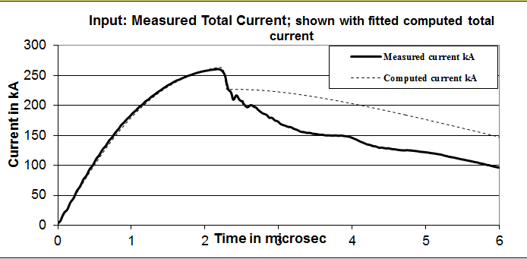

**Figure 8** Extended dip *ED* in current observerable for

Hydrogen gas at 2.66 Torr, 10kV.

This is significant as NX-3 is primarily a type T1 DPF with a small *Lo* of 47nH; but it exhibited type T2 DPF, which has a large *Lo,* characteristics which are found to have an *ED* beyond the regular dip *RD* [2]. To fit the *ED* features in the Lee Model Code, it was suggested by Lee [2] in other studies that we fit it using anomalous resistance functions to extend the 5-phase model to a 6-phase model. Extending the arguments offered in other studies, it appears that NX-3 shows T1 characteristics in the optimized regions; whereas in the less optimized region of operation (too early or too late peak currents), the focus shows type T2 characteristics. This may be explained by the amount of energy pumped into the pinch – in the optimized regions, energy is pumped efficiently into the pinch; hence, less remnant energy is available to drive later-time events such as the *ED*. In the less optimized regions, energy is not so efficiently pumped into the pinch so that there is more remnant energy, which is available for later-time events such as ‘instabilities’ leading to the observed anomalous resistance. If this explanation is correct then it could likely be applicable to all T1 (low inductance) PF devices. However, further analysis and experiments need to be conducted to study the effects of anomalous resistivity in DPF devices.

For anode A26Z126 – from the fitting results for the 2filling gases, we can conclude that the variation of the *fm* value with pressure is not so extensive. However, the *fm* for Hydrogen gas at 14kV is found to vary quite substantially, ~30%. The variation could be due to multiple reasons; one possible reason could be the large variance in plasma parameters in NX-3 after it was repaired due to a faulty electrode in the earlier firing. After the chamber was cleaned, Hydrogen gas was used first to collect data and it may have affected the data sets as a new chamber could be possibly loaded with impurities from the surrounding environment. The data for Neon gas however confirms that the variance in *fm* is within acceptable range (~6 – 20%) for this anode.

Similar observations were also made for the extended current dip *ED* in the low and high pressures for this anode and filling gases.

For anode A40Z70 – from the fitting results for the 2 filling gases, we can conclude that variation of the *fm* value with pressure is not so extensive. The variance in *fm* and *fmr* obtained for the last anode is also consistent with the previous 2 anodes. However, we note that the *fmr* for Hydrogen gas at 10kV was significantly higher (0.80). This is due to the double current peaks observed (See Fig. 9) at these discharge parameters which results in poor fitting in the Lee Model Code, similar to the extended current dip *ED* observed earlier. The phenomenon may be due to the large amount of remnant energy available to drive later-time events.

Surprisingly, the extended current dip *ED* was only observed in Hydrogen gas at 14kV in the low operating pressures. Hence, the need for further analysis and experiments to better understand how the anomalous resistance of NX-3 affects the *ED* observed in this study.

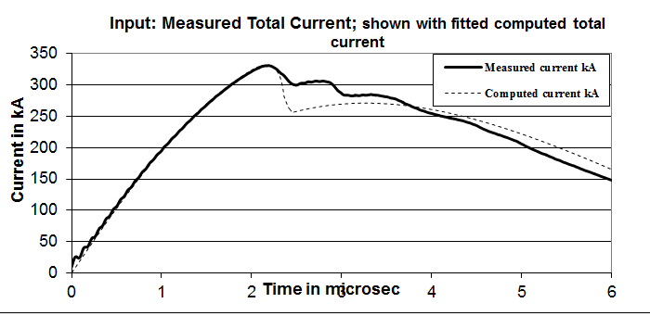

**Figure 9** Multiple current peaks observed for A40Z70 fired with Hydrogen gas at 10kV

We also note that when the 3 anode designs are viewed in comparison, it is found that the A26Z126 and A40Z70 anode designs were observed to have similar results in *fm* which is approximately 2 – 3 times the *fm* found in the A20Z126 anode design. It is a fascinating find as the A26Z126 and A20Z126 anode designs are more similar in dimensions which should provide with similar *fm* values; but it is found in this study that the slightly wider anode may exhibit plasma characteristics similar to A40Z70 anode design.

1. **CONCLUSION**

In this study, we have used Lee Model Code RADPFV5.15 to fit the computed current waveforms to the measured current waveforms for NX-3 to find the model parameters versus the different filling gases (Ne, H2and D2) using 3 different anode designs. For all 3 anode designs, we obtained a good fit for allfeatures at the optimized region of operation. In the first design A20Z126, we found that Neon gas has a value of *fm* = 0.042 ± 0.0085, Hydrogen gas has an *fm* = 0.120 ± 0.012, and Deuterium has a *fm* = 0.150 ± 0.040. For anode design A26Z126, we found Neon gas has a value of *fm* = 0.126 ± 0.020, and Hydrogen gas has *fm* = 0.330 ± 0.073. For the final anode design A40Z70, Neon gas has a value of *fm* = 0.087 ± 0.015, and Hydrogen gas has an *fm* = 0.335 ± 0.050. The *fmr* was generally constant within each anode, filling gas and operational voltage, and the values for *fc* and *fcr* were kept constant at 0.7.We also found that the current waveforms exhibited an extended dip *ED* which is beyond the regular dip *RD* modeled in the Lee Model Code in less optimized regions of operations (very low and very high pressures). There is scope for more research and analysis to understand how anomalous resistance affects the extended dip *ED* in NX-3 which is primarily a type T1 plasma focus device but exhibiting type T2 characteristics in less optimized regions of operations.

|  |  |
| --- | --- |
| **REFERENCES** | |
| [1] | S. Lee (2010) ‘Radiative Dense Plasma Focus Computation Package:RADPF’. (archival website 2013)  <http://www.plasmafocus.net/IPFS/modelpackage/File1RADPF.htm> |
| [2] | S.Lee, S.H. Saw, A.E. Abdou, H. Torreblanca. “Characterizing plasma focus devices – role of the static inductance – instability phase fitted by anomalous resistances.” Journal of Fusion Energy 30 (4): p277 (2011).doi: 10.1007/s10894-010-9372-1 |
| [3] | S. Lee, T.Y. Tou, S.P. Moo, M.A. Elissa, A.V. Gholap, K.H. Kwek, S. Mulyodrono, A.J. Smith, Suryandi, W. Usada, M.Zakaullah. “A simple facility for the teaching of plasma dynamics and plasma nuclear fusion.” American Journal of Physics.**56**: 62-28 (1998). |
| [4] | S. Lee, “A sequential plasma focus.” IEEE Transactions Plasma Science.**19**: 912-919 (1991). |
| [5] | L. Mahe, “Soft X-rays from compact plasma focus.” PhD Thesis, School of Science, Nanyang Technological University, December 1996, Chapter 5, pp 143. |
| [6] | Siahpoush V., Tafreshi M. A., Sobhanian S., and Khorram S., “Adaptation of Sing Lee’s model to the Filippov type plasma focus geometry,” *Plasma Phys. Control. Fusion*, 2005, *47*, no.7, 1065–1075 |
| [7] | S. H. Saw, P. Lee, R.S. Rawat, S. Lee. “[Optimizing UNU/ICTP PFF Plasma Focus for Neon Soft X-ray Operation](http://ieeexplore.ieee.org/xpl/articleDetails.jsp?tp=&arnumber=5072258&contentType=Journals+%26+Magazines&sortType%3Dasc_p_Sequence%26filter%3DAND%28p_IS_Number%3A5154036%29).”IEEE Transactions Plasma Science.37 (7): 1276-1282 (2009). |
| [8] | S. Lee, P. Lee, S.H. Saw, R.S. Rawat. “Numerical experiments on plasma focus pinch current limitation.” Plasma Physics Control Fusion 50 (6). 065012 (2008) |
| [9] | M. Akel, Sh. Al-Hawat, S.H. Saw, S. Lee. “Numerical experiments on Oxygen soft X-Ray emissions from low energy plasma focus using Lee Model.” Journal Fusion Energy.29 223-231 (2010). |
| [10] | S. Lee, S.H. Saw, P. Lee, R.S. Rawat, H. Schmidt. “Computing plasma focus pinch current from total current measurement.”Applied Physics Letters 92 (11) 111501 (2008). |
| [11] | SP Chow, S Lee, BC Tan, Current sheath studies in a co-axial plasma focus gun, Journal of Plasma Physics 8 (1), 21-31 (1972) |
| [12] | TY Tou, S Lee, KH KwekNonperturbing plasma-focus measurements in the run-down phase, IEEE Transactions on Plasma Science, 17 (2), 311-315 (1989) |
| [13] | Sh. Al-Hawat, M. Akel, S. Lee, S.H. Saw. “Model parameters versus gas pressures in two different plasma focus devices operated in Argon and Neon.” Journal of Fusion Energy 31: 13-20 (2012). doi:10.1007/s10894-011-94 |
| [14] | S. H. Saw, S. Lee, F. Roy, P. L. Chong, V. Vengadeswaran, A. S. M. Sidik,Y. W. Leong, and A. Singh. “In situ determination of the static inductance and resistance of a plasma focus capacitor bank.”Review of Scientific Instruments **81**, 053505 (2010) |



**BIOGRAPHIES OF AUTHORS**

**Muhammad Rasyid** is currently in his 4th year of the B.Sc. (Ed) program in Nanyang Technological University (National Institute of Education). He is currently a General Education Officer with the Ministry of Education. His teaching subjects include secondary level Physics and English Language.

**Sing Lee** received the B.Sc. and M.Sc. degrees from the University of Malaya (UM), Kuala Lumpur, Malaysia, in 1964 and 1966, respectively and the Ph.D. degree from the Australian National University, Canberra, Australia, in 1970. He was a Professor of Applied Physics and headed research groups in Plasma and Pulse Technology and the Physics Department at UM and was Head of Division of Physics and Head Academic Group of Natural Sciences at Nanyang Technological University, National Institute of Education, Singapore. He was Alexander von Humboldt Fellow (1975–1976) at Kernforschunglange, Juelich, West Germany, Commonwealth Academic Staff Fellow (1981–1982) at Imperial College, London, and Visiting Professor and United Nations University Special Fellow (1986–1987) at Flinders University of South Australia. He was the Founder President of the Asian African Association for Plasma Training (AAAPT), the Associate Director of the AAAPT Research and Training Centre of the Institute of Physics, Academia Sinica, Beijing, Far Eastern Representative of the International Centre for Theoretical Physics; and ardent advocate and implementer of south–south technology creation and transfer, especially in plasma fusion, laser, and pulse technology. A Chartered Physicist and Fellow of the Institute of Physics (U.K.), Life and Hon Fellow of the Institute of Physics Malaysia, and Life Fellow of the Singapore Institute of Physics and the Samahang Pisikang Pilipinas, he is the Founder Principal of the (web-based) Institute for Plasma Focus Studies, Melbourne, Adjunct Professor (honorary) INTI International University, Malaysia and Emeritus Professor at University of Malaya, Malaysia.

**R S Rawat** received the B.Sc. (Hons), M.Sc. and Ph.D. degrees from University of Delhi, Delhi, India in 1985, 1987 and 1994 respectively. He is presently an Associate Professor with National Institute of Education, Nanyang Technological University, Singapore. His current research interests include development of repetitive miniature plasma focus device as portable neutron source, charged particle and radiation emission from focus devices for nano-phase material synthesis, ion-implantations and lithography applications and magnetic nanoparticles/nanocomposites and dilute magnetic semiconductor thin films of transition metal doped ZnO using pulsed laser depositions. He has authored 136 research papers in journals of international repute and about 63 research papers in conference proceedings. He is currently honorary secretary of Asian African Association for Plasma Training and honorary secretary of Institute of Physics, Singapore.

**Augustine Tuck Lee Tan** received the Ph.D. degree from the National University of Singapore (NUS), Singapore, in 1993.

During the Ph.D. program, he worked with Herzberg Institute of Astrophysics, Ottawa, ON, Canada, for eight months, and at the University of Washington, Seattle, in high-resolution infrared spectroscopy of gases of atmospheric interests. He spent two years of postdoctoral research with the Department of Physics, NUS. Later, he worked for four years as a Senior Engineer in photolithography, and plasma etching of III–V semiconductor materials in Hewlett-Packard, Singapore and San Jose. He is currently with the Natural Sciences and Science Education, National Institute of Education (NIE), Nanyang Technological University, Singapore. He currently teaches undergraduate and graduate academic subjects such as optics, waves, molecular spectroscopy, biological materials, and gemmology. Since 2005, he has been appointed as Associate Dean, Academic Research, with NIE. He is experienced in wafer fabrication technology, and failure analysis techniques of Fourier transform infrared (FTIR) spectroscopy, SEM, TEM, XPS, and EDXF. He is currently involved in microlithography using soft X-rays from dense neon and argon plasma focus with the Plasma Laboratory, NIE. Furthermore, he is researching on high- resolution FTIR spectroscopy of gaseous molecules, and in gemmology. Since 1991, he continues to be actively researching on FTIR spectroscopy of gases in collaboration with NUS and Jet Propulsion Laboratory, California Institute of Technology, Pasadena, CA. He is the author of 125 papers in international journals of U.S. and U.K., including three in Physical Review (U.S.). He is a member of the Institute of Physics, Singapore, an external reviewer of research grants, an examiner of Ph.D. theses, and a research mentor to secondary schools and colleges.

**Leonard Ngoei** is currently in his 4th year of the B.Sc. (Ed) program in Nanyang Technological University (National Institute of Education). He is currently a General Education Officer with the Ministry of Education. His teaching subjects include secondary level Physics and Chemistry.

**Paul Lee** received the B Sc (Hons) (1992) and PhD (1996) from University of London (Imperial College) and PGDipTHE (1999) from Nanyang Technological University. He is currently an Associate Professor at the Nanyang Technological University (National Institute of Education). He was visiting Associate Professor at University of Washington, Seattle and Technological Educational Institute, Crete during 2007. His current research interests include plasma physics, materials science and physics education.

**LIST OF TABLES**

|  |  |
| --- | --- |
| **Item** | **Page** |
| **Table 1** Parameters for Lee Model | 2 |
| **Table 2** Summary of parameters used in the Lee Model Code for the study of massf and massfr with 3 anodes and 3 filling gases | 2 |
| **Table 3** Summary of results obtained from RADPFV5.15 of Lee Model for NX-3 for anode A20Z126 for the optimized pressure regions. | 4 |
| **Table 4** Summary of results obtained from RADPFV5.15 of Lee Model for NX-3 for anode A26Z126 for the optimized pressure regions. | 4 |
| **Table 5** Summary of results obtained from RADPFV5.15 of Lee Model for NX-3 for anode A40Z70 for the optimized pressure regions. | 4 |

**LIST OF FIGURES**

|  |  |
| --- | --- |
| **Item** | **Page** |
| **Figure 1** The simplified electrode assembly configuration | 2 |
| **Figure 2** Current trace for NX-3 short circuit test. This experiment was done with Neon as at 25 mbar | 3 |
| **Figure 3** The graph on the top shows the *dI/dt* measured using the Rogowski Coil and the right shows the *I* in kA after integration and multiplying by the calibration factor, *K1* | 3 |
| **Figure 4** Fitting of computed current to the measured current | 3 |
| **Figure 5** Comparison of mass factor, *fm* values obtained from calculated and measured current waveforms using Lee Model Code on NX-3 for Anode A20Z126 | 4 |
| **Figure 6** Comparison of mass factor, *fm* values obtained from calculated and measured current waveforms using Lee Model Code on NX-3 for Anode A26Z126 | 4 |
| **Figure 7** Comparison of mass factor, *fm* values obtained from calculated and measured current waveforms using Lee Model Code on NX-3 for Anode A40Z70 | 4 |
| **Figure 8** Extended dip *ED* in current observerable for Hydrogen gas at 2.66 Torr, 10kV | 4 |
| **Figure 9** Multiple current peaks observed for A40Z70 fired with Hydrogen gas at 10kV | 5 |