[1]

Neutron Emission Characteristics of NX-3 Plasma Focus Device: Speed Factor as the Guiding Rule for Yield Optimization

Rishi Verma, R. S. Rawat, P. Lee, T. L. Tan, Hashim Shariff, J. Y. Goh, S. V. Springham, A. Talebitaher, Usman Ilyas, and A. Shyam

***Abstract*—This paper reports the results of characterization and optimization experiments carried out on a newly developed NX-3 dense plasma focus device (20 kJ @ 20kV, quarter time period of ~3μs and 10kJ/600kA @ 14kV) at Plasma Radiation Source Lab, NIE, Nanyang Technological University, Singapore. Initial experiments were conducted with an electrode assembly configuration having anode radius and length of 20 and 160 mm respectively for detailed neutron emission characterization of NX-3 device followed by further optimization of neutron yield using various other electrode configurations designed using Lee Code. At ≥10kJ operation, the average neutron yield of the order of 109 neutrons/pulse in 4πsr were obtained for the deuterium filling gas pressure range of 6 to 8mbar. The neutron yield of ~4.6×109 neutrons/pulse at 10kJ/6mbar is highest ever reported for a device with the same stored energy. The neutron anisotropy measurements points to the beam target mechanism as the dominant neutron production mechanism for NX-3 plasma focus device. Further optimization of neutron yield in NX-3 was achieved with the peak average neutron yield being enhanced from ~(2.38±0.31)×109 neutrons/shot for initial electrode configuration to about ~(3.40±0.43)×109 neutrons/shot for the electrode configuration with anode radius and length of 26 and 140mm respectively. The analysis of neutron yield results for various electrode assembly configurations demonstrates the speed factor as a key optimization tool for maximization of neutron yield.**

*Index Terms*—dense plasma focus, neutron yield, anisotropy, speed factor

# Introduction

s

ince its conception in early 1960’s, the dense plasma focus (DPF) device has been recognized as an intense source of energetic ions, electrons, soft/hard x-rays and neutrons (when operated with deuterium). The operation of plasma focus device involves the transfer of electrical energy stored in the capacitor bank across the coaxial cylindrical electrodes assembly (i.e. central anode and outer cathode) in a gas filled chamber which results in initiation of discharge along the surface of an insulator sleeve at closed end of the coaxial electrode assembly. In due course of time an axisymmetric current sheath is formed which then accelerates axially and finally converges radially in on the axis of the anode until a minimum radius is reached resulting in the formation of magnetically compressed short-lived (~50 – 100ns), high temperature (1 – 2keV), and dense (~1019-20 cm-3) pinched plasma column (focus). The short-lived pinched plasma column is soon disrupted by the rapid growth of magneto-hydrodynamic (MHD) instabilities. Coincident with this disruption, bursts of ions, electrons, soft/hard x-rays and neutrons are produced [1].

In the recent years, due to diversified potential applications of neutron sources in the noninvasive interrogation of explosives and narcotic drugs by using Pulsed Fast/Thermal Neutron Analysis (PFTNA) technique [2], thermonuclear reactor wall material studies [3], dark matter research [4], radioisotope production [5], medical neutron therapy [6] and soil humidity measurements [7]; there has been an fast growing demand of efficient commercially viable pulsed neutron sources with appreciable flux. Amongst various competing technologies [8,9] dense plasma focus (DPF) device based pulsed neutron sources have evolved as relatively most simple, reliable and long lasting alternative. Realization of this fact has revitalized research and development of plasma focus device in wide energy range by various research groups across the globe [10-13]. In order to make plasma focus devices useful, for the widest possible range of applications, it is mandatory to have sufficient time averaged neutron flux, typically in the order of 107 – 1010 n/s [14], by operating the device either in single shot or in repetitive mode [15,16]. To meet such requirement of high flux, reliable neutron source that can be used for applied research, a 20kJ plasma focus device named NX-3 has been developed at Plasma Radiation Sources Lab, National Institute of Education, Nanyang Technological University, Singapore.

For a given device, the neutron emission depends on the specific design and operating parameters of the DPF. This includes configuration, shape and material of the electrode assembly, insulator shape and material, stored energy, discharge current, gas composition and the filling gas pressure. In this paper, along with detailed description of system hardware, design and construction, we present the neutron emission characteristics of newly developed NX-3 dense plasma focus device for various electrode assembly configurations with an aim of device optimization and to explore the correlation between the neutron yield and the speed factor [17].

# NX-3 Plasma Focus Device: Electrical Layout, Electrode Assembly And Diagnostics Arrangement

## Electrical Layout and Characteristics of NX-3 DPF Device

The NX-3 plasma focus device is driven by a 100μF, 20kJ modular capacitor bank. It comprises of eight parallely connected, 2.5kJ (12.5μF, 20kV, 80% reversal, 150 kA) low inductance (<40nH) metal-can capacitors (#SM203YW012H procured from Aerovox Corp., USA), arranged in modular fashion. The quarter time period of the discharge current is ~3μs. For rapidly transferring the energy stored in capacitors to the DPF load, 150kA/20kV hold-off pseudospark (PS) switches (model #TDI1-150k/25 procured from M/s Pulsed Technologies Ltd., Russia) [16] have been installed on each capacitor. The specified inductance and jitter of PS switch is ≤20nH and ≤3ns. It may be noted that unlike pressurized sparkgap switches, pseudospark switch (PS) is a sealed low pressure-switching device with cold cathode. Similar to the classical hydrogen (H2) thyratron, the range of operating pressure for the pseudospark switch corresponds to the conditions of the left side of the Paschen curve, where the electron free path for ionization is much in excess of the main electrode separation. Pseudospark switches have sealed stacked ceramic-metal construction, with H2 as a buffer gas in the pressure range 0.2 to 0.6 mbar (in operational mode). The H2 pressure inside switch is adjusted by varying H2 generator heater current. Pure hydrogen is the most preferred gas in energy transfer switches due to following reasons: (i) fastest turn-on compared with other pure gases and their mixtures, (ii) fastest recovery that facilitates highest repetition rate, and (iii) lowest electrode-erosion rate. The synchronized operation of PS switches for all eight modules was achieved using an indigenously designed 8-Channel reservoir heating system (for controlling the Hydrogen gas pressure inside each of the PS switches) and a high performance 8-Channel Blumlein pulser based triggering system of low rise time (<10ns) and low jitter (±1ns).

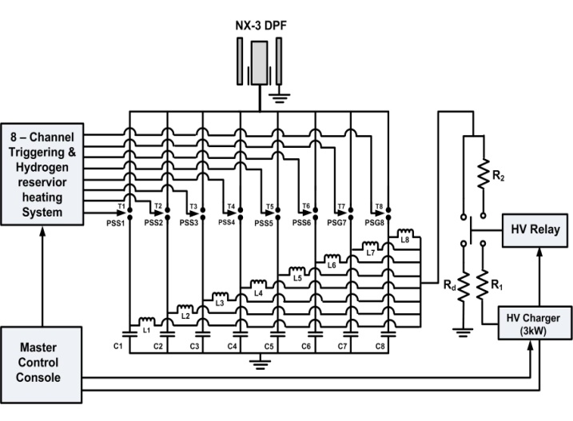

Fig.1. ScematicReperesentation of main electrical circuit in NX-3 DPF device.

The schematic representation of main electrical circuit for NX-3 device is shown in Fig. 1. The eight modules of capacitor bank (C1 – C8) are individually attached with eight in-line single pseudospark switches (PS1 – PS8). On the high voltage side, the eight-capacitor modules are charged in parallel by the constant power charger ‘RCS 3000’ (procured from M/s Converter Power Inc., USA). The trigger inputs (T1 – T8) are used to simultaneously switch all the PS switches to discharge the stored energy of modules (C1 – C8) into the plasma focus load. To protect the charger from high reverse voltages exceeding the maximum ratings, two resistors R1 and R2 (1kΩ, 300W) are used in the charging circuit. The eight inductors, L1 – L8 (of 360μH each), in the charging path of capacitors have the specific function of isolating the modules during discharge. Under the situation when one of the switches fails to fire, the fault current is lowered because of the large inductance in the discharge path and thus the chances of cross flow of energies in-between the modules is avoided. The function of the high voltage (HV) relay (model #E30-DT-40-1-31-BD procured from M/s Ross Engg. Corporation, CA, USA) is to connect charging terminals with capacitor bank, only when charging command is enabled else all the capacitors are in dump mode by default.

The connections between the capacitors to PS switches and PS switches to DPF load were done using suitable combinations of rigid transmission lines in coaxial/parallel plate geometry and parallel coaxial cables to achieve optimized electrical characteristics, ease and flexibility of connectivity and the best utilization of available limited space. For interconnection between capacitor and PS switch, an individual PS switch is rigidly mounted over capacitor head in the coaxial geometry so as to minimize the connection inductance and ensure symmetric flow of the discharge current. For connecting each of the modules to the collector plate assembly of the DPF device, eight numbers of 3 meter long URM67 cables (with rated inductance of ~250nH/m) were used in parallel. The collector plate assembly of DPF device, which provides mounting platform for DPF coaxial-electrode assembly and DPF vacuum chamber, is a parallel plate configuration and accepts 64 nos. of URM67 coaxial cables coming from eight different modules (i.e. 8 cables from each module). In between the plates, 5mm thick Teflon sheet has been used for insulation. The assembled collector plate assembly is depicted in NX-3 experimental setup shown in Fig. 2. The termination of cables (coming from various modules) underneath the collector plate assembly is also shown in the inset. The measured total inductance, contributed by: capacitor bank + transmission lines + switch + focus tube is about 54±2nH.

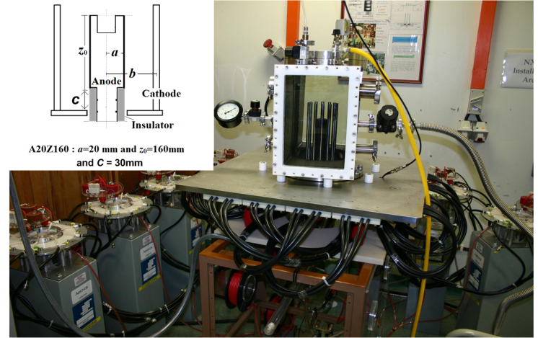

Fig.2. The newly commissioned NX-3 plasma focus device. The inset shows the electrode assembly configuration A20Z160.

## The Electrode Assembly

*1) Initial Electrode Assembly Dimensions*: According to Lee and Serban [17] most of the neutron optimized plasma focus devices have the typical speed factor *s*, with  (where, is the peak discharge current in kA, is the anode radius in cm and is the filling gas pressure in Torr), of about 89±8 kA cm-1 Torr-1/2. Hence by using the short circuit peak discharge current measured by current probe and by approximating a deuterium operating pressure (in the range of 5 – 10mbar), the preliminary value of anode radius is obtained. Based on the quarter time period of the discharge current, which represents the time for the discharge current to reach the maximum value, the approximate anode length (*Za*) was estimated using the relation  where *va* and *vr* represent the typical axial and radial speeds of current sheath in axial and radial phases having typical values of about 10 and 25 cm/µs, respectively [18].

The initial coaxial electrode assembly of the NX-3 plasma focus head consists of a cylindrical anode of stainless steel (SS) having length (*z*) of 160mm, radius (*a*) of 20mm and a squirrel cage cathode, consisting of twelve, 12mm diameter brass rods, uniformly spaced on a coaxial circle of radius (*b*) of 51mm. This electrode assembly is named as A20Z160 (where A and Z symbolize anode radius and length in mm) and can be seen in the inset of the photograph shown in Fig. 2. A 60mm deep cavity of 32mm diameter was bored at the center of anode to reduce the ablated metal impurity during the pinch phase. An insulator sleeve of Pyrex glass with a breakdown length of 30mm was placed between the anode and cathode. The inner and outer diameter of insulator sleeve is 33mm and 40mm, respectively.

*2) Other Electrode Assembly Configurations for Further Optimization and Investigation of Correlation between Speed Factor and Neutron Yield for NX-3*: While the experiments were being conducted and analyzed using initial electrode assembly configuration A20Z160, the further optimization of NX-3 neutron yield and an investigation of finding the correlation between the speed factor and the neutron yield were planned. For this purpose, various electrode configurations were finalized using the Lee Code [19, 20] using the electrical parameters of NX-3 device and some simple assumptions. The quarter time period of NX-3 PF device (~ 3µs) is similar to that of the UNU-ICTP PF device [17, 19] and hence it was assumed that the Lee Code model parameters of mass and current shedding factors [19, 20] for NX-3 device are similar to both of these devices. Various electrode configurations were finalized in such a way that the Lee Code simulations allow the operation of device over different speed factors and the simulated neutron yields remain within a factor of 2 for all configurations. The dimensional details of all electrode assembly configurations (A20Z160, A26Z160, A55Z160, A20Z140, A26Z140 and A55Z70) along with Lee Code simulated neutron yields are given in Table I. The cathode radius, *b*, was increased to 81mm for A55Z160 and A55Z70 configurations to accommodate the 55mm radius anode.

*C. Diagnostics Setup for NX-3*

The employed diagnostics includes – (i) Rogowski Coil: The fast electric discharge current drives all physical processes in the plasma focus device; in turn all physical processes in the focus affect the current waveform [21]. Thus discharge current waveform is the most important indicator of plasma focus performance and was measured using a high bandwidth Rogowski coil. (ii) 3He proportional counter for neutron yield measurement: A high sensitivity 3He proportional counter was used for the measurement of neutron output in 4πsr. A 3He neutron detector tube #2533 (from LND Inc., USA) placed inside a cylindrical polyethylene moderator of 8cm thickness (estimated using MCNP i.e. Monte Carlo N-Particle Transport Code) was used for D-D neutron yield measurement. (iii) Beryllium activation counters for measuring anisotropy in neutron

Table I

Different electrode assembly configurations and corresponding optimum neutron yields obtained using Lee Code (based on the current and mass factors from UNU-ICTP device) along with their experimentally measured yields

|  |  |  |  |  |  |
| --- | --- | --- | --- | --- | --- |
| Anode Design | Anode radius  (*a*) | Anode Length  (*z*0) | Cathode Radius  (b) | Optimum Neutron Yield by Lee Code  (neutrons/pulse) | Experimentally measured optimum Neutron Yield (neutrons/pulse) |
| A20Z160 | 20 mm | 160 mm | 51 mm | 6.7×108 | (2.4±0.3)×109 |
| A26Z160 | 26mm | 160 mm | 51 mm | 7.0×108 | (2.5±0.2)×109 |
| A55Z160 | 55mm | 160 mm | 81 mm | 3.9×108 | (1.1±0.1)×107 |
| A20Z140 | 20 mm | 140 mm | 51 mm | 6.8×108 | (1.5±0.1)×109 |
| A26Z140 | 26 mm | 140 mm | 51 mm | 8.0×108 | (3.4±0.4)×109 |
| A55Z70 | 55 mm | 70 mm | 81 mm | 7.3×108 | (1.1±0.6)×109 |

yield: A calibrated pair of identical size Beryllium activation counters was used for measuring anisotropy in neutron yield. The details of beryllium activation counter are provided elsewhere [22]. (iv) Scintillator photomultiplier detectors (Plastic and CsI) for time resolved measurements: For the time resolved measurements of neutrons and hard x-rays emission, combination of two different scintillators NE-102A (diameter – 52mm, thickness – 40mm) and CsI (diameter – 50mm, thickness – 50mm) were used along with 14-stage high gain photo-multiplier tube EMI 9813BK. The CsI scintillator, in combination with NE-102A plastic scintillator, was to unambiguously discriminate hard x-ray and neutron peaks as CsI has very low cross section for fast neutrons but reasonably high cross section for hard x-rays having energy in the range of 15 – 150keV. The greater details of these diagnostics can be found elsewhere [10, 15, 16, 21, 22].

# Results and Discussion

This section is divided into two sub-sections: the first subsection reports the results and discussion for initial electrode assembly configuration of A20Z160 and second subsection reports the neutron yield and its correlation with speed factor for various electrode configurations.

## Neutron Yield, Stability and Anisotropy for A20Z160 Electrode Assembly Configuration

The performance of the NX-3 device, with A20Z160 electrode assembly configuration, was investigated for the single shot operation mode for the charging voltage and deuterium filling gas pressure in the range of 12 to 15kVand 3 to 10mbar, respectively. For reducing the effect of contamination on radiation yields, the gas was refreshed after every five shots. Neutron yield measurements were done by using the 3He detector placed at a distance of 1.5m in the side-on direction. The measured average neutron yield and time to pinch (defined as the time from breakdown to the pinch formation) at different D2 gas pressures for A20Z160 are shown in Fig. 3 and 4, respectively. It may be noted from the results depicted in Fig. 3 and 4 that the neutron yield increased with the increase in charging voltage as the stored energy as well as the peak discharge current flowing through the system increased. The neutron yield maximized at 15kV, ~8mbar D2 filling gas pressure producing the average maximum neutron yield of about (2.8±0.3)×109 neutrons/shot. Recently, from a compilation of experimental data over a wide range of energies, neutron yield scaling has been thoroughly reviewed by S. Lee *et al.* [23], using the five-phase Lee model (RADPFV5.13) [19], and found to follow Yn~ (3.2×1011)×Ipinch4.5where Ipinch is the pinch current that actually participates in the focus pinch phase. Following this latest scaling law, with the estimated pinch current of ~330kA (from Lee model [19]) at ~15kV discharge, the expected yield is about ~2×109 neutrons/shot. This is in the same order as measured experimentally.The time to pinch, being 3.3±0.1μs at ~8mbar was found consistent with the quarter time period of the capacitor bank (i.e. ~3.0μs under short circuit condition) and ensured the matching of anode design parameters with electrical discharge characteristics of NX-3 device. It may be noted that, each of the data points shown in the respective graphs is an average of 5 plasma focus shots.

The neutron yield trends at various operating voltage/stored energy show that besides an optimum pressure that produces maximum neutron yield, there also exists upper and lower pressure limits for neutron production. This can be explained using the effect of ambient gas pressure on thermonuclear and beam target mechanisms. From a thermonuclear point of view [24], the optimum neutron yield can be achieved provided the peak current occurs simultaneously with pinch. This condition was shown to have the interdependence among anode length, charging voltage and filling gas pressure. If two of the parameters are kept fixed, then the third can be fine tuned to satisfy the condition for obtaining the optimum yield. Moreover, logically, the initial increase in filling gas pressure increases the plasma density in the pinch, increasing thereby the reaction rate probability and the neutron yield. But beyond a critical pressure (which depends on the other operating parameters of the focus machine) increasing the pressure does not increase the neutron yield as the time to pinch increases further and the pinch does not occur simultaneously with peak current resulting in lower heating of the pinch plasma and thus lowering of neutron yield. The growth time  of the Rayleigh-Taylor (RT) instability in accelerated dynamic pinches is given by , where  is the sheath acceleration and  is the dominant wavelength of perturbation [25]. In this relation, it may be noted that instability growth time varies inversely with sheath acceleration. At lower pressures since the sheath acceleration becomes very high therefore the RT instability develops so rapidly that it prohibits even the formation of a well defined pinched plasma column that leads to inefficient beam-target interaction and hence poor neutron yield. Near the optimum operating pressure, the current sheath acceleration is adequate for efficient instability formation. This results in strong instability generated deuteron beam resulting in higher neutron yield by efficient beam-target mechanism [26].

Since gradual degradation in neutron yield with the subsequently increasing number of shots during the run is a widely evidenced fact in all energy ranges of plasma focus devices, the reproducibility of neutron yield performance in NX-3 plasma focus device was also investigated. Fig. 5 shows the bar plot of the neutron yields for a sequence of 30 shots in the purging and non-purging mode. In purging mode, the evacuation (up to ~10-4 mbar) was done after every sequence of five consecutive shot and then the chamber was refueled with pure D2 for the next series. In the non-purging mode, the chamber was evacuated only once before starting series of discharges and then all 30 consecutive shots were taken under static gas fill conditions. While operating the device in either mode inter-shot interval of ~1 minute was maintained to allow temperature relaxation. The charging voltage and D2 filling gas pressure was kept fixed at ~14kV/6mbar through out this investigation.

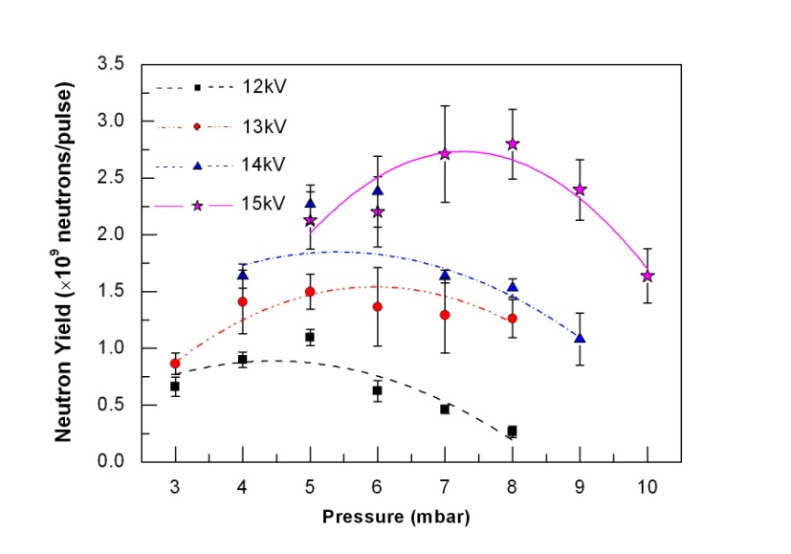

Fig.3. Average neutron yield at different charging voltages and D2 gas filling pressures for A20Z160 electrode assembly configuration.

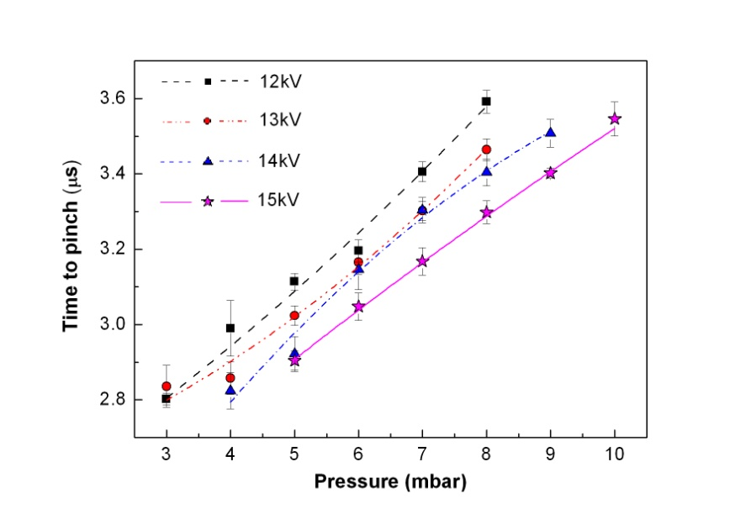

Fig.4. Average time-to-pinch at different charging voltages and D2 gas filling pressures for A20Z160 electrode assembly configuration.

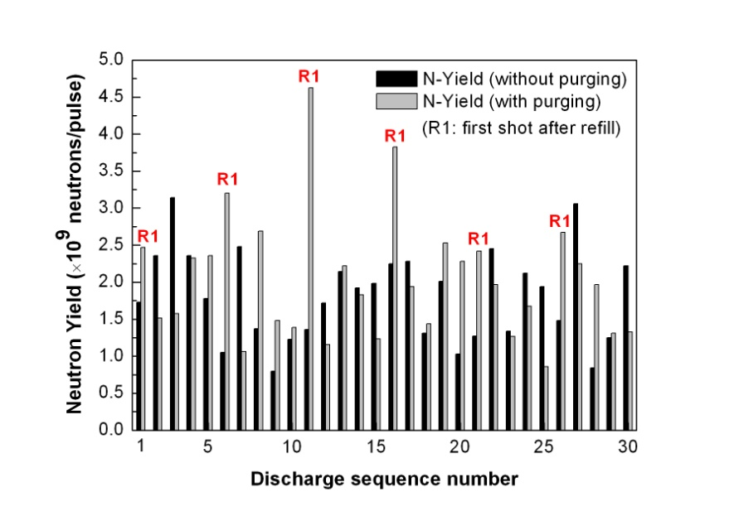

Fig.5. Bar plot of neutron yields obtained for purging and non-purging mode of operation at 14kV/6mbar.

It may be observed from the results shown in Fig. 5 that in the purging mode of operation, the first shot of five shot sequence always gave the maximum yield (refer the neutron yields of 1st, 6th, 11th, 16th, 21st and 26th shots designated as R1 in the graph). A record yield of ~4.7×109 neutron/pulse may also be noted on the 11th shot. The relative comparison of neutron yields reported by various

Table II

Relative comparison of *Eo* and *N* reported by various laboratories.

|  |  |  |
| --- | --- | --- |
| Laboratories | Energy/ *Eo* (kJ) | Neutron Yield/ *N* (neutrons/pulse) |
| Los Alamos [27] | 12 – 38 | (4 – 20)×109 |
| Limeil [28] | 16.4 – 48 | (2.5 – 12)×109 |
| Culham [29] | 27 – 51 | (1 – 7)×109 |
| Nashville [30] | 25 | (2.4 – 10)×109 |
| NX–3 [this work] | 10 | (1 – 4.7)×109 |

laboratories [27-30] of their plasma focus devices operating in the similar energy range as that of NX-3 device has been indicated in Table II.The trend of slight degradation in neutron yield in subsequent shots (after the first shot) remains consistent throughout. Conversely, in non-purging mode (i.e. under the static gas fill condition) no specific trend in the neutron yield fluctuation was observed. The average neutron yield of 30 shots was ~(2±0.2)×109 neutron/pulse for the purging mode; and ~(1.8±0.1)×109 neutron/pulse for non-purging mode. The minor reduction in average neutron yield for longer shot sequence may be attributed to the contamination of the fuel gas due to significant anode material ablation by the high current discharge in large plasma focus devices.

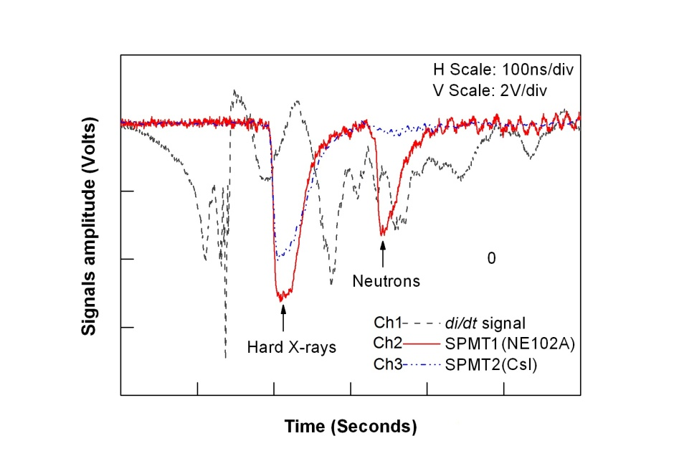

Fig.6. Oscilloscope traces of (i) current derivative signal on Ch1 from Rogowski coil, and (ii) hard x-ray / neutron signal on Ch2 from SPMT1 and on Ch3 from SPMT2. Note: Horizontal (H) scale is 100ns/dv and Vertical (V) scale is 2V/div.

The oscilloscope traces of the typical signals (Ch2 and Ch3) from the scintillator-photomultiplier detectors SPMT1 (having NE102A plastic scintillator) and SPMT2 (having CsI inorganic scintillator) and the corresponding current derivative signal (Ch1) measured by the Rogowski coil, for a typical shot at 15kV/ 8mbar D2 filling gas pressure are collectively shown in Fig. 6. Both the scintillator photomultiplier detectors were placed in the side-on direction at the same distance of 3m from the plasma focus. For avoiding saturation of the signals, the SPMT’s were screened using 8mm lead sheets. Two distinct peaks were observed in the SPMT signals (Ch2 and Ch3) with a time difference of ~140ns between them. The first peak is of non-thermal, hard x-rays produced by the interaction of instability generated energetic electrons with the stainless steel anode, whereas the second peak was confirmed to be due to neutrons on the basis of time of flight separation. The coincident and overlapping trace of SPMT2 detector signal on the SPMT1 detector signal also confirmed the identity of hard X-ray and neutron peak. The relatively lower cross section of CsI scintillator for neutrons is evident in the corresponding trace. The typical durations of hard X-ray and neutron pulses (estimated from full width at half maximum i.e. FWHM) were 50±7ns and 40±5ns (assuming that majority of emitted neutrons have typical energy ~2.45MeV).

In order to match the timing of SPMT signals, identical lengths of double-shielded coaxial cables were used for signal transport. The delay of ~50ns in hard X-ray peak with respect to the steep minimum of the current derivative signal is due to the inherent delay of ~30ns in the photomultiplier tube signal and the excess length of cables used for the transport of SPMT detector signals.

The estimation of anisotropy in the neutron fluence is an important investigation to characterize the plasma focus device as neutron source. It also helps to identify the prevailing dominant mechanism of neutron production in a device. As mentioned in the section 2.3, for measuring fluence anisotropy *Y0°/Y90°* (*i.e.* neutron flux ratios in the axial and radial direction) cross-calibrated pair of Beryllium detectors was used. The detectors were placed at the identical distances of 28cm from the anode top in the end-on and side-on directions outside the chamber.

During the anisotropy investigation the charging voltage was kept fixed at ~14kV and D2 filling gas pressure was varied in the range of 4 to 8mbar. The relative variation of average neutron anisotropy as a function of pressure is shown in Fig. 7. Each data point shown in the graph is an average of 5 shots. The average neutron anisotropy of ~3.2 at 4mbar, ~2.9 at 6mbar and ~2.5 at 8mbar indicates that the neutron production mechanism at play depends upon the operating gas pressure, a result which was also obtained by Zakaullah *et al* [31]. The presence of relatively large anisotropy, under neutron-optimized conditions, indicates a deuteron velocity distribution with a peak along the axis and rules out the possibility of purely thermonuclear neutron emission [10]. Graph shown in Fig. 8 represents the variation of the neutron anisotropy as a function of the neutron yield for each of the 5 plasma focus shots at each pressure setting. It may be observed in the graph that at all pressure settings; higher neutron yields have been obtained with correspondingly higher neutron anisotropies. For the optimum pressure of 6mbar, the maximum neutron yield of ~3×109 neutron/pulse coincides with the peak neutron anisotropy of ~3.2 indicating the dominance of beam target mechanism of neutron production in NX-3 plasma focus device.

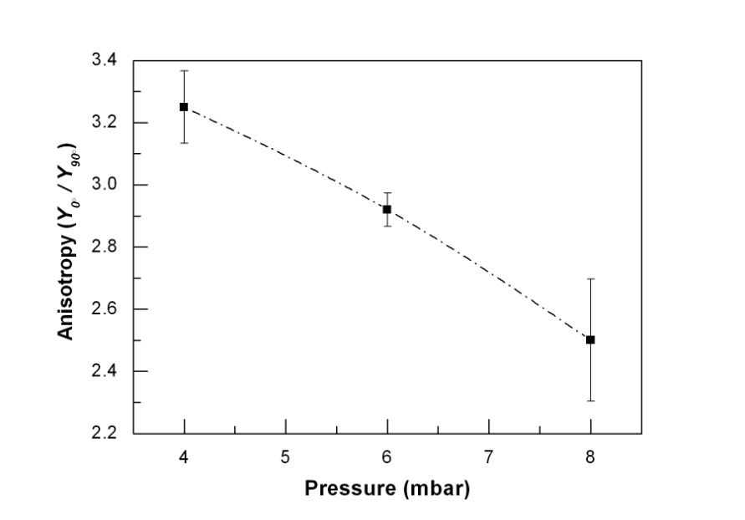

Fig.7. Variation in neutron anisotropy as a function of D2 gas filling pressure for A20Z160 electrode assembly configuration.

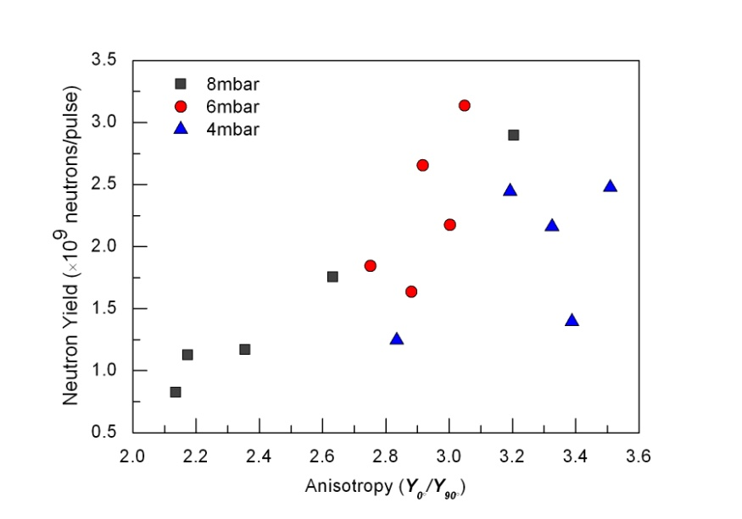

Fig.8. Neutron anisotropy as a function of total neutron yield for discharges at 4mbar, 6mbar and 8mbar D2 gas filling pressures for A20Z160 electrode assembly configuration (relative measurement error is about 1%).

## Neutron Yields for Various Electrode Assembly Configurations; Speed Factor as an Optimization Tool

The average neutron yield in the deuterium pressure range of 0.25 to 9mbar at 14kV (~10kJ) for different electrode assembly configurations (A20Z160, A26Z160, A55Z160, A20Z140, A26Z140 and A55Z70) was measured. The variation in average neutron yield and the time to pinch as function of deuterium filling gas pressure is plotted in Fig. 9 and 10 respectively. The peak average neutron yield, refer Fig. 9, was ~(2.38±0.31)×109 neutrons/shot for initial A20Z160 configuration which increased marginally to ~(2.54±0.24)×109 neutrons/shot for A26Z160 but increased significantly by about 1.4 times to ~(3.40±0.43)×109 neutrons/shot for A26Z140. The increase in anode radius from 20 to 26mm while keeping the anode length same at 160mm increased the yield marginally; but the increase in anode radius with simultaneously decrease in anode length to 140mm increased the yield significantly. It seems to suggest that increasing anode radius and reducing anode length from the initial A20Z160 configuration increased the average neutron yield. The other three anode configurations (A20Z140, A55Z70 and A55Z160), however, resulted in lower average neutron yield. One of these electrode configurations, A55Z70 has a further increase in anode radius and reduction in anode length as compared to initial A20Z160 and new A26Z140 configurations but the average neutron yield has rather decreased. It means that either there is no particular rule to follow or there is a limit to variation in anode dimensions along the line of a specific trend/rule to further optimize the neutron yield.

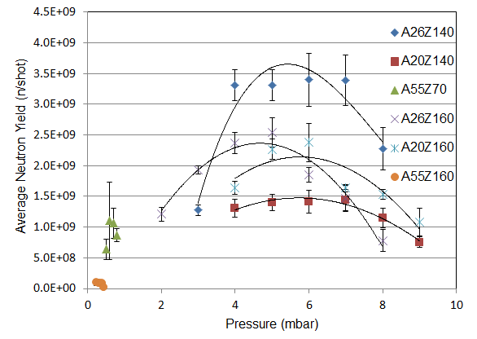

Fig.9. Average neutron yield for different electrode assembly configurations at 14kV charging for different D2 gas filling pressures.

It is also interesting to note that electrode assembly configurations with significantly higher anode radius of 55 mm (i.e. A55Z160 and A55Z70) were able to produce pinch plasma column (confirmed through the dip in current derivative signal of Rogowski coil) and neutron yield at low filling gas pressures of less than 1 mbar. The average neutron yield dropped significantly by almost about two orders of magnitude to 107 neutrons/shot for electrode assembly configuration A55Z160 i.e. when only the anode radius was increased significantly to 55mm from initial 20mm or optimized 26 mm anode while keeping the anode length same at 160mm. The reduction in anode length to 70mm for the anode of radius 55mm in A55Z70 increased the average neutron yield back to the level of high 108 to low 109 neutrons/shot.

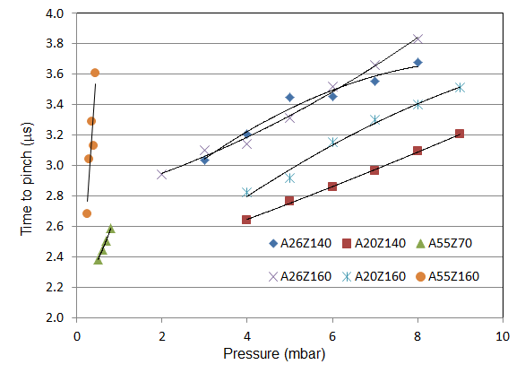

Fig.10. Average time to pinch for different electrode assembly configurations at 14kV charging for different D2 gas filling pressures.

The comparison of plots in Fig. 9 and 10 indicates that for most of the electrode configurations (A20Z160, A26Z160 and A26Z140) higher average neutron yield was obtained when the time to pinch was about 3.2 to 3.6 µs; which is close to the quarter time period of the NX-3 PF device. However, for the electrode configuration A55Z160 even though the time to pinch in the similar range was obtained for some of the operating pressures, refer Fig. 10, but the neutron yield was relatively low whereas A55Z70 had relatively low time to pinch between 2.4 to 2.6 µs but the average neutron yield was significantly better. This further emphasizes that the rule for neutron yield optimization is not unique or simple but it is rather a complex mix of few interdepending variables such as the one in speed factor [17]. To gain the better understanding of the trends of neutron yields for different electrode assembly configurations the corresponding speed factors, *s*, were investigated.

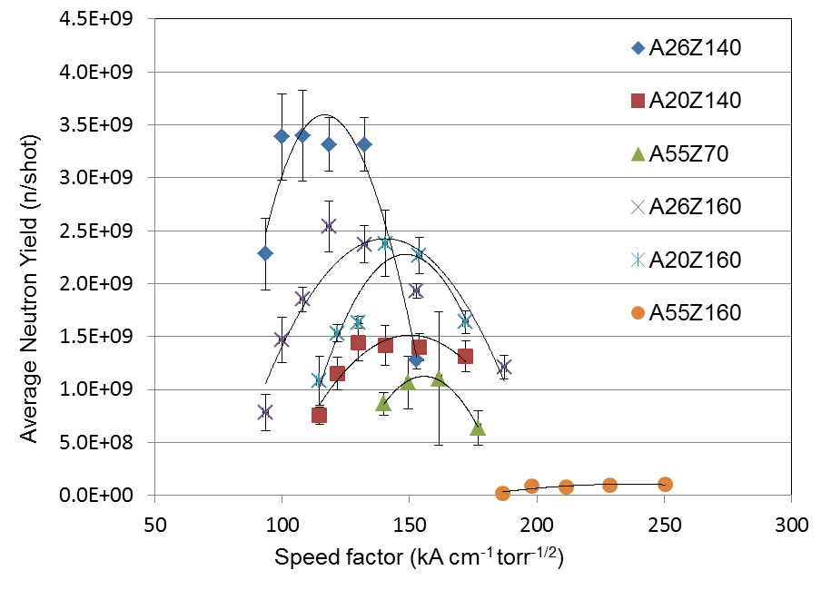

Figure 11. Average neutron yield as function of speed factor for different electrode assembly configurations at 14kV charging. The band shows the range of typical values of speed factor for neutron optimized devices [17].

The average neutron yield is plotted as a function of speed factor in Fig. 11. The speed factor, , is calculated using *Io*=600kA (the peak discharge current at 14kV charging voltage), the anode radius *a* of the given electrode assembly configuration, and the pressure *P* as the experimentally measured filling gas pressure of deuterium (converted in Torr). According to Lee and Serban [17], most of the neutron optimized plasma focus devices have the typical speed factor value of about 89±8 kA cm-1 Torr-1/2, depicted by a band in Fig. 11. The Fig. 11 shows that for all electrode assembly configurations the values of speed factor was mostly higher than the typical value for neutron optimized devices. The configuration A26Z140 with highest neutron yield had speed factor ranging from about 94 to 153 kA cm-1 Torr-1/2 while the configuration A55Z160 with lowest neutron yield had very high speed factors in the range from 187 to 250 kA cm-1 Torr-1/2. It is remarkable to note that lower is the deviation in value of the speed factor from the reported typical value for neutron optimized focus devices the higher is the average neutron yield from the NX-3 device. This highlights the reliability of the speed factor as the guiding rule for neutron yield optimization in plasma focus device.

# Conclusion

In conclusion, NX-3 dense plasma focus device has been successfully commissioned and demonstrated as reproducible, high yield pulsed neutron source producing average yield in the order of ~109 neutrons/pulse with pure deuterium operation. The precisely engineered device construction and judiciously chosen initial electrode assembly configuration (A20Z160) with the help of Lee Code formulations made the realization of this high performance device possible. A record neutron yield ~4.6×109 neutrons/pulse was demonstrated at 10kJ/14kV/6mbar/pure D2. With DT operation the yield is expected to be in the order of ~1011 neutrons/pulse (due to the 100× higher cross section of DT reaction at low energies). The neutron yield reproducibility/stability investigation demonstrated a systematic trend in neutron yield performance for the purged mode of operation. First shot of each batch resulted in substantially larger neutron yield than the followed shots. In the non-purging mode of operation neutron yield from shot to shot fluctuated widely. Anisotropy in the neutron fluence of NX-3 plasma focus device was found to be relatively higher i.e. ~2.9 at optimum setting of 10kV/6mbar. Also, higher neutron yields have been found to be associated with higher anisotropy. This corroborates the dominance of beam target mechanism of neutron production in NX-3 device.

The further optimization of NX-3 neutron yield and an investigation of finding the correlation between the speed factor and the neutron yield were conducted using various electrode configurations (A20Z160, A26Z160, A55Z160, A20Z140, A26Z140 and A55Z70). These configurations were finalized using the Lee Code [19, 20] based on the electrical parameters of NX-3 device and some simple assumptions to allow the operation of device over different speed factors subjected to the conditions that the simulated neutron yields remain within a factor of 2 for all configurations. It was found that for all electrode assembly configurations the values of speed factor were mostly higher than the typical value (89±8 kA cm-1 Torr-1/2) for neutron optimized devices and lower is the deviation in value of the speed factor from the reported typical value the higher is the average neutron yield from the NX-3 device. Since the speed factor for the A26Z140, the best among the six configurations used, was still on the higher side therefore one can conclude that further optimization is still possible if the speed factor can be shifted to the typical values (the band drawn in Fig. 11) proposed by Lee and Serban [17]. The trend shows that it probably possible to further increase the average neutron yield in NX-3 PF device to about (4.0-4.5) ×109 neutrons/shot.

Acknowledgements

The authors are grateful to the National Institute of Education/Nanyang Technological University, Singapore, for AcRF grant RP 4/07 TTL. One of us, RV, would like to thank Prof. P. K. Kaw, Director, Institute for Plasma Research, Bhat, Gandhinagar, Gujarat, India for providing the opportunity to gain extended research experience at Plasma Radiation Source Laboratory, Nanyang Technological University, Singapore.

References

[1] M. Mathuthu, T. G. Zengeni and A. V. Gholap, *IEEE Trans. Plasma Sci*., **25**(6), 1382 (1997).

[2] [V. Gribkov](http://scitation.aip.org/vsearch/servlet/VerityServlet?KEY=APCPCS&possible1=Gribkov%2C+V.&possible1zone=author&maxdisp=25&smode=strresults&aqs=true), [A. Dubrovsky](http://scitation.aip.org/vsearch/servlet/VerityServlet?KEY=APCPCS&possible1=Dubrovsky%2C+A.&possible1zone=author&maxdisp=25&smode=strresults&aqs=true), [L. Karpinski](http://scitation.aip.org/vsearch/servlet/VerityServlet?KEY=APCPCS&possible1=Karpinski%2C+L.&possible1zone=author&maxdisp=25&smode=strresults&aqs=true), [R. Miklaszewski](http://scitation.aip.org/vsearch/servlet/VerityServlet?KEY=APCPCS&possible1=Miklaszewski%2C+R.&possible1zone=author&maxdisp=25&smode=strresults&aqs=true), [M. Paduch](http://scitation.aip.org/vsearch/servlet/VerityServlet?KEY=APCPCS&possible1=Paduch%2C+M.&possible1zone=author&maxdisp=25&smode=strresults&aqs=true), [M. Scholz](http://scitation.aip.org/vsearch/servlet/VerityServlet?KEY=APCPCS&possible1=Scholz%2C+M.&possible1zone=author&maxdisp=25&smode=strresults&aqs=true), [P. Strzyzewski](http://scitation.aip.org/vsearch/servlet/VerityServlet?KEY=APCPCS&possible1=Strzyzewski%2C+P.&possible1zone=author&maxdisp=25&smode=strresults&aqs=true), and [K. Tomaszewski](http://scitation.aip.org/vsearch/servlet/VerityServlet?KEY=APCPCS&possible1=Tomaszewski%2C+K.&possible1zone=author&maxdisp=25&smode=strresults&aqs=true), *AIP Conf. Proc*. **875**, 415 (2006).

[3] D. Ravenscroft, D. Bulmer, F. Coensgen, J. Doggett, A. Molvik, P. Souza, L. Summers, V. Williamson, *Proc. 14th IEEE/NPSS Symp. on Fusion Engineering*, **2**, 1064 (1991).

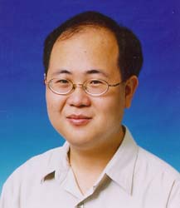[4] F. N. Beg, K. Krushelnick, C. Gower, S. Torn, A. E. Dangor, A. Howard, T. Sumner, A. Bewick, V. Lebedenko, J. Dawson, D. Davidge, M. Joshi, J. R. Gillespie, *Appl. Phys. Lett.*, **80,** 3009 (2002).

[5] M. Sumini, D. Mostacci, F. Rocchi, M. Frignani, A. Tartari, E. Angeli, D. Galaverni, U. Coli, B. Ascione, G. Cucchi, *Nucl. Instrum.Methods Phys. Research A*, **562,** 1068 (2006).

[6] V. Benzi, F. Mezzetti, F. Rocchi, M. Sumini, *Nucl. Instrum.Methods Phys. Research B*, **213,** 611 (2004).

[7] J. Pouzo, M. Milanese, R. Moroso *AIP Conf. Proc.***669**, 277 (2003).

[8] T. E. Mason, D. Abernathy, J. Ankner, A. Ekkebus, G. Granroth, M. Hagen, K. Herwig, C. Hoffmann, C. Horak, F. Klose, S. Miller, J. Neuefeind, C. Tulk, X. L. Wang, *AIP Conf. Proc*., **773,** 21 (2005).

[9] David L. Chichester and James D. Simpson, *The Industrial Physicist*, **9** 22 (2003).

[10] R. Verma, R. S. Rawat, P. Lee, M. Krishnan, S. V. Springham and T. L. Tan, *Plasma Phys. Control. Fusion*, **51,** 07508 (2009).

[11] L. Soto, C. Pavez, P. Silva, J. Moreno, M. Barbaglia and A. Clausse, *Plasma Sources Sci. Technol.*, **18,** 015007 (2009).

[12] R. K.Rout , P. Mishra, A. M. Rawool, L. V. Kulkarni and S. C. Gupta, *J. Phys. D: Appl. Phys.*, **41,** 205211 (2008).

[13] B.L. Bures, M. Krishnan, R.E. Madden, F. Blobner, IEEE Transactions on Plasma Science, 38 (2010) 667-671.

[14] V. Raspa, F. Di Lorenzo, P. Knoblauch, A. Lazarte, A. Tartaglione, A. Clausse and C. Moreno, *PMC Physics A* , **2:5** (2008). doi:10. 1186/1754-0410-2-5,

[15] Rishi Verma, R S Rawat, P Lee, S V Springham, T L Tan and M Krishnan, *J. Phys. D: Appl. Phys*., **42**, 235203 (2009).

[16] Rishi Verma, R S Rawat, P Lee, S V Springham, T L Tan and M Krishnan, *J. Fusion Energy*, **doi:**10.1007/s10894-012-9517-5, 1 (2012).

[17] S. Lee and A. Serban, *IEEE Trans. on Plasma Sci*., **24,** 1101(1996)

[18] M. S. Rafique, *Compression dynamics and radiation emission from a deuterium plasma focus*, PhD Dissertation*,* Nanyang Technological University, Singapore (2000).

[19] S. Lee, Radiative Dense Plasma Focus Computation Package: RADPF, (2011)http://www.plasmafocus.net

[20] S. Lee, R. S. Rawat, P. Lee and S. H. Saw, *J. Appl. Phys.* **106**, 023309 (2009).

[21] S. Lee, S. H. Saw, R. S. Rawat, P. Lee, R. Verma, A.Talebitaher, S. M. Hassan,A. E. Abdou, Mohamed Ismail, Amgad Mohamed, H. Torreblanca, Sh Al Hawat, M. Akel, P. L. Chong, F. Roy, A. Singh, D. Wong and K. Devi, *J. Fusion Energy*, **31** (2), 198, (2011).

[22] S. Mahmood , S. V. [Springham](http://adsabs.harvard.edu/cgi-bin/author_form?author=Springham,+S&fullauthor=Springham,%20S.%20V.&charset=UTF-8&db_key=PHY), T. [Zhang](http://adsabs.harvard.edu/cgi-bin/author_form?author=Zhang,+T&fullauthor=Zhang,%20T.&charset=UTF-8&db_key=PHY), R. S. [Rawat](http://adsabs.harvard.edu/cgi-bin/author_form?author=Rawat,+R&fullauthor=Rawat,%20R.%20S.&charset=UTF-8&db_key=PHY), T. L. [Tan](http://adsabs.harvard.edu/cgi-bin/author_form?author=Tan,+T&fullauthor=Tan,%20T.%20L.&charset=UTF-8&db_key=PHY), M. [Krishnan](http://adsabs.harvard.edu/cgi-bin/author_form?author=Krishnan,+M&fullauthor=Krishnan,%20M.&charset=UTF-8&db_key=PHY), F. N. [Beg](http://adsabs.harvard.edu/cgi-bin/author_form?author=Beg,+F&fullauthor=Beg,%20F.%20N.&charset=UTF-8&db_key=PHY), S. [Lee](http://adsabs.harvard.edu/cgi-bin/author_form?author=Lee,+S&fullauthor=Lee,%20S.&charset=UTF-8&db_key=PHY), H. [Schmidt](http://adsabs.harvard.edu/cgi-bin/author_form?author=Schmidt,+H&fullauthor=Schmidt,%20H.&charset=UTF-8&db_key=PHY), P. [Lee](http://adsabs.harvard.edu/cgi-bin/author_form?author=Lee,+P&fullauthor=Lee,%20P.&charset=UTF-8&db_key=PHY)*Rev. Sci. Instrum.* **77** 10E713 (2006).

[23] S. Lee, *Plasma Phys. Control. Fusion,***50,**105005 (2008).

[24] C. Moreno, H. Bruzzone, J. Martinez and A. Clausse I*EEE Trans. Plasma Sci.,***28,** 1735 (2000).[25] L. Bilbao and H. Bruzzone*Phys. Lett.,***101A**, 261 (1984).

[26] A. Bernard, A. Coudeville, A. Jolas, J. Launspach and J. de Mascureau, *Phys. Fluids*, **18**, 180 (1975).

[27] J. Mather, *Phys. Fluids*, **8**, 366 (1965).

[28] A. Bernard, A. Coudeville, J. Watteau, *Phys. Lett.*, **33a**, 477 (1970).

[29] N. Peacock, P. Wilcock, R. Speer, P. Morgan, *Proc. 3rd Int. Conf. in Plasma Physics and Controlled Nuclear Fusion Research*, **2**, 51 (1968).

[30] J. Lee, L. Shomo, M. Williams, H. Hermansdorfer, *Phys. Fluids*, **14**, 2217 (1971).

[31] M. Zakaullah, I. Akhtar, G. Murtaza and A. [Waheed](http://scitation.aip.org/vsearch/servlet/VerityServlet?KEY=ALL&possible1=Waheed%2C+A.&possible1zone=author&maxdisp=25&smode=strresults&aqs=true)*Phys. Plasmas***6**, 3188 (1999).

Rishi Verma received the B.E. degree in electrical engineering from Barkatullah University, Bhopal, India, in 1998 and the Ph.D. degree from Nanyang Technological University, Singapore, in 2010. He is currently with Energetics and Electromagnetics Division, Bhabha Atomic Research Centre, Visakhapatnam, India. His current interests include basic and applied research in various aspects of pulsed power, dense magnetized plasmas, compact and portable radiation generators, and repetitive pulsed power systems. Dr. Verma is a member of the Plasma Science Society of India (PSSI), India.

**Paul Lee** received the B Sc (Hons) (1992) and PhD (1996) from University of London (Imperial College) and PGDipTHE (1999) from Nanyang Technological University. He is currently an Associate Professor at the NanyangTechnologicalUniversity (National Institute of Education). He was visiting Associate Professor at University of Washington,Seattleand Technological Educational Institute, Crete during 2007. His current research interests include plasma physics, materials science and physics education.

**R S Rawat** received the B.Sc.(Hons), M.Sc. and Ph.D. degrees from University of Delhi, Delhi, India in 1985, 1987 and 1994 respectively. He is presently an Associate Professor with National Institute of Education, Nanyang Technological University, Singapore. His current research interests include development of repetitive miniature plasma focus device as portable neutron source, charged particle and radiation emission from focus devices for nano-phase material synthesis, ion-implantations and lithography applications and magnetic nanoparticles/nanocomposites and dilute magnetic semiconductor thin films of transition metal doped ZnO using pulsed laser depositions. He has authored 136 research papers in journals of international repute and about 63 research papers in conference proceedings. He is currently honorary secretary of Asian African Association for Plasma Training and honorary secretary of Institute of Physics, Singapore.

**Augustine Tuck Lee Tan** received the Ph.D. degree from the National University of Singapore (NUS), Singapore, in 1993.

****During the Ph.D. program, he worked with Herzberg Institute of Astrophysics, Ottawa, ON, Canada, for eight months, and at the University of Washington, Seattle, in high-resolution infrared spectroscopy of gases of atmospheric interests. He spent two years of postdoctoral research with the Department of Physics, NUS. Later, he worked for four years as a Senior Engineer in photolithography, and plasma etching of III–V semiconductor materials in Hewlett-Packard, Singapore and San Jose. He is currently with the Natural Sciences and Science Education, National Institute of Education (NIE), Nanyang Technological University, Singapore. He currently teaches undergraduate and graduate academic subjects such as optics, waves, molecular spectroscopy, biological materials, and gemmology. Since 2005, he has been appointed as Associate Dean, Academic Research, with NIE. He is experienced in wafer fabrication technology, and failure analysis techniques of Fourier transform infrared (FTIR) spectroscopy, SEM, TEM, XPS, and EDXF. He is currently involved in microlithography using soft X-rays from dense neon and argon plasma focus with the Plasma Laboratory, NIE. Furthermore, he is researching on high- resolution FTIR spectroscopy of gaseous molecules, and in gemmology. Since 1991, he continues to be actively researching on FTIR spectroscopy of gases in collaboration with NUS and Jet Propulsion Laboratory, California Institute of Technology, Pasadena, CA. He is the author of 125 papers in international journals of U.S. and U.K., including three in Physical Review (U.S.). He is a member of the Institute of Physics, Singapore, an external reviewer of research grants, an examiner of Ph.D. theses, and a research mentor to secondary schools and colleges.

**Hashim Shariff** received the DipEd(2001) from National Institute of Education(NIE), BSc(2003) and MSc (2012) from Nanyang Technological University. He is currently a Head of Department (Science) in Yu Neng Primary School (MOE), Singapore-469623. His current research interests include plasma physics and Science education.

**J Y Goh** received the B Sc (Hons) (2012) from Nanyang Technological University (National Institute of Education).She is currently a General Education Officer with the Ministry of Education. Her current teaching subjects include Secondary level physics and mathematics.

**Stuart V. Springham** was born in Glasgow, U.K., on October 28, 1960. He received the B.Sc. de- gree in physics from the University of Strathclyde, Glasgow, in 1982 and the Ph.D. degree in experimental nuclear physics from the University of Edinburgh, Edinburgh, U.K., in 1989. From 1989 to 1992, he was a Senior Software Engineer with Computervision Research and Development, Cambridge, U.K. Since 1992, he has been with the National Institute of Education (NIE), Nanyang Technological University (NTU), Singapore. He joined NIE/NTU as a Lecturer, and became Senior Lecturer in 1997 and Associate Professor in 1999. His research interests are in radiation and nuclear diagnostics for fusion plasmas. His current research is focused on measuring the energetic and spatial distributions of deuteron beams, and fusion protons and neutrons within the dense plasma focus (DPF) operated in deuterium gas. This research is aimed at understanding the nature of the fusion mechanism in DPF devices. He is a member of the Institute of Physics (U.K.) and the Institute of Physics (Singapore).

**Alireza Talebitaher** received his B.Eng. degree in Electrical/Electronic engineering from the Amirkabir Industrial University (Polytechnic of Tehran), Iran, in 1994 and his Ph.D. in experimental plasma physics from Nanyang Technological University (NTU), Singapore in 2012. In the years of 2000-2007 he was working in Plasma Physics Research Center, Azad University, Tehran, Iran as a staff engineer, researcher and lab instructor. Now he is doing research on behaviour of fusion reaction in plasma focus device and teaching the physics subjects. His current research is focused on using the Coded Aperture Imaging technique for investigation of spatial distribution of fusion source in plasma focus devices. He is a Member of the Institute of Physics Singapore.

**Usman Ilyas** received his M.Phil in Applied Physics from University of Engineering and Technology Lahore, Pakistan, in 2009 and currently perusing his PhD in Applied Physics from NIE, Nanyang Technological University Singapore. He joined the university of Engineering and Technology as lecturer in 2007. His research interests involve thin films of ZnO-based wide band gap dilute magnetic semiconductors. His current research focuses on the investigation of origin of room temperature ferromagnetism in dilute magnetic semiconductors for their use in spintronics.

**Dr. Anurag Shyam** has done his graduation and masters in Physics from St. Stephens College, Delhi University in 1975. He joined Bhabha Atomic Research Centre, Mumbai in 1975 and completed his Ph.D. in 1981. He is presently leading, Pulse Power and Development of RFQ for Accelerators Division at Institute for Plasma Research, Gandhinagar, Gujarat, India and Energetics and Electromagnetics Division at Bhabha Atomic Research Centre, Visakhapatnam, India. His research activity includes work on pulsed power systems, fusion neutronics, neutron/gamma tomography and plasma focus device. Dr. Shyam is a member of the Plasma Science Society of India (PSSI), India.

1. Manuscript received xxxxxxx. This work was supported by the AcRF Tier-1 RP 4/07 TTL, Nanyang Technological University, Singapore

   R. Verma was with Natural Sciences and Science Education, National Institute of Education, Nanyang Technological University, Singapore-637616 and is currently working at Bhaba Atomic Research Centre, Autonagar, Visakhapatnam, India-530012. (e-mail: rishiv9@gmail.com).

   R. S. Rawat, P. Lee, T. L. Tan, S. V. Springham, A. Talebitahir, and U. Ilyas are with Natural Sciences and Science Education, National Institute of Education, Nanyang Technological University, Singapore-637616, (e-mails: paul.lee@nie.edu.sq; rajdeep.rawat@nie.edu.sq; augustine.tan@ nie.edu.sg; stuart.springham@nie.edu.sg; mtalebi69@yahoo.com; iusman82@gmail.com).

   A. Shyam is with Bhaba Atomic Research Centre, Autonagar, Visakhapatnam, India-530012 (email: shyam.anurag@gmail.com).

   Hashim Sharif is with Yu Neng Primary School, Singapore-469623 (e-mail: hashim_bin_mohd_shariff@moe.edu.sg).

   J. Y. Goh is with is currently a General Education Officer with the Ministry of Education, Singapore (e-mail: goh_jia_ying_michelle @moe.edu.sg).