Preliminary Results for Kansas State University Dense Plasma Focus (KSU-DPF).
- E. Abdou¹, M. I. Ismail¹, A. E. Mohamed¹, S. Lee^{2,3,4}, S. H. Saw^{2,3}
¹Kansas State University, Manhattan, KS66502,USA ²INTI International University, 71800 Nilai, Malaysia
³Institute for Plasma Focus Studies, Melbourne, Australia
⁴Nanyang Technological University National institute of Education, Singapore

Abstract
Kansas State University Dense Plasma Focus (KSU-DPF) was developed to be used as a multi- radiation source. In this paper the experiment set up is shown. A short- circuit test was done to calculate the static parameters, L_{o} and r_{o}, Preliminary results for the time of flight, the dependence of the focus time on the pressure and first estimation of the neutron yield and its dependence on pressure were introduced. In addition the fitting of the current signals to the 6 -phase Lee Model produced some interesting results..
Introduction
A dense Plasma Focus (DPF) is a pulsed power device capable of producing short-lived (tens of ns), hot and dense) plasma electromagnetic (JxB) compressions. It was invented in early 1960’s independently by Mather in the USA and by Flippov in the former Soviet Union ^{[1]}. The main differences between both types are in the electrode dimensions specifically the aspect ratio of anode radius ‘a’ to the axial length (z). It is characterized by simple design, easy maintenance and low cost. The DPF is a multi-radiation source capable of producing simultaneously different types of radiation like fusion neutrons (~2.45 Mev from deuterium-deuterium or 14.5 Mev from deuterium-tritium fusion reactions), hard x-rays of hundreds of kev energy (due to electron beam hitting anode), ion beams and electron beams (energy in the range of Mev), and GHz electromagnetic radiation. These multi-radiations give the plasma focus diversity in its applications.
Apparatus
The KSU Dense Plasma Focus is of Mather’s type. It is composed of three main parts: Capacitor and charging system, device head and diagnostic techniques. The capacitor used is an Aerovox capacitor 12.5 uF capacitance with rated voltage 20 kV and stored energy 2.5 kJ. It is charged by a General Atomics power supply with rated voltage 30 kV. The capacitor is connected to the electrodes through a TDI1-200k/25H, 10 ns jitter, Thyratron.
The device head is composed of a stainless steel rod with 100 mm length and 7.5 mm radius surrounded by a cage of 6 bars of brass as a cathode with radius of 25 mm. At the launching end (see Fig 1), the anode and cathode are separated by a Pyrex glass insulation tube 68 mm length and 1.6 mm thick. Both cathode and anode are contained in a stainless steel chamber with two glass windows and several openings for evacuating, pressure control and monitoring processes. A schematic diagram of the experiment is shown in figure 1.
Several diagnostics are used including a Rogowski coil to measure the di/dt, Northstar high voltage probe HV5 60/100 kv DC/AC 80 MHz to measure the voltage signal, and several neutron detectors:
- BC-418 plastic scintillator, 0.5 ns rise time (for neutron time of flight TOF)
- LiI scintillator with Bonner spheres
- ³He detector with Bonner sphere
- Fast neutron(> 100 keV ) bubble detector.
- X-ray detectors like BC-418 plastic scintillator, 0.5 ns rise time and four-channel filtered PIN diode BPX65 spectrometer.
r_{o}
Cathode
Anode
Insulator
Spark Gap
L_{o}
C

FIG. 1 Schematic diagram of the DPF circuit.
Operation and Determination of static parameters:
In the dense plasma focus the static parameters, L_{o}, r_{o} and C_{o} are very important to know. Co is the capacitance of the capacitor bank and the value is provided by the manufacturer of the capacitors. The value of Co could also be determined, if there is a reason to suspect the manufacturer’s supplied value, by a R-C leakage test using a large enough resistance of accurately known value and with the correct voltage rating. A short- circuit test should be done to determine the Lo and ro, inductance and resistance of the electric circuit itself. For the short-circuit test the anode was connected directly to the cathode by a metal disc at the position where the plasma focus discharge would initiate were it not short-circuited. The circuit in this case is considered to be a series RLC circuit. The DPF equivalent circuit in this case is considered to be under-damped with ^{[2]}.
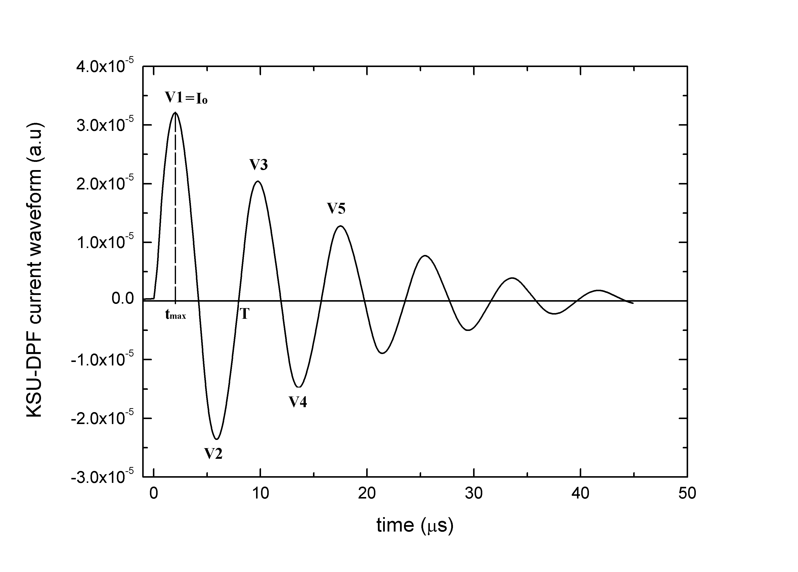

Fig.2 the measured wave form for the short circuit test at 17 kV

The short circuit test was done with 17 kV producing the sinusoidal wave shown in figure 2. With some approximations the static parameters (L_{o}, R_{o}) and the peak current (I_{o}) can be determined from the following equations ^{[3]}.
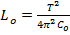 , 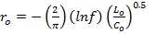,
Where is the reversal ratio obtained from the peaks of graph 2 Hence, 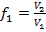 ,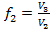, 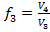 , 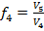 and = ( which is the average of various reversal ratios, Here = 0.80. From the graph also the time period is calculated by taking the average of three time periods to make it more accurate ,T=7.85.
From previous data L_{o} is calculated to be 124.9 nH, r_{o}= 14.4 and finally the peak current is 152.8 kA.
Dividing the peak current by the maximum current given from figure 2 gives the calibration factor of the Rogowski coil equal to 4.775E6 kA/V. [please check: is this calibration constant correct?]
Many shots were taken with different gas pressures. The time derivative of the current flows to the anode and the voltage across the tube were picked up by the Rogowski coil and voltage probe, respectively. The time derivative was integrated numerically by the oscilloscope to get the current. Typical signals for current derivative, voltage and current are shown in figure 3a, 3b and 3c. An increase in the focusing time is noticed with the gas pressure increase which agrees with the previous work ^{[4],[5]}. The dependence of pinch time at the gas pressure is shown in figure 3d.
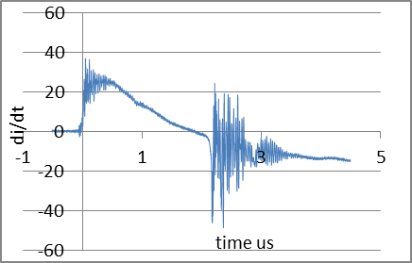
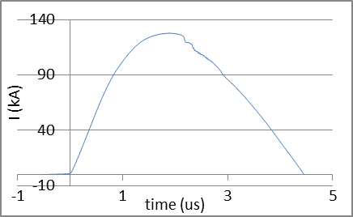
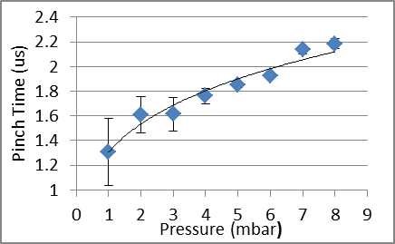
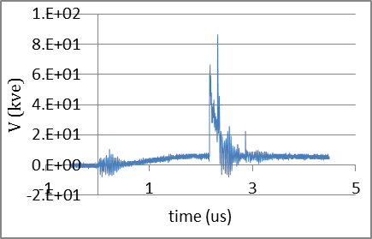
d
a
b
c

FIG.3. A typical signal for the current derivative(a), the voltage across the electrodes(b), the current integrated by the oscilloscope(c) and the dependence of focusing time on the gas pressure (d).

Time-of-Flight Neutron-Measurements (TOF)
Time-of-flight (TOF) neutron measurements is an important technique to give information on the time-resolved neutron energy spectra for short pulsed plasma radiation source like z-pinches and dense plasma focus ^{[6]}. This technique typically uses a scintillation-photomultiplier system to register the time resolved hard x-ray and nuclear-fusion neutron pulses. The neutron energy is calculated by measuring the time difference between the hard x-ray pulse and the neutron pulse^{[7]}; in order to verify that the neutrons have an energy of 2.45 MeV.
c

FIG. 4 The output signal of the PMT placed 3 m away and at 90º
In the KSU Dense Plasma Focus a BC-418 plastic scintillator is equipped with a HAMAMATSU H7195 Photomultiplier. The scintillator-PMT system was placed at 3 m distance from the Dense Plasma Focus device at 90º direction and was connected to the oscilloscope to register the signals. One of the signals is shown in figure 4. The two spikes at the figure represent the hard X-ray signal which reaches the scintillator first and the neutron emission which reaches 138.7 ns later. By the time difference between the two signals we calculate the velocity of the neutrons which is 21.62E+6 m/s and gives energy nearly equal to 2.45 MeV. [give the measured value.]
Neutron yield Measurements:
Much work has been carried out to find the mechanism of neutron production in pinched plasma discharges (Z-Pinch, X-Pinch and Plasma Focus). Thermonuclear reaction, Beam target and gyrating particle models have been proposed as neutron production mechanisms. Typically accepted mechanisms are the thermonuclear reactions and ion beam-target fusion where the total neutron yield Y=Y_{th}+Y_{b-T}^{[8]}. The neutron yield is estimated using a BTI BD-PND bubble detector located 17.5 cm away from the center electrode at radial direction. The dose equivalent of the BD is 6.7 b/mrem, given by the manufacturer, while its conversion factor is 3.48E-05 (mrem/ n cm⁻²). Using this conversion factor the maximum neutron yield obtained at a single shot was 2.8E8. A series of shots were taken with different Deuterium pressure ranged from 1 to 8 mbar and the neutron yield was measured using a ³He detector located 621 cm away from the Plasma Focus at radial direction. Figure 5 shows the dependence of neutron yield on the deuterium pressure which agrees with the previous work ^{[4],[5],[9]}.

FIG. 5 Neutron yield dependency on the pressure.
Fitting KSU-DPF with Lee Model
The KSU-DPF is characterized by its high inductance. It is noticed that the current wave signals have an extended dip beyond the regular dip. Such signals are fitted with the 6 phases Lee Model ^{[10]}, an extension to the 5 phase model by adding anomalous resistance terms to represent the instabilities occur during and after the pinch phase. Figure 6 show the fitting of KSU-DPF current signal to the 6 phase Lee Model for a neon discharge.
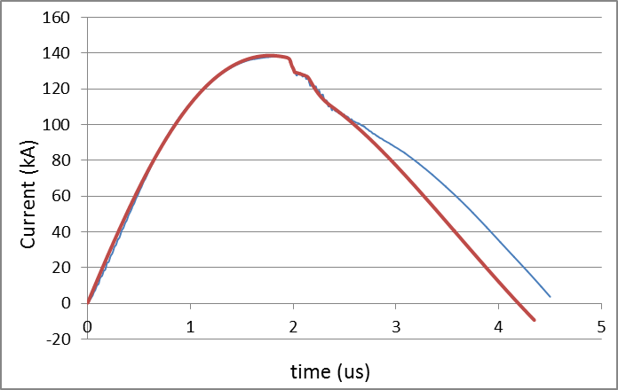
Experimental curve
Computational Curve
FIG.6 The fitting of 1.5 mbar Neon current signal to 6-phase Lee Model.

Conclusion:
The KSU-DPF short circuit test showed that it is a high inductance machine,. The current signals, obtained by Rogowski coil, all show an extended dip beyond the regular dip¹⁰ and they were fitted by the 6 phase Lee Model. By using of a scintillator- photomultiplier system placed 3 m away from the focus at 90º the neutron energy was verified to be 2.45 Mev. Analyzing many shots at different Deuterium pressures showed that the time to the focus increases as the pressure was increased. Over the pressure range from 1 to 8 mbar Deuterium the time to focus varied from 1.31 to 2.19 us. The maximum neutron yield measured in one shot as estimated by the bubble detector at radial direction was 2.8 x 10⁸. Moreover, the neutron yield estimation by ³He detector showed good agreement with the previous work and it showed that the maximum neutron yield was obtained at the optimum pressure of the machine which is 5 mbar.
References
- A. Bernard, et al, ”Scientific Status of Plasma Focus Research”, J. Moscow Phys. Soc. 8 (1998) 93-170.
- Michele Frignani,” Simulation of Gas Breakdown and Plasma Dynamics in Plasma Focus Devices”, Ph.D thesis, Alma Mater Studiorum Università degli Studi di Bologna, 2007.
- S. H. Saw, et al, In situ determination of the static inductance and resistance of a plasma focus capacitor bank, Review of Scientific Instruments 81, 053505 _2010.
- Cesar Moreno, et al,” Small-Chamber 4.7 kJ Plasma Focus for Applications”, CP563, Plasma Physics: IX Latin American Workshop,2001.
- César Moreno, Conceptual Engineering of Plasma-Focus Thermonuclear Pulsors, IEEE Transactions on Plasma Science, vol. 28, no. 5, October 2000.
- Krzysztof J. Tomaszewski, Diagnostic System for Time-of-Flight Neutron Measurements, Plasma and Fusion Science, 2006.
- V. Siahpoush, et al, Preliminary Results of Neutron Production in Sahand Plasma Focus Device”, 2nd International Conference on Nuclear Science and Technology in Iran, Shiraz University April 27-30,2004.
- Leopoldo Soto, New Trends and Future Perspectives on Plasma Focus Research, Plasma Phys. Control. Fusion 47 (2005) A361–A381.
- H. R. Yousefi, et al, “Investigation of the Neutron Production Mechanism in a 20 kJ Plasma Focus Device, Journal of Fusion Energy, Vol. 25, No. 3/4, December 2006.
- S Lee, S H Saw, A E Abdou and H Torreblanca,” Characterizing Plasma Focus Devices- Role of the Static Inductance-Instability Phase Fitted by Anomalous Resistances”, J Fusion Energy DOI 10.1007/s10894-010-9372-1; Published online: 25 December 2010

