[1]

Preliminary Results of Kansas State University Dense Plasma Focus (KSU-DPF)

1. E. Abdou, Mohamed I. Ismail, Amgad E. Mohamed, S. LEE, S. H. Saw, R. Verma

***Abstract*— KSU-DPF is a 2.5 kJ Dense Plasma Focus (DPF) machine newly commissioned at the Plasma Radiation Physics Laboratory at Kansas State University (KSU). The machine was designed to be used as a multi-radiation source for applications in nuclear science and engineering. Neutrons are emitted from Deuterium-Deuterium D-D fusion reactions during high-power electric discharges at 17 kV, 140 kA and 5 mbar. The machine circuit parameters are measured using the short circuit test. The emitted neutrons were measured using several radiation detection techniques. The 2.45 MeV characteristic D-D neutron energy was confirmed using Time Of Flight TOF Technique using BC-418 plastic scintillator. The maximum neutron yield was roughly measured to be 2.8 x 108 neutrons per shot using a set off BTI BD-PND bubble detectors Moreover, the neutron yield variation with pressure was measured and compared to the computed neutron yield using Lee Model. Finally, the measured current showed good agreement with Lee 6-phase Model.**

*Index Terms*— Dense Plasma Focus, Lee Model, Multi-radiation source, Neutron yield.

# INTRODUCTION

A dense Plasma Focus (DPF) is a pulsed power device capable of producing short-lived (tens of ns), hot (Ti ~ keV) and dense (>1019 cm-3) plasma. The machine was independently discovered in the early 60s by Mather in the USA and Filippov in the former Soviet Union [1]. The main difference between Mather and Filippov machine types is the inner electrode aspect ratio (the aspect ratio is defined as the diameter (d) to the axial length (z)). The DPF can be utilized as a multi-radiation source capable of producing simultaneously different types of radiation like: fusion neutrons (~2.45 MeV from D-D or 14.1 MeV from deuterium-tritium D-T fusion reactions), hard x-rays, (~ hundreds of keV generated as a result of upstream electron beam hitting the bottom of the anode hole), ion and electron beams (~MeV, downstream ion beam and upstream electron beam accelerated as a result of the developed electric field at the end of the compression phase) and finally, electromagnetic radiation ( ~ GHz). The KSU-DPF experimental and computational (using Lee Model [2],[3] results will be discussed.



# Apparatus

The KSU-DPF has a Mather’s type geometry. The machine uses an Aerovox capacitor (c = 12.5 µF, L = 40 nH, Vmax=20 kV and Imax= 200 kAmp). A 35 kV, 8 kJ/s General Atomics GA power supply is used as a charger. The capacitor is connected to the electrodes through a TDI1-200kAmp/25kV, 10 ns jitter, Thyratron switch. The central anode is a hollow cylinder with 117 mm height from the cathode base and 7.5 mm radius. Various central electrodes made from Copper, Brass and Stainless-Steel with straight and tapered geometries were manufactured and will be used to characterize the radiation output of the machine. The central electrode is surrounded by a squirrel-cage cathode consisting of 6 equally-spaced Brass bars with 25 mm radius and 120 mm height. At the base, the anode is electrically insulated using a Pyrex glass tube with 68 mm height and 1.6 mm thick, the active Pyrex height is 15 mm. A schematic diagram of the experiment is shown in fig. 1. Several diagnostics were used to measure the machine electrical parameters (Rogowski coil, high voltage probe) and radiation output (plastic scintillators, LiI scintillator and 3He detector with Bonner spheres and bubble detectors were used for neutron measurement and plastic scintillators and BPX photodiodes were used for x-ray measurements).



Anode

ro

Cathode

Insulator

Spark Gap

Lo

C

Fig. 1. Schematic diagram for the DPF circuit.

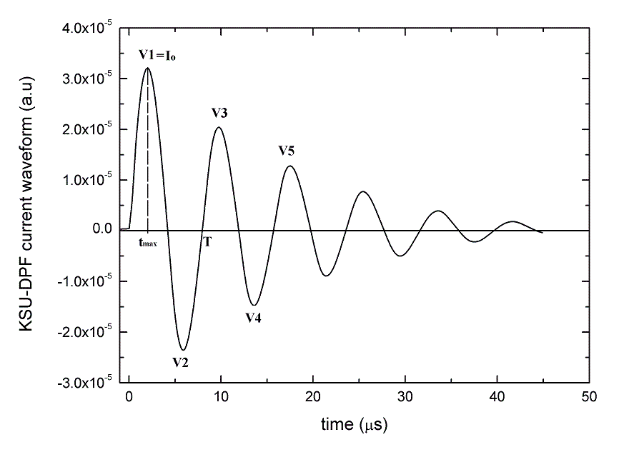

Fig.2. The measured wave form for the short circuit test at 17 kV

# Operation and Determination of static parameters:

The short circuit test is performed to accurately measure the machine static parameters i.e. Lo (circuit inductance in nH), ro (circuit resistance in m) and Co (circuit capacitance taken as 12.5 F). During the test, the anode was connected directly to the cathode (short circuited using an Aluminum circular disk in place of the central electrode connecting the cathode base). The circuit can be electrically represented as a series-RLC circuit. Usually the DPF equivalent circuit in this case is considered to be under-damped i.e. [4].



The short circuit test was done at 17 kV producing the damped sinusoidal waveform shown in fig. 2. With some approximations the static parameters (Lo, ro) and the peak current (Io) are calculated from the following equations[5]:

(1)



(2)



(3)



Where: is the average values of the reversal ratio obtained from the peaks of fig. 2.



Hence, ,, and



(4)



The KSU-DPF Average reverse ratio was calculated to be = 0.7974. The discharge period T=7.85 was calculated by averaging over the first three periods in figure 2. The machine static and discharge parameters are estimated to be: Lo = 124.94 *nH,* ro= 14.4 Ipeak (discharge peak current)= 152.8 kA operating at 17 kV.



During the discharge, the time derivative of the discharge current is measured using calibrated Rogowski coil (4.78 E+6 kA/V) and the discharge voltage is measured using NorthStar HV probe (100 kVDC and 80 MHz) The output of the Rogowski and the HV probe are connected using a tri-axial cable to a 7000 series Tektronix DPO Oscilloscope inside a Faraday cage. The time derivative of the current is integrated numerically using the DPO oscilloscope to obtain the current.

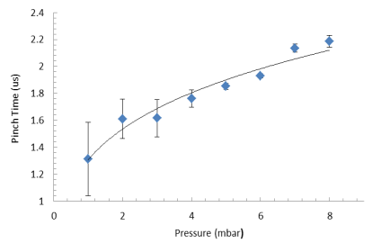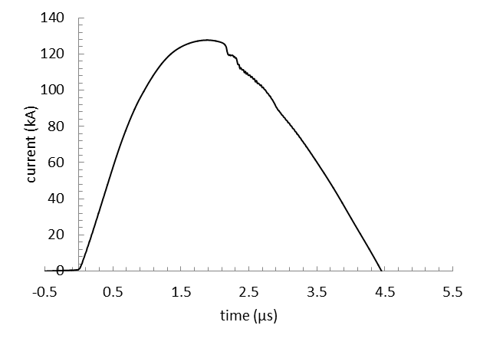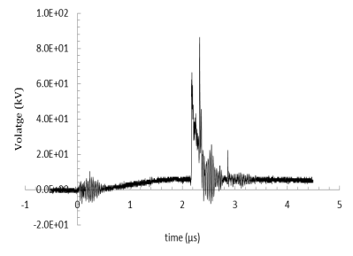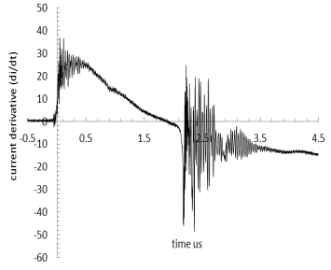

a

b

c

d

Fig.3. A typical signal for the current derivative(a), the voltage across the electrodes(b), the current integrated by the oscilloscope(c) and the dependence of focusing time on the gas pressure (d).

Typical signals for current derivative, voltage and the numerically integrated current are shown in fig. 3a, 3b and 3c.

An increase in the focusing time is noticed with the increase in gas pressure which is consistent with previous literature work[6],[7]. The pressure dependence of pinch time is shown in fig. 3d. This pressure dependence agrees with scaling consideration based on the speed factor. [8]

# Time-of-Flight Neutron-Measurements (TOF)

In dense plasma focus, the Time of flight (TOF) technique is used to give information on the time-resolved neutron energy spectra [9]. This technique is always performed using scintillation detector-photomultiplier system to register the time resolved hard x-ray and neutron pulses. The KSU- DPF TOF detector is a BC-418 plastic scintillator optically connected to HAMAMATSU H7195 Photomultiplier (PMT). The electrical output is connected to the DPO oscilloscope inside a Faraday cage using a tri-axial cable to reduce the signal noise. The scintillator-PMT system was placed at a distance of 3 m away from the Dense Plasma Focus device at 90o from the machine vertical axis.



Fig. 4. The output signal of the PMT placed 3 m away and at 9

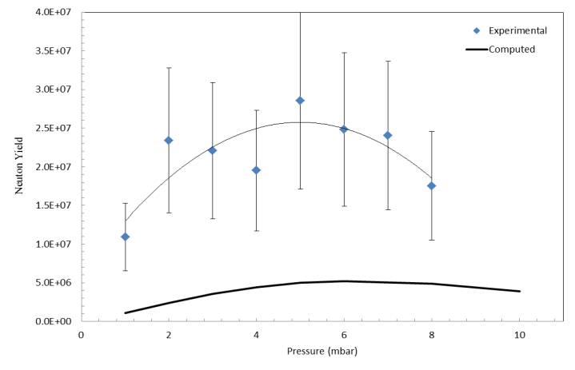

Fig. 5. Neutron yield dependency on the pressure.

Measuring the TOF was done using the time difference between the x-ray and neutron pulses shown in fig.4[10].The two spikes shown in figure 4 represent the hard X-ray signal which reached the scintillator first followed by the neutron signal 138.74 ns later. The estimated neutron velocity based on the measured time of flight is 21.62E+6 m/s and the corresponding neutron energy is 2.45 MeV.

# Neutron yield Measurements:

The neutron generation mechanism is still debated in the pinched plasma discharge (Z-Pinch, X-Pinch and Plasma Focus) communities. Thermonuclear reaction, Beam target and gyrating particle models were all proposed as a possible neutron generation mechanisms but the most accepted mechanisms are the thermonuclear reactions and ion beam-target fusion where the total neutron yield Y=Yth+Yb-T [11].

The Neutron yield was estimated using a BTI BD-PND bubble detector located 17.5 cm away from the center electrode at radial direction. The dose equivalent of the BD is 6.7 b/mrem, given by the manufacturer, while its conversion factor 3.48E-05 (mrem/ n cm-2). Using this conversion factor the maximum neutron yield obtained at a single shot was 2.8E8 on axis. A series of shots were taken at different Deuterium pressure ranging from 1 to 8 mbar and the neutron yield was measured using a 3He detector located 621 cm away from the Plasma Focus at radial direction. Fig. 5 shows the dependence of neutron yield on the Deuterium pressure compared to theoretical neutron yield as calculated using Lee Model [12]

A recent detailed comparison shows good agreement of measured neutron yield with that computed from the Lee Model code [12] in the case of Chilean PF-400J and the Mexican FN-II. These two machines have been identified as T1 low inductance machines [13]. These results and those of other typical T1 machines including the NX2, PF1000 show that the measured neutron yield [3] of these T1 machines agree with the yield computed from the Lee Model code to within a factor of 2. Reviewing these results the one glaring example in which the measured yield [14] greatly exceeds the yield computed from the Lee Model code [3] is that of the UNU ICTP PFF. For this machine the measured yield is 1E+8 n per shot [14] whilst that computed from the Lee Model code [3] is 2E+7 n per shot.

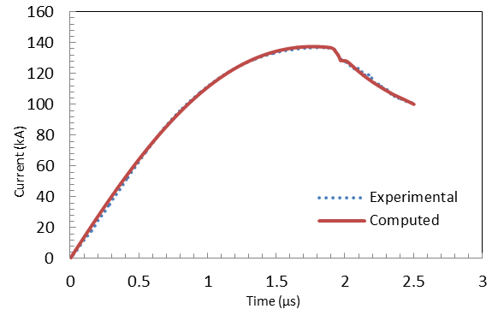

Fig.6. The fitting of 1.5 mbar Neon current signal to 6-phases Lee Model.

The measured yield is greater than the computed by a factor of 5. The UNU ICTP PFF is a high inductance (L0=114 nH) T2 machine. We conclude from this review of measured and computed data that whereas T1 (low inductance) machines show good agreement (within a factor of 2) between the measured (optimized) and computed (from Lee model code) neutron yields, the measured and computed neutron yields of T2 (high inductance) machines as represented by the UNU ICTP PFF and the KSU PF have measured yields that exceed the computed yield by a typical factor of 5. This conclusion may be significant in elucidating further the neutron production mechanism pertaining to beam-target and to further processes which may involve the instabilities of the pinch processes.

# Fitting KSU-DPF with Lee Model

The KSU-DPF is characterized by its high inductance and has been classified as Type T2. It is noticed that the current waveform signals have an extended dip beyond the regular dip. Such signals are fitted with the 6 phase Lee Model [13], an extension to the 5 phase model by adding anomalous resistance terms to represent the developed instabilities during the pinch phase. Fig. 6 shows the fitted KSU-DPF current signal to the 6 phase Lee Model.

VII. CONCLUSION:



The KSU-DPF short circuit test showed that it is a high inductance machine,. The current signals, obtained using Rogowski coil have an extended dip beyond the regular one and they were fitted using the 6 phase Lee Model. Using a scintillator- photomultiplier system placed 3 m away from the focus at 90o, the neutron energy was confirmed verified to be the characteristic 2.45 MeV D-D fusion energy. Analyzing many shots at different Deuterium pressures showed that the pinch occurred later on time as the pressure increase. Where, for the pressure range from 1 to 8 mbar Deuterium the Pinch time varied from 1.310 to 2.186 µs.



The maximum neutron yield measured in one shot as estimated by the bubble detector at radial direction was 2.8E+8. The maximum neutron yield was obtained at the optimum pressure of 5 mbar. The comparison between experimental and computed neutron yield indicates that the optimum pressure has reasonable agreement between the computed and measured one, the fall-off on both sides also has reasonable agreement and finally the measured median values have around 5 times higher neutron yield than the computed in the region near the optimum. This 5 times excess discrepancy in measured neutron yield for the KSU PF (a high inductance T2 PF) is also found for the other published T2 machine the UNU ICTP PFF; whereas other machines, all low inductance T1, have closer agreements (within factor of 2) between the measured and computed neutron yields.

*Acknowledgement*

We acknowledge discussions with Rishi Verma which contributed to our first ideas about the possibility of differences in neutron yields of high and low inductance plasma focus machines..

# References

[1] A. Bernard, et al,”Scientific status of plasma focus research”, J. Moscow Phys. Soc. 8 (1998) 93-170.

[2] S. Lee, “Radiative Dense Plasma Focus Computation Package (2011)” RADPF [www.plasmafocus.net](http://www.plasmafocus.net) ,

http://www.intimal.edu.my/school/fas/UFLF/

[3] S Lee and S H Saw, “Neutron Scaling Laws from Numerical Experiments”, J. Fusion Energy **27** 292-295 (2008).

[4] Michele Frignani,” Simulation of Gas Breakdown and Plasma Dynamics in Plasma Focus Devices”, Ph.D thesis, Alma Mater Studiorum Università degli Studi di Bologna, 2007.

[5] S. H. Saw, et al, “In situ determination of the static inductance and resistance of a plasma focus capacitor bank”, Review of Scientific Instruments 81, 053505, May 2010.

[6] Cesar Moreno, et al,” Small-chamber 4.7 kJ plasma focus for applications”, CP563, Plasma Physics: IX Latin American Workshop, 2001.

[7] César Moreno, Horacio Bruzzone, Javier Martínez, and Alejandro Clausse, “Conceptual engineering of plasma focus thermonuclear pulsors”, IEEE Transactions on Plasma Science, vol. 28, no. 5, October 2000.

[8] S.Lee & A.Serban,” Dimensions & Lifetime of Plasma Focus Pinch”, IEEE Trans Plasma Science. USA (1996) 24, 1101-1105

[9] Tomaszewski, Krzysztof J, “Diagnostic system for time-of-flight neutron measurements”, 16th IAEA Technical Meeting on Research using Small Fusion Devices; XI Latin American Workshop on Plasma Physics. AIP Conference Proceedings, Volume 875, pp. 41-44 (2006).

[10] V. Siahpoush, et al, “Preliminary Results of Neutron Production in Sahand Plasma Focus Device”, 2nd International Conference on Nuclear Science and Technology in Iran”, Shiraz University April 27-30,2004.

[11] A Bernard, H Bruzzone, P Choi, H Chuaqui, V Gribkov, H Herrera, K Hirano, A Krejci, S Lee, C Luo, F Mezzetti, M Sadowski, H Schmidt, K Ware, C S Wong, V Zoita. Scientific Status of Plasma Focus Research. J Moscow Phys Soc 8 (1998) 93-170

[12] S Lee, S H Saw, L Soto, S P Moo, S V Springham, [Numerical experiments on plasma focus neutron yield versus pressure compared with laboratory experiments](http://www.plasmafocus.net/IPFS/Papers/2009%20listofpapers.htm), [Plasma Phys. Control. Fusion **51** 075006](http://www.iop.org/EJ/abstract/0741-3335/51/7/075006/) (11pp) (2009).

[13] S Lee, S H Saw, A E Abdouand H Torreblanca,” chracterizing Plasma Focus Devices- Role of the Static Inductance-Instability Phase Fitted by Anomalous Resistances”, J. Fusion. Energ. 2010.

[14] S. Lee, T.Y. Tou, S.P. Moo, M.A. Elissa, A.V. Gholap, K.H. Kwek, S. Mulyodrono, A.J. Smith, Suryadi, W.Usala, M. Zakaullah. A simple facility for the teaching of plasma dynamics and plasma nuclear fusion. American J. Phys., USA (1988), 56: 62-68.

1. Manuscript received.

   A. E. Abdou , Mechanical and Nuclear Engineering department, Kansas State University, Manhattan, KS66506 USA.(Corresponding author, Tele.503-724-9000, email- aeabdou@ksu.edu)

   Mohamed I. Ismail, Mechanical and Nuclear Engineering department, Kansas State University, Manhattan, KS66506 USA (Email- mismail1@ksu.edu).

   Amgad E. Mohamed, Mechanical and Nuclear Engineering department, Kansas State University, Manhattan, KS66506 USA. (Email- [engaesm@ksu.edu](mailto:engaesm@ksu.edu)).

   S. Lee, INTI International University, 71800 Nilai, Malaysia, Institute for Plasma Focus Studies, Melbourne, Australia.. (Email- [leesing@optusnet.com.au](mailto:leesing@optusnet.com.au)).

   S. H. Saw, INTI International University, 71800 Nilai, Malaysia Institute for Plasma Focus Studies, Melbourne, Australia (email- ([sorheoh.saw@newinti.edu](mailto:sorheoh.saw@newinti.edu)).

   R. Verma, Pulsed Power group, Institute for Plasma Research, Bhat, Gandhinagar, Gujarat 382428, India. ([Email-rishiv9@gmail.com](mailto:Email-rishiv9@gmail.com))